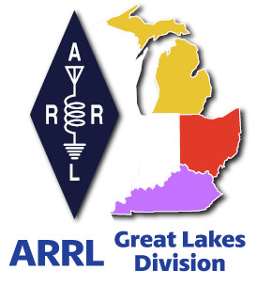
^{The}GLD
Newsletter

April 2024

What’s inside…

Amateur Radio, it’s not just for breakfast anymore | Results from Survey
2024 Division Hamfests | National News

Scott’s Stuff
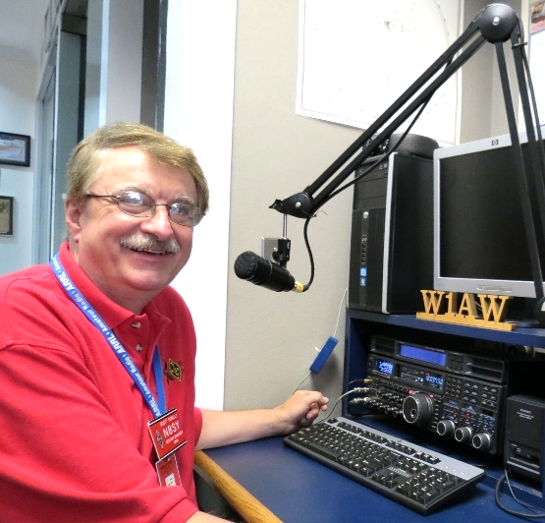
Hi Gang,


Well, it’s April 1st so, let the jokes begin!!! Mother Nature looks like she’s the first in line with these strangely odd weather patterns this year. And of course, let’s not forget the upcoming solar eclipse on April 8th. I can’t remember when the last time was when so much planning went into an event that has a 70% chance of not being visible due to rain or at the very least, a heavy cloud base. All is not bad news, however. All this planning has included Amateur Radio in most cases, and that’s a good thing.

Spring has sprung for sure and so have a bunch of hamfests. I’ve had the privilege of attending quite a few of them lately and there’s a full calendar of them looking ahead! I’m so looking forward to May and better weather. And, speaking of May, that really signals the beginning of lots of warmer weather coming and of course, the Dayton Hamvention. Have you gotten your tickets and rooms reserved for Hamvention yet? You know it’s only 47 days away, so you’d better get on the stick quickly, as room reservations are going fast!
Oh, if you haven’t noticed this yet, the Hamvention is also going to be the ARRL National Convention this year as well!!!

Ok, let’s get down to business.

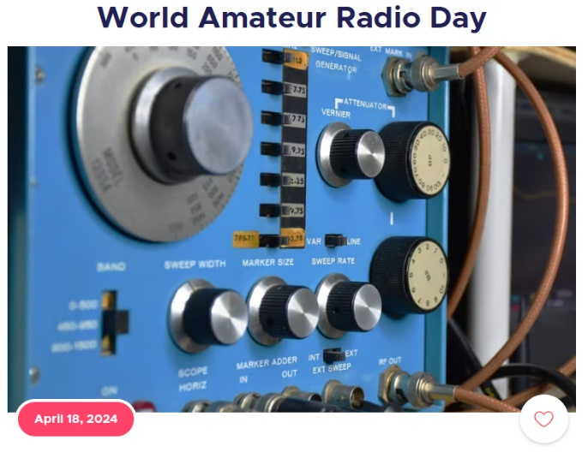
World Amateur Radio Day is coming up on Thursday, April 18th. Is your club doing any kind of special event or operating that day? If not, it’s not too late to put something together and have a blast doing it. Remember, World Amateur Radio Day is to celebrate all the contributions that amateurs have made to their communities and citizens around the world.

The Ohio Section is once again sponsoring NVIS Day on Saturday, April 27th. This is a really fun event for everyone to do. Ever built a NVIS antenna before? Here a link to a lot of NVIS information…
https://arrl-ohio.org/SEC/nvis_day.html

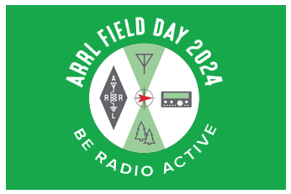
Field Day is also fast approaching (June 22/23). Is your club making plans to have Field Day this year? If they are, don’t let them forget to get signed up on the Field Day locator http://www.arrl.org/field-day-locator Hey, if you can, meet with your local government officials and ask them for a Proclamation for Amateur Radio that weekend. Most local governments will be happy to do this and don’t forget to invite the news media to be there as well. This is great PR for everyone, and you get extra points for your efforts too! Amateur radio groups are encouraged to share a copy of their proclamations with ARRL via pr@arrl.org

ARRL will often share these proclamations to advance legislative efforts, creating additional support of awareness for amateur radio among lawmakers.

Dayton Hamvention…
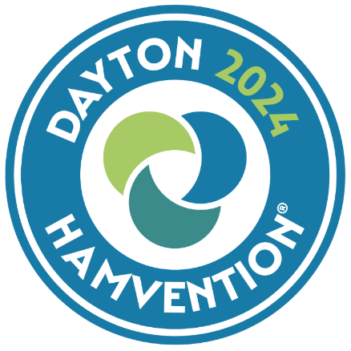
The Great Lakes Division will once again have a booth at Hamvention inside the ARRL area. I haven’t seen the final details on the booths yet, but it does appear that we will be on the inside next to the store this year. We are asking everyone to bring a QSL Card with them to post on the Division’s Brag Board. Don’t have a QSL? How’s about a business card instead? This year we are making sure that you know well in advance so that we can have even more cards on display. Be sure to stop by... and don’t forget to bring your QSL card with you to post!

Hey club leaders, have your meetings been hybrid (ie... Zoom, Teams, Go-To-Meeting) as well as in-person? Doing a hybrid meeting does take a little extra effort on the clubs’ part, but for those who don’t travel well at night, or just can’t make the meeting because of distance, this is really a great thing for them. Yes, it’s a little more work for whomever sets the equipment up, but it means so much to those who just could not attend the meeting any other way. It also opens the door for acquiring new members too.

Yes, I have been told by a few club leaders that they have actually seen an uptick in membership from people outside of their area/state since starting their hybrid meetings. Having hybrid meetings also opens doors for a whole new world of programs and guest speakers for your club as well! You might consider one of the great recorded webinars that are listed in the ARRL Learning Center or even a live presentation from a guest that’s hundreds or thousands of miles away. Hybrid meetings doesn’t mean that you don’t show up in person when you can. It’s more for those who just can’t attend but would really like to.

There are many great recorded webinars out there from folks all over the world that are informative and fun. Most of these webinars are around 30 minutes or so, which is just the right amount of time. Remember the posterior rule... “The brain can only absorb with what the butt can withstand!”
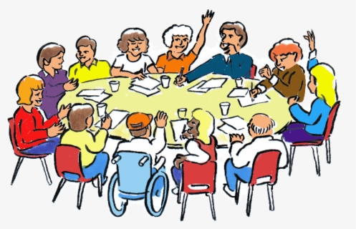

Survey… I found the responses to the Survey last month once again very interesting. The results are posted below. Now, is there a question that you’d like to see posted that hasn’t been so far? Let me know. Oh, and there’s another questionnaire posted, GLD-3.

Pictures… I’ll bet that your club members have thousands of pictures that could be assembled in the same way as the folks at the Massillon ARC did. What a great promotional tool this can be for your club. Is there a magic bullet that a club can use to gain members? The answer is “NO.” It takes hard work and the willingness of the entire club to make things happen.

That’s going to do it from me this time around. Hope to catch ya’ on the air, at a club meeting or a hamfest soon!!

73,

Scott Yonally, N8SY
Director
Great Lakes Division
n8sy@arrl.org



Amateur Radio, it’s not
just for breakfast anymore.

From Roy, W8REH
Great Lakes Division
Vice Director

I was recently having lunch with my good friend Lew Ramey which we often do as a group with others from the early CORC/weather net days including Stan Broadway, N8BHL and Malt Brown, WB8WKZ. That day it was just Lew and I. From the many conversations this group typically has had, it later occurred to me how our long past acceptance and adaptation to change defined what has become the future we now enjoy today.

In the mid 1970’s, this group and others from the whole local Amateur Radio community, developed what was to become the Central Ohio Severe Weather Net. A member of the Central Ohio Radio Club (CORC) board, Stew Banks, W8FEH (SK), Lew the head of the Columbus National Weather Service (NWS) Office along with the extensive CORC repeater network developed under the direction of John Hull, W8RRJ, were essential in making this early concept a huge success.

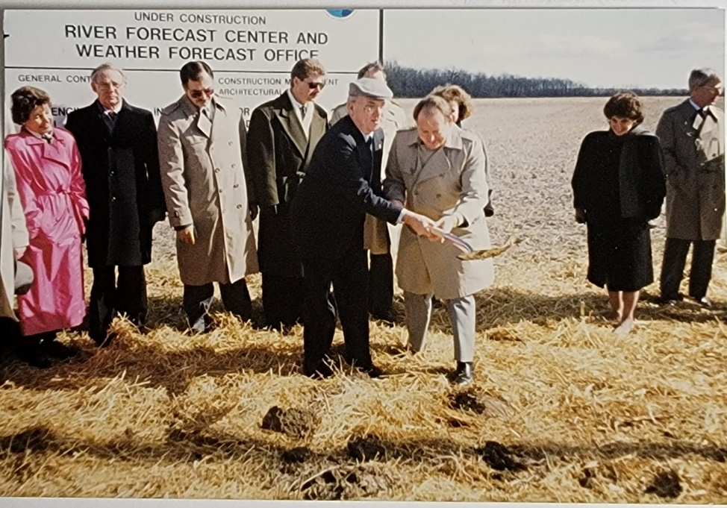
Then . . . NEXRAD Doppler radar technology, coupled with funding politics and other factors outside our control changed everything. The Columbus, Dayton, and Cincinnati NWS offices with their obsolete weather radars would be replaced by one modern, longer range NEXRAD system supported by a single NWS office located in Wilmington, Ohio. As NWS went through this massive national reorganization driven by this new technology, Amateur Radio communities all around the country were faced with unexpected changes. Lew chose to stay as MIC (Meteorologist in Charge) in Columbus and help facilitate the transition rather than relocate, retiring when complete.
Wilmington NWS
Ground Breaking Event
Jerry Lindsey Dayton NWS and Lew Remy Columbus NWS

Apparently existing weather spotter network considerations were not on the list of the decision makers, so the Amateur Radio community was left to find solutions to support the new consolidated offices with their hugely expanded areas of responsibility. The Wilmington site selected for this new centralized NWS office was in rural Clinton County, Ohio with an extremely small ham population in comparison to the metropolitan areas being served by the previous offices. In this case the new challenging need was to take and forward severe weather spotter reports from over fifty counties located in three states and two different time zones.

Knowing that none of the existing organizations serving this area could possibly meet the challenge alone, members of Clinton County ARA stepped up and organized a task force/steering committee group. This group was made up of representatives from each of the existing spotter groups along with the Wilmington group now tasked to support the new NWS NEXRAD office placed in their county. They quickly realized that a traditional spotter net large enough to cover this expanded area would not only be unmanageable, but inefficient. The group ultimately concluded that the existing nets should continue to operate as independent sections and feed spotter reports into the central Wilmington location for coordination there. This allowed each to retain its identity and to tailor its design to the needs of their individual community. Those located within offices being closed would also need to find new fixed base homes. Then the realization hit, there was a whole geographic area of responsibility encompassing south/central Ohio and north/central Kentucky that could not be covered effectively by any of the existing nets. DeForest ARA of Adams County Ohio came to the rescue establishing an all new fourth net to provide coverage for that area.

The group realized that a new repeater system concept would be required to coordinate such a large area and maintain efficiency and the flexibility required by the varied needs of all the individual local groups. John Perone, W8RXX, with his technical knowledge of the extensive central Ohio repeater system worked closely with the group to develop the required, never tried new system design.
Each of the remote reporting sections was tasked with developing additional technical solutions to facilitate linking of their section to the new central Wilmington location while also addressing all their local needs.

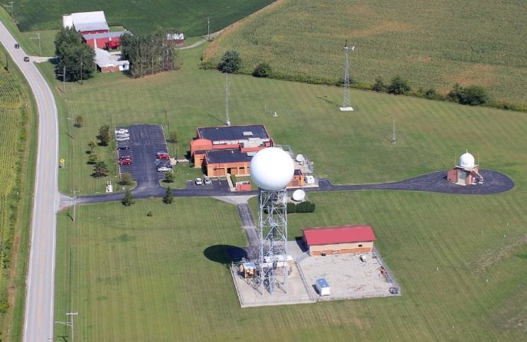
As some of these early participants relocated around the country and with the support of NWS management, the word spread of this weather spotting concept. Sky Warn as it is known throughout the country today, became the result of these early concept creators’ migration, mimicking this success in many Amateur Radio communities around the country.
NWS Wilmington Today

It has now been thirty years since we faced the major challenges just described. Change continues to test the Amateur Radio community. Faced with an aging ham population, how do we find the people with the passions to propel our hobby into the future like those exhibited in this success story? I was sitting at breakfast with Paul Gehringer WB8ZZR who provided most of the content for this article, when he pulled out his phone to show me real time telemetry being sent from that morning’s weather balloon launch. Yes, they still use balloons, but the technology that he was showing me is an amazing, whole new dimension to the weather spotting I was involved in 40 years ago.

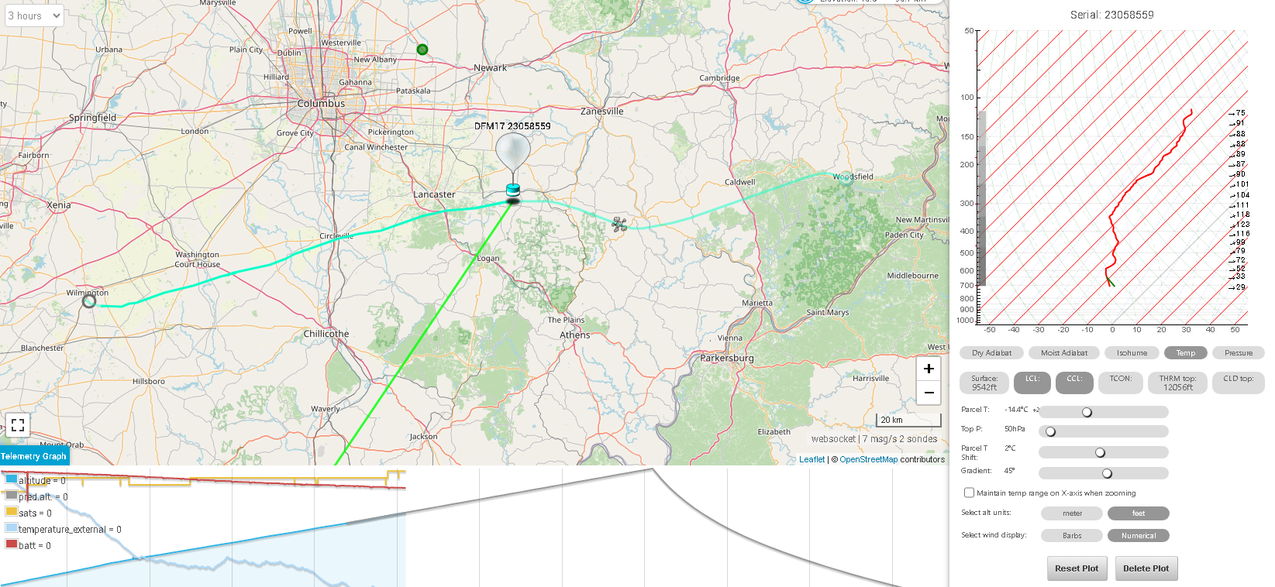

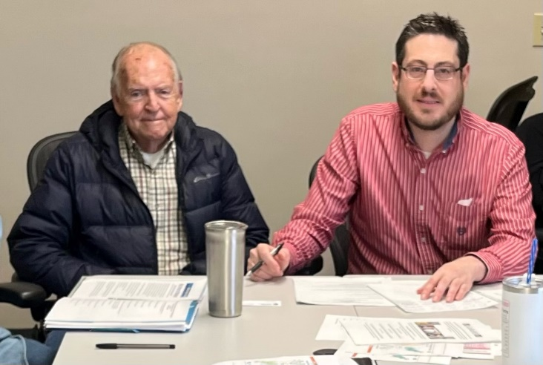
Paul invited Lew and me to their annual spring steering committee meeting at the Wilmington NWS office. Kind of like a 30th class reunion for us.
Retired Lew Ramey (L) – Brandon Peloquin (R) NWS Warning Coordination Meteorologist

With the goal of igniting new passions, are all of us doing all we can to provide awareness and acceptance of new unfamiliar technologies as part of how we describe Amateur Radio to others? I recently met a newly licensed high school girl at HamCation and I asked what her future ambitions were. She said she wanted to go on to school in meteorology.

To me that sounds likely to become another success story of how Amateur Radio provides direction and passion for future endeavors and careers, just as it has for many of us.
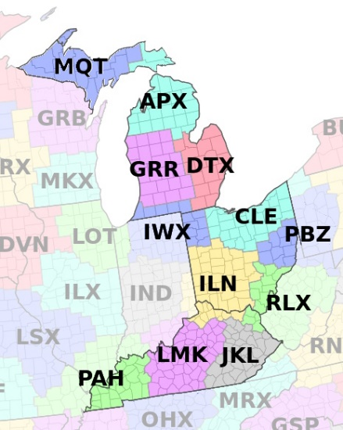
Amateur Radio, It’s not JUST for breakfast, contesting, DX or (Insert your own passion here) anymore!

If you are not already involved with a NWS/Amateur Radio Severe Weather Spotting group, you can help. There are many opportunities around the Great Lakes Division. Just talk with your local club or find the NWS Forecast office supporting your area.

Grand Rapids Michigan ((GRR); Gaylord Michigan (APX); Marquette Michigan (MQT); Detroit/Pontiac Michigan (DTX); Northern Indiana (IWX); Wilmington Ohio (ILN); Cleveland Ohio (CLE); Louisville Kentucky (LMK); Jackson Kentucky (JKL); Paducah Kentucky (PAH); Charleston West Virginia (RLX); Pittsburgh Pennsylvania (PBZ)

Thanks in advance for sharing your perspective.

73,

Roy Hook, W8REH
Vice Director
Great Lakes Division
w8reh@arrl.org

Results from GLD-2 Survey:

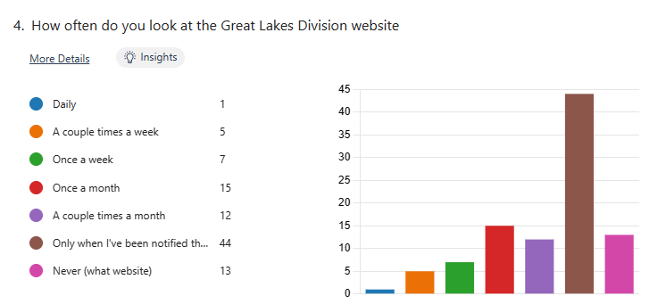
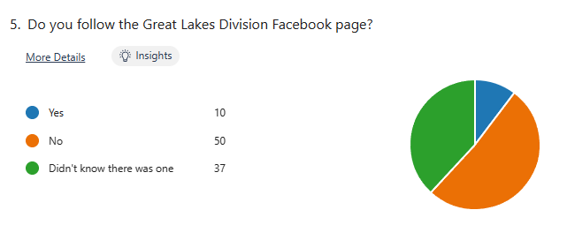
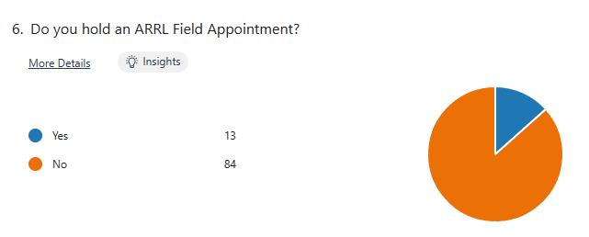
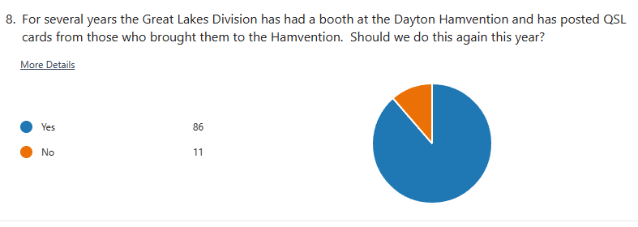

There’s another new survey on the website GLD-3. I really would like to hear your feedback to the questions asked. Please take just a couple of minutes of your time and take the survey.

Got a question that you think should be asked? Let me know… n8sy@n8sy.com


Here’s a link to it…

2024 Division Hamfests
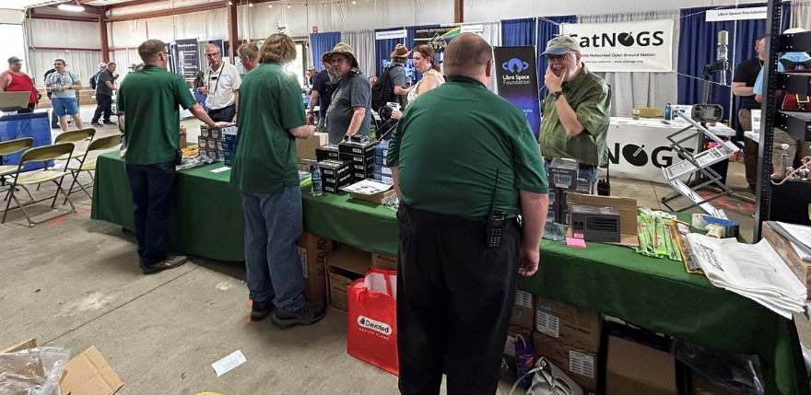
Here in the Great Lakes Division, we have over 50 hamfests a year, including the largest one in the country, Hamvention. This year Hamvention will also be the ARRL’s National Convention as well, which means that there will be some very special things happening there.

So, if you haven’t started planning your hamfest schedule yet, you really need to start now.

Please post this listing in your club's newsletter and announce the swaps on your local nets. Talk them up. Let's fully support all of our hamfests in every way possible. It means success for everyone. Be sure to invite your ARRL Officials as soon as your date is set.

If your ARRL Affiliated club plans to request Hamfest Sanctioning, you should make that request well in advance of the scheduled Hamfest date, as this allows adequate time for QST Listings. QST announcements require a 3-month lead time. To be fair to our Division's clubs, the Great Lakes Division policy is to offer a club ARRL Sanctioning for a limit of two hamfests/swaps in any given calendar year, and they must be four months apart. If your swap is cancelled or the date is going to change, please notify ARRL HQ.

04/13/2024 - Cuyahoga Falls Amateur Radio Club 68th Hamfest  Location: Cuyahoga Falls, OH  Type: ARRL Hamfest  Sponsor: Cuyahoga Falls Amateur Radio Club, Inc.  Website: http://www.w8vpv.org/hamfest  Learn More | 04/13/2024 - Mid-Ohio Valley Amateur Radio Club  Location: Bidwell, OH  Type: ARRL Hamfest  Sponsor: Mid-Ohio Valley Amateur Radio Club  Learn More
04/20/2024 - Centreville Michigan Hamfest  Location: Centreville, MI  Type: ARRL Hamfest  Sponsor: St. Joseph County MI Amateur Radio Club  Learn More | 04/27/2024 - Tusco Amateur Radio Club Hamfest, Electronics, and Computer Show  Location: Dover, OH  Type: ARRL Hamfest  Sponsor: Tusco Amateur Radio Club W8ZX  Website: http://www.w8zx.net/hamfest  Learn More
04/28/2024 - Athens Hamfest  Location: Athens, OH  Type: ARRL Hamfest  Sponsor: Athens County Amateur Radio Association  Website: https://www.ac-ara.org/  Learn More | 05/04/2024 - AC8RC Mini-Swap and Trunk Sale  Location: Dorr, MI  Type: ARRL Hamfest  Sponsor: Allegan County Radio Club  Website: http://ac8rc.org  Learn More
05/04/2024 - Wexaukee ARC Swap and Shop  Location: Cadillac, MI  Type: ARRL Hamfest  Sponsor: Wexaukee ARC  Website: http://wexaukeearc.org  Learn More | 05/05/2024 - Lucas County ARES Trunk Sale & Swap Meet  Location: Toledo, OH  Type: ARRL Hamfest  Sponsor: Lucas County ARES  Website: http://lucasares.org  Learn More
05/11/2024 - 05/16/2024  RV Radio Network  Location: Millersburg, OH  Type: ARRL Convention  Sponsor: RV Radio Network  Learn More | 05/16/2024 - 05/19/2024  Four Days In May  Location: Fairborn, OH  Type: ARRL Convention  Sponsor: QRP Amateur Radio Club International  Website: http://qrparci.org/fdim  Learn More
05/17/2024 - 05/19/2024  Dayton Hamvention, ARRL National Convention  Location: Xenia, OH  Type: ARRL Convention  Sponsor: Dayton Amateur Radio Association  Website: https://hamvention.org  Learn More | 06/01/2024 - FCARC Summer Hamfest  Location: Wauseon, OH  Type: ARRL Hamfest  Sponsor: Fulton County Amateur Radio Club  Website: https://k8bxq.org/hamfest  Learn More
06/01/2024 - IRA Hudsonville Hamfest  Location: Hudsonville, MI  Type: ARRL Hamfest  Sponsor: Independent Repeater Association  Website: http://www.w8ira.org  Learn More | 06/02/2024 - Annual Chelsea Amateur Radio Club Swap Meet  Location: Chelsea, MI  Type: ARRL Hamfest  Sponsor: Chelsea Amateur Radio Club  Website: http://wd8iel.com  Learn More
06/08/2024 - LARS 2024 Yooper Hamfest  Location: Newberry, MI  Type: ARRL Hamfest  Sponsor: Luce Amateur Radio Services, Inc.  Website: www.w8nby.org  Learn More | 06/15/2024 - MARC Hamfest  Location: Midland, MI  Type: ARRL Hamfest  Sponsor: Midland Amateur Radio Club  Website: http://w8kea.org  Learn More
06/16/2024 - Monroe Hamfest  Location: Monroe, MI  Type: ARRL Hamfest  Sponsor: Monroe County Radio Comm Association  Website: http://mcrca.org/  Learn More | 07/06/2024 - Mansfield Mid Summer Trunkfest  Location: Mansfield, OH  Type: ARRL Hamfest  Sponsor: Intercity Amateur Radio Club  Website: http://W8WE.ORG  Learn More
07/20/2024 - Ashtabula County Hamfest  Location: Pierpont, OH  Type: ARRL Hamfest  Sponsor: Amigos Radio Club Ashtabula  Website: https://sites.google.com/view/arca-home/  Learn More | 07/21/2024 - Van Wert Hamfest  Location: Van Wert, OH  Type: ARRL Hamfest  Sponsor: Van Wert Amateur Radio Club  Website: http://w8fy.org  Learn More
08/03/2024 - 2024 Columbus Hamfest  Location: Grove City, OH  Type: ARRL Hamfest  Sponsor: Aladdin Shrine Audio Unit  Website: http://www.columbushamfest.com  Learn More | 08/03/2024 - U.P Hamfest  Location: Rapid River, MI  Type: ARRL Hamfest  Sponsor: Delta County Amateur Radio Society  Learn More
08/10/2024 - Cincinnati Hamfest  Location: Owensville, OH  Type: ARRL Hamfest  Sponsor: Milford ARC  Website: https://CincinnatiHamfest.org  Learn More | 08/18/2024 - Warren Hamfest  Location: Cortland, OH  Type: ARRL Hamfest  Sponsor: Warren Amateur Radio Association  Website: https://www.w8vtd.com/  Learn More
09/07/2024 - Greater Louisville Hamfest  Location: Shepherdsville, KY  Type: ARRL Hamfest  Sponsor: Greater Louisville Hamfest Association  Website: http://LouisvilleHamfest.com  Learn More | 09/08/2024 - Findlay Hamfest  Location: Findlay, OH  Type: ARRL Hamfest  Sponsor: Findlay Radio Club  Website: http://w8ft.org  Learn More
09/14/2024 - Richmond, Kentucky, Hamfest  Location: Richmond, KY  Type: ARRL Hamfest  Sponsor: Central KY ARS (CKARS)  Website: http://ckars.org  Learn More | 09/15/2024 - Adrian Hamfest  Location: Adrian, MI  Type: ARRL Hamfest  Sponsor: AARC  Website: http://w8tqe.com  Learn More
09/22/2024 - Cleveland Hamfest  Location: Berea, OH  Type: ARRL Hamfest  Sponsor: Hamfest Association of Cleveland  Website: https://www.hac.org  Learn More | 09/28/2024 - Top of Michigan Amateur Radio Club & Thunder Bay Amateur Radio Club Hamfest  Location: Gaylord, MI  Type: ARRL Hamfest  Sponsor: Top of Michigan ARC Gaylord and Thunder Bay ARC Alpena  Website: http://www.nm8rc.org  Learn More
10/05/2024 - Kalamazoo Hamfest  Location: Kalamazoo, MI  Type: ARRL Hamfest  Sponsor: Kalamazoo Amateur Radio Club (KARC), Southwest Michigan Amateur Radio Team (SMART)  Website: http://www.kalamazoohamfest.org/  Learn More | 10/05/2024 - Northwest Ohio Amateur Radio Club (NWOARC) Hamfest  Location: Lima, OH  Type: ARRL Hamfest  Sponsor: Northwest Ohio Amateur Radio Club, Inc.  Website: http://www.nwoarc.com  Learn More
10/06/2024 - U.S.E.C.A. (Utica Shelby Emergency Communication Association) Hamfest  Location: St. Clair Shores, MI  Type: ARRL Hamfest  Sponsor: U.S.E.C.A.  Website: http://USECAARC.ORG  Learn More | 10/12/2024 - Muskegon Color Tour Hamfest  Location: Muskegon, MI  Type: ARRL Hamfest  Sponsor: Muskegon County Emergency Communication Services, Inc.  Website: http://www.mcecs.net/hamfest  Learn More
10/26/2024 - Hazard Hamfest  Location: Hazard, KY  Type: ARRL Hamfest  Sponsor: Kentucky Mountains Amateur Radio Club  Learn More | 10/27/2024 - 2024 MARC Hamfest at MAPS  Location: N. Canton, OH  Type: ARRL Hamfest  Sponsor: Massillon Amateur Radio Club  Website: https://www.w8np.net  Learn More
12/01/2024 - LCARC Amateur Radio Swap/Hamfest  Location: Troy, MI  Type: ARRL Hamfest  Sponsor: L'Anse Creuse Amateur Radio Club  Website: http://www.n8lc.org  Learn More | 12/07/2024 - Winter Hamfest  Location: Archbold, OH  Type: ARRL Hamfest  Sponsor: FCARC  Website: https://k8bxq.org/hamfest  Learn More

You can always find the latest updates for upcoming hamfests on the Great Lakes Division website.
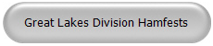
Just click to get to the latest hamfest updates.


Is your club website listed on the Great Lakes Division website?

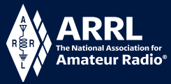
National News

Amateur Radio Importance Highlighted at National Hurricane Conference
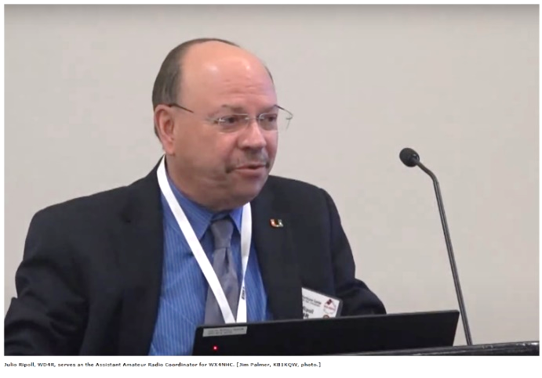
The National Hurricane Conference was held March 25 - 28, 2024, in Orlando, Florida. Amateur radio was well represented at the event. A series of workshops were held that focused on amateur radio's involvement in hurricane tracking, coverage, and recovery.
Among the presenters was the Assistant Amateur Radio Coordinator of WX4NHC at the National Hurricane Center (NHC) Julio Ripoll, WD4R. Ripoll gave a history of amateur radio's involvement in NHC, including the use of tube radios in the 1980s and the Yaesu FTDX-1200 used today.

WX4NHC is also equipped with VHF/UHF radios to access the Florida Statewide Amateur Radio Network (SARnet), as well as digital equipment to communicate with the VoIP Hurricane Net, IRLP, and Winlink to receive emails via amateur radio.

"We were the only means of communication between the National Hurricane Center and the National Weather Service Field Office in Slidell, Louisiana, during Hurricane Katrina," Ripoll said. He went on to highlight other instances of reports given by ham radio that provided mission-critical information that had a major impact on the way NHC handled a storm.
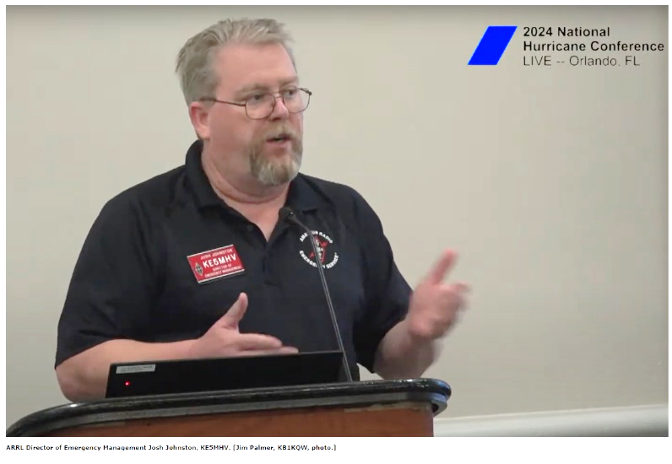
ARRL Director of Emergency Management Josh Johnston, KE5MHV, gave a presentation to the crowd of hurricane experts, meteorologists, and emergency managers about the Amateur Radio Emergency Service® (ARES®).

He spoke of ARRL's role on the board of SAFECOM, a program managed by the Cybersecurity and Infrastructure Security Agency (CISA) that sets the standards of interoperability procedures. Being a part of the group solidifies the Amateur Radio Service as a robust resource before and during times of crisis.

Johnston shared that in 2023, ARES volunteers contributed at least $21.8 million in volunteer hours to their local communities. "Is amateur radio still relevant? Absolutely! Are we still involved in the places that are doing things the right way? Amateur radio absolutely is," he said.

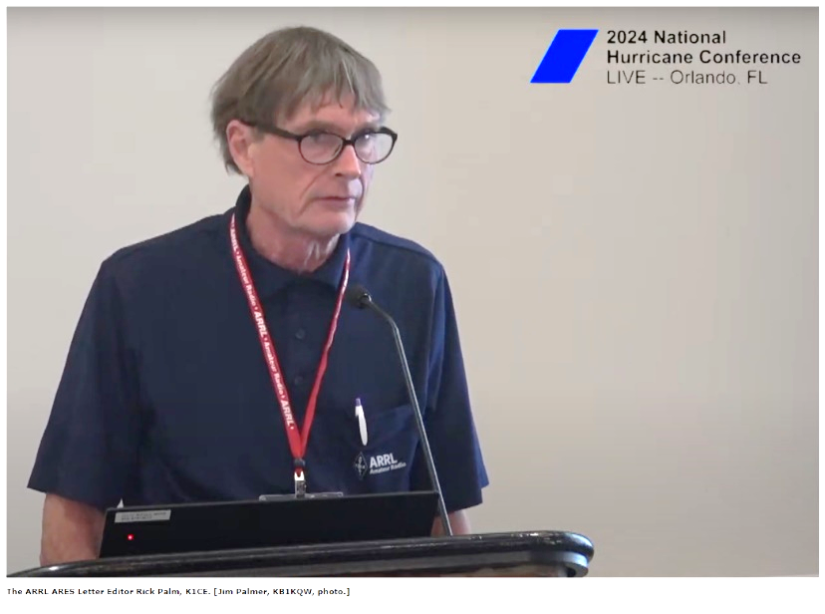
Johnston highlighted the relationship between ARRL and the Federal Emergency Management Agency (FEMA), as well as ARRL's position as a net control station within the SHAred RESources High Frequency Radio Program (SHARES) managed by CISA.

Among other presenters was ARRL’s The ARES Letter Editor
Rick Palm, K1CE.

He shared a harrowing tale of his family riding out a direct hit from Hurricane Idalia in August 2023. The damage and impact he felt gave him a new perspective on emergency communications, as he went from a volunteer communicator to a storm victim.
Read more about his experience in the "Public Service" column in the January 2024 issue of QST.

Watch a video of the amateur radio workshops at the 2024 National Hurricane Conference on YouTube, courtesy of Jim Palmer, KB1KQW.

Club Commission Program

Line Up and Sign-Up Club Activity to Generate Club Funds. The Club Commission Program is a way for ARRL Affiliated clubs to generate funds for the club by allowing their members to join or renew their ARRL membership through the club. The club then receives a commission for membership. New members earn the club a $20 commission with renewals earning $5 each.

Hosting a membership night at a club meeting is a great way to utilize this program. Below are five easy steps for how to do so. You may adapt these to fit your club's needs, but the basic process remains the same.

Step 1. Prior to your membership night, let club members know that at the upcoming meeting they can expect the opportunity to join ARRL or renew their existing membership applications.

Step 2. Designate someone to be stationed at the membership table to accept applications and renewals.

Step 3. Print out the ARRL Membership Application form from the ARRL website so that each member who wishes to join or renew will have an opportunity to fill out an application and select the membership options that apply.

Step 4. After gathering all of the applications and payments, fill out one Club Reconciliation Form and send the entire package to ARRL. Full payment for the application is submitted. The Club Reconciliation Form is available at the ARRL site as well.

Step 5. Once the applications are received by ARRL, they will be processed, and the commission will be issued to your club. After full payment is made to ARRL, commission is paid to the club.

Commission is only paid on Standard memberships, not Blind, Family, or Student memberships. Complete program details, as well as the required forms, are available under the Club Commission Program tab at Affiliated Club Benefits.

ARRL Youth Licensing Grant Program

Here’s one of those little talked about programs to help our youth. I’ll be that many of you didn’t even know about the ARRL Youth Licensing Grant Program. It started in 2022 and covers the one-time FCC $35 application fee for new license candidates younger than 18-years old for tests administered under the ARRL Volunteer Examiner Coordinator (ARRL VEC) program. Yes, the ARRL will cover the $35 FCC fee for youth who are getting into Amateur Radio
Additionally, candidates younger than 18-years old would pay a reduced exam session fee of $5 to the ARRL VEC VE team at the time of the exam. The $5 fee is for all candidates under the age of 18 regardless of the exam level taken. Proof of under 18 status is required at the session (what to bring to an exam session).
Both of these programs are sponsored by YOUR ARRL.

Candidates younger than 18-years old will pay a reduced exam session fee of $5 to the ARRL VEC VE team when taking an exam. Proper identification must be presented to and verified by the team, per the procedures for all exam candidates (what to bring to an exam session). The $5 fee is for all candidates under the age of 18 regardless of the exam level taken. Want more information about these programs? Licensing Grant Program

Wanted… Your Photo’s

Have you seen the Photo Gallery on the Great Lakes Division website? If you haven’t you really need to, your face may be among the many already posted there.




I’m always looking for more pictures to use in the Gallery, newsletter, banner and video display. Please, send me your pictures!!! Send them to: n8sy@n8sy.com

Here & There
