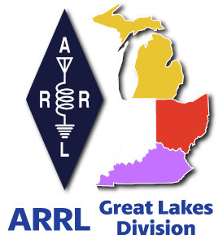
^{The}GLD
Newsletter

May 2024

What’s inside…

What is COIAK? | Results from Survey
2024 Division Hamfests  Amateur Radio License Map | Club Commission Program  Youth Licensing Grant Program

Scott’s Stuff
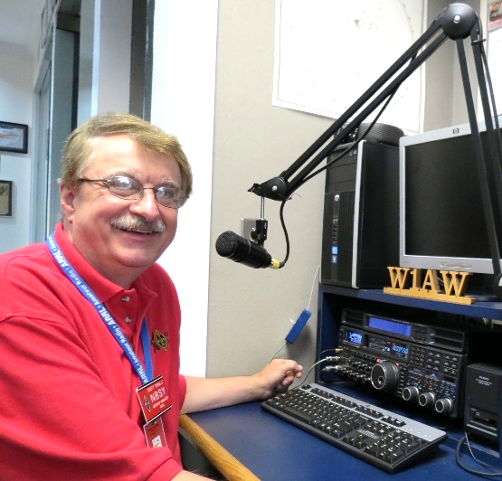
Hi Gang,

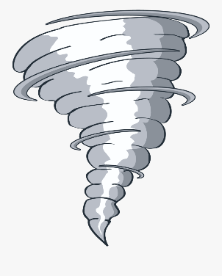
Well, it’s May 1st, Mayday. Ok, I dread telling all of you this, but it looks like Ohio is fast becoming the center of “Tornado Alley.” So far this year Ohio has had 40 recorded tornadoes. That’s more than anywhere else in the country, and it’s just the beginning of May! We have all of May and June to go yet.

April showers bring May flowers, and the Mayflower brought the pilgrims to the Dayton Hamvention! It’s now just 16 days away. Are you ready for the FUN to begin?

Ok, let’s get down to business.

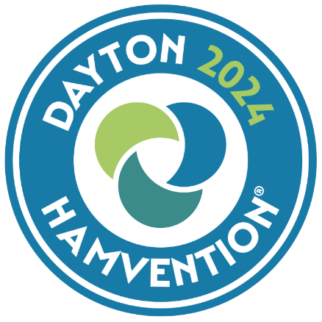
Hamvention… This year the Hamvention is also the “National Convention” for the ARRL. There’s a ton of forums scheduled for just about any interest within ham radio you could have. There’s also an ARRL Forum scheduled and I’m going to be the moderator. You’ll definitely want to sit in on that one for sure. It’s scheduled for 11am on Saturday in Room 3.

Have you downloaded the ARRL Events App yet? If you haven’t, you really should. It’s your guide for Hamvention. You can download it from the Google or Apple Apps store. Just search on ARRL Events App.

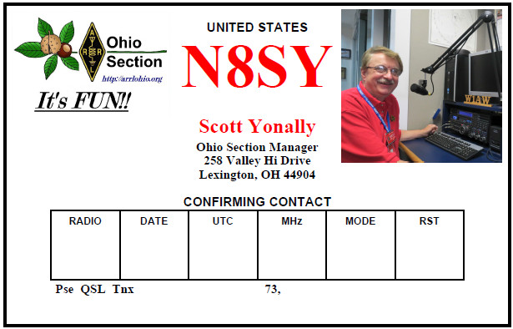
Keeping with the Convention theme just a bit more... The Great Lakes Division will once again have a booth at Hamvention inside the ARRL area, just like last year. We are asking everyone to bring a QSL Card with them to post on the Division’s Brag Board. We were overwhelmed last year with the amount of great QSL Cards that we got. This year we are making sure that you know well in advance so that we can have even more cards on display. And, we WILL have a much larger Brag Board to display all the great cards we get! Be sure to stop by the booth and say “Hey”… Want to talk? This is a great time to have that one-on-one conversation with us. Oh, and don’t forget to bring your QSL card with you to post as well!
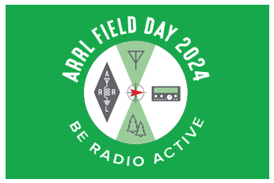
Field Day is fast approaching as well (June 22/23). Is your club making plans to have Field Day this year? If they are, don’t let them forget to get signed up on the Field Day locator http://www.arrl.org/field-day-locator Hey, if you can, meet with your local government officials and ask them for a Proclamation for Amateur Radio that weekend. Most local governments will be happy to do this and don’t forget to invite the news media to be there as well. This is great PR for everyone, and you get extra points for your efforts too! Amateur radio groups are encouraged to share a copy of their proclamations with ARRL via pr@arrl.org

ARRL will often share these proclamations to advance legislative efforts, creating additional support of awareness for amateur radio among lawmakers.
Oh, and one more thing... This isn’t mentioned much but is so very important to make sure you do. Have someone assigned to take pictures!! Lots of them. Just about everyone nowadays has a phone with a camera built into it, so there’s really no excuse anymore for not taking pictures, and.... send them to me at: n8sy@n8sy.com

I will be out and about again this year visiting as many of the Field Day sites as I can get to on Saturday and Sunday. There are a lot of great sites to visit, and I’ll do my best to try to get to yours!


Survey… I found the responses to the Survey last month once again very fascinating to say the least. The results are posted below.

Is there a question that you’d like to see posted that hasn’t been so far? Let me know. Oh, and there’s another questionnaire posted, GLD-4.

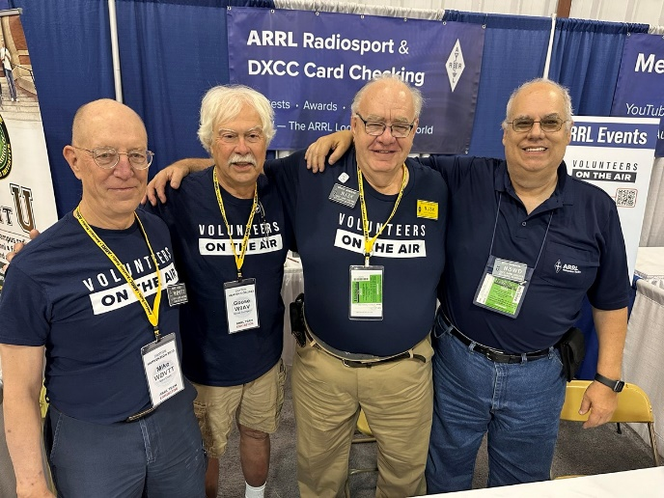
Pictures… I’ll bet that your club members have thousands of pictures that could be assembled in a video or even just in a photo book that could be passed around from time to time at a meeting or special gathering. It’s really a very special tool that the club can use to gain members and show off some of the really great things your club has done over the years. It takes some work organizing them, but the payoff is well worth the effort for sure, especially if the entire club gets involved. So, why not have FUN and enjoy those magical moments together!

That’s going to do it from me this time around. Hope to catch ya’ on the air, at a club meeting or a hamfest soon!!

73,

Scott Yonally, N8SY
Director
Great Lakes Division
n8sy@arrl.org


What is COIAK?
Roy, W8REH

An acronym I heard years ago seems often to be appropriate today. COIK. It stands for “clear only if known” or also COIAK, “clear only if already known”. I find references both ways, the latter being how I was originally exposed to it.

In recent conversations it was pointed out that for a hobby viewed to be all about communication, we sure don’t do a very good job at it. In fact, ineffective was the term used. Today’s modern digital communications uses a two-way street, with “hand shaking”, “encryption” and “error correction” to address accuracy and effectiveness. Written and oral communication could benefit greatly from this concept.

If we can agree, in order to sustain our hobby, we need to attract and retain new untapped talent, we all must do a better job of communicating and encouraging people with interests and skills which may be somewhat different than our own. Attempting to communicate only with terms above the comprehension of the common beginner may be more expedient at times and make some feel more accomplished in their specialty. I am not suggesting that we need to dumb down the hobby as some have accused, but instead avoid drowning out sparks of interest that we may come across. Consider that your audience may actually be a mixture of beginners to the very experienced.

Einstein’s summarization might apply more often than we think, “If you can't explain what you are doing to a nine-year-old, then either you still don't understand it very well, or it's not all that worthwhile in the first place.”

The barrage of acronyms used in our hobby and most technical endeavors we encounter are an area where I think we can do better. I am not suggesting that we can eliminate the use of acronyms. As we communicate in writing, be aware that hopefully your communication may touch many unintended recipients. Some much needed mentorships may result. I suggest that you ALWAYS define acronyms, abbreviations, and ham lingo the first time they appear in any of your writing. Having the description appear once won’t hurt, and even the more experienced may find it helpful. Recently I found a “User’s Guide” instruction manual for a new piece of equipment I purchased. It might have been more appropriate if it were labeled “Programmer’s Reference”. It greeted me with a mass of acronyms like gpsd, hamlib, fldigi, flarq, arq, flamp, flwrap, flmsg, flrig, flwkey, kcat, linsim, comptext, comptty, goio, with no glossary of terms or descriptions included, which was most discouraging to me. Using Mr. Google (an internet search for those likely living under a rock and completely shielded from the computer world) only further revealed the obscurity of the encountered terms.

Much of the time two-way communication is not possible or at least difficult as with magazines, broadcast media and yes to a large extent this newsletter. We do, however, beg for your feedback.

Writers often put a large effort into producing an interesting piece that is brief, to the point and well-organized, hoping to facilitate communication. Today I find more and more people unwilling to spend the time to even read much more than the first line or even the first words of a few paragraphs, feeling they captured all they need. There is clear evidence that this is becoming standard practice for some, regardless of the medium. I hope you will share your thoughts on how respect for our author’s hard work can be improved.

I look forward to meeting as many of you as possible at the Dayton Hamvention May 17-19. Please stop by the ARRL Great Lakes Division booth, bring your QSL card to post and talk to me with your ideas and solutions. Let’s turn this into two-way communication. This is your 2024 ARRL National Convention and your Division is the host. See you soon.

73,

Roy Hook, W8REH
Vice Director
Great Lakes Division
w8reh@arrl.org

Results from GLD-3 Survey:

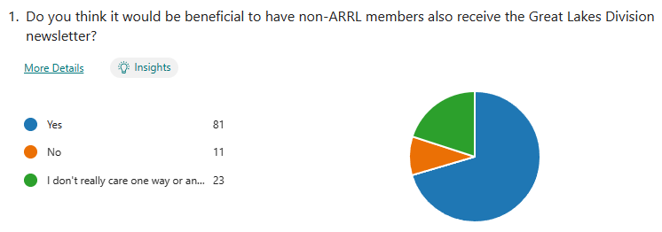

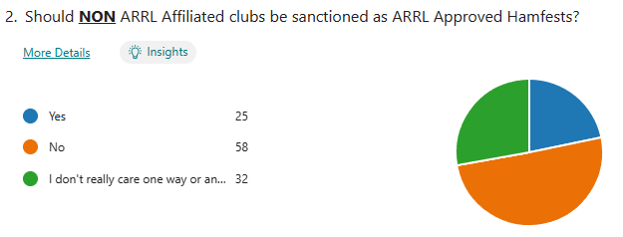

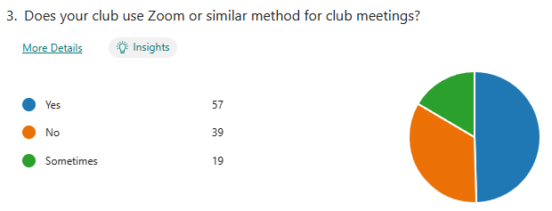

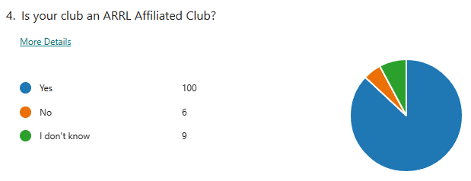

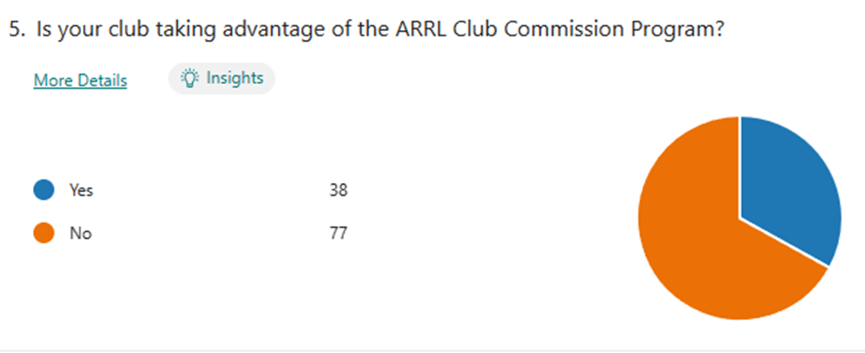

Looking at the results it seems like an overwhelming number of you feel that non ARRL members should also receive the Great Lakes Division Newsletter. That’s great to see that you feel this way since the newsletter is posted on the website for anyone to view.

Question number 2 has a majority of folks saying that a policy needs to be made that only ARRL Affiliated Clubs should be allowed to request ARRL sanctioning of their hamfests. I agree and have added this new requirement to the one that already exists.

Question 3 seems like a majority of clubs are doing hybrid now. I know that there’s mixed emotions about this one. Many folks want to meet in person and have the actual face to face contact. But there are some who just can’t get out and this does give them a way of attending and participating. It also opens up a big world of presenters as well. If they aren’t needing to travel, most can do their presentations without leaving the shack!

Question 4 is really satisfying to know that we have soooo many ARRL Affiliated Clubs.

Question 5 is one that I knew would be low, but I do have hope that your club can be enticed by the commission of $20 per new member and $5 for each renewal. This is FREE money and it’s yours for just filling out a form.

There’s another new survey on the website GLD-4. I really would like to hear your feedback to the questions asked. Please take just a couple of minutes of your time and take the survey.


Here’s a link to it…

Got a question that you think should be asked? Let me know… n8sy@n8sy.com

ARRL Club Commission Program

Line Up and Sign-Up Club Activity to Generate Club Funds. The Club Commission Program is a way for ARRL Affiliated clubs to generate funds for the club by allowing their members to join or renew their ARRL membership through the club. The club then receives a commission for membership. New members earn the club a $20 commission with renewals earning $5 each.

Hosting a membership night at a club meeting is a great way to utilize this program. Below are five easy steps for how to do so. You may adapt these to fit your club’s needs, but the basic process remains the same.

Step 1. Prior to your membership night, let club members know that at the upcoming meeting they can expect the opportunity to join ARRL or renew their existing membership applications.

Step 2. Designate someone to be stationed at the membership table to accept applications and renewals.

Step 3. Print out the ARRL Membership Application form from the ARRL website so that each member who wishes to join or renew will have an opportunity to fill out an application and select the membership options that apply.

Step 4. After gathering all of the applications and payments, fill out one Club Reconciliation Form and send the entire package to ARRL. Full payment for the application is submitted. The Club Reconciliation Form is available at the ARRL site as well.

Step 5. Once the applications are received by ARRL, they will be processed, and the commission will be issued to your club. After full payment is made to ARRL, commission is paid to the club.

Commission is only paid on Standard memberships, not Blind, Family, or Student memberships. Complete program details, as well as the required forms, are available under the Club Commission Program tab at Affiliated Club Benefits.

Amateur Radio License Map

This little project was created by Ross, KT1F. He’s been working on this on and off for about a year as time and motivation allows.

Amateur Radio License Map | Ham Info (tetranz.com)

This is more of an excuse to have some fun with Maps and Geocoding than anything else, but it hopefully provides something interesting to play with. “Geocoding” means to convert physical addresses into longitude and latitude coordinates. Behind the scenes, this site has been slowly geocoding all active amateur radio addresses in the FCC license data. The FCC data includes all licenses which have a status of “active”.

I’ve found it an interesting project with lots of little challenges. Some of this is because of the wide variation of population and therefore “ham density” throughout the country. I’ve had to balance that with performance issues both at the database query level and practical limitations of Google Maps. The data is also kind of messy with multiple licensees at one address and multiple addresses at the same location. This last issue is mostly due to spelling variations. In general, one marker appears on the map for each unique latitude / longitude point.

The performance / data quantity compromise I’ve come up with is that it searches within a 20-mile radius of the map center and has a limit of 200 location markers. The results are sorted by distance which means that the circle is complete until it hits the 200 markers. I haven’t found a grid square that has more than 200 so if you center on a grid square, I think we always get all in that square.

The initial geocoding was done in bulk using Nominatim / OpenStreetMap. This succeeded in finding about half of all addresses. Then over a long period of time the rest were processed using Geocodio.

Geocoding continues using Geocodio at a rate of 125 per hour or a total of 2500 per day which keeps it within the free limit. Every hour it selects 125 addresses from the database to geocode. These are chosen with the following priorities.

- New addresses that have not been geocoded before.

- Those that previously succeeded on OpenStreetMap. Reprocessing these with Geocodio seems to be improving the results.

- Those that previously failed. Some now succeed because of better data.

A weekly import from the FCC usually happens early Wednesday morning eastern time. Only those stations with a status of “active” are retained. About 1000 addresses are added and deleted each week. Geocoding the new addresses is usually completed by late Wednesday.
Of course, some addresses are PO Boxes and other mailing services. Addresses starting with “PO Box” are simply excluded. Also, many licensees are not active in the hobby. Be that as it may, it can be fun to play with the Street View feature of the maps to look for antennas.

Although I've only considered data from the USA, it's written in a generalized way so it can handle data from other countries but I'm not aware of any other countries who make their data publicly available. Feedback is welcome. The easiest way is by email to tetranz (at) gmail.com

Use this map to find amateur radio license holders in the USA.
Amateur Radio License Map | Ham Info (tetranz.com)

- Select the type of input (callsign, grid square, zip code or street address) on the left.
- Enter an appropriate search value on the right.
- Hit the button.
- Scroll down to see the map.

The selection determines the center of the map.

When the map appears, you can adjust the zoom level and drag the map around. If you're looking at a sparsely populated area, you'll probably need to zoom out.

After two seconds of not moving, it will reload with stations for the new area. You can also click on the grid square labels to center the map on that square. Use the "Show grid labels" checkbox to temporarily remove the grid square lines and labels if they get in the way.

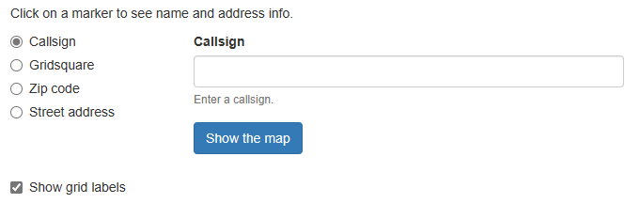
Give it a try, I know that you’ll find it very fascinating for sure. Thanks so much Rick for creating this little app that we can have fun with.

2024 Great Lakes Division Hamfests
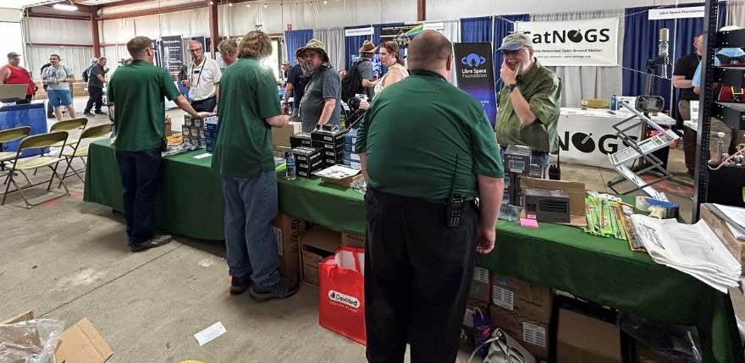
Here in the Great Lakes Division, we have over 50 hamfests a year, including the largest one in the country, Hamvention. This year Hamvention will also be the ARRL’s National Convention as well, which means that there will be some very special things happening there.

So, if you haven’t started planning your hamfest schedule yet, you really need to start now.

Please post this listing in your club's newsletter and announce the swaps on your local nets. Talk them up. Let's fully support all of our hamfests in every way possible. It means success for everyone. Be sure to invite your ARRL Officials as soon as your date is set.

If your ARRL Affiliated club plans to request Hamfest Sanctioning, you should make that request well in advance of the scheduled Hamfest date, as this allows adequate time for QST Listings. QST announcements require a 3-month lead time. To be fair to our division’s clubs, the Great Lakes Division policy now has 2 requirements for any ARRL Sanctioning.

Any club requesting ARRL sanctioning within the Great Lakes Division must now be an ARRL Affiliated Club with a maximum of two hamfests/swaps in any given calendar year, and they must be at least four months apart. If your swap is cancelled or the date is going to change, please notify ARRL HQ.

05/04/2024 - AC8RC Mini-Swap and Trunk Sale  Location: Dorr, MI  Type: ARRL Hamfest  Sponsor: Allegan County Radio Club  Website: http://ac8rc.org  Learn More | 05/04/2024 - Wexaukee ARC Swap and Shop  Location: Cadillac, MI  Type: ARRL Hamfest  Sponsor: Wexaukee ARC  Website: http://wexaukeearc.org  Learn More
05/05/2024 - Lucas County ARES Trunk Sale & Swap Meet  Location: Toledo, OH  Type: ARRL Hamfest  Sponsor: Lucas County ARES  Website: http://lucasares.org  Learn More | 05/11/2024 - GMARC Trunk Swap at the PPG  Location: Shelby Twp., MI  Type: ARRL Hamfest  Sponsor: General Motors Amateur Radio Club (GMARC)  Website: http://GMARC.org  Learn More

05/11/2024 - 05/16/2024  RV Radio Network  Location: Millersburg, OH  Type: ARRL Convention  Sponsor: RV Radio Network  Learn More | 05/16/2024 - 05/19/2024  Four Days In May  Location: Fairborn, OH  Type: ARRL Convention  Sponsor: QRP Amateur Radio Club International  Website: http://qrparci.org/fdim  Learn More
05/17/2024 - 05/19/2024  Dayton Hamvention, ARRL National Convention  Location: Xenia, OH  Type: ARRL Convention  Sponsor: Dayton Amateur Radio Association  Website: https://hamvention.org  Learn More | 06/01/2024 - FCARC Summer Hamfest  Location: Wauseon, OH  Type: ARRL Hamfest  Sponsor: Fulton County Amateur Radio Club  Website: https://k8bxq.org/hamfest  Learn More
06/01/2024 - IRA Hudsonville Hamfest  Location: Hudsonville, MI  Type: ARRL Hamfest  Sponsor: Independent Repeater Association  Website: http://www.w8ira.org  Learn More | 06/02/2024 - Annual Chelsea Amateur Radio Club Swap Meet  Location: Chelsea, MI  Type: ARRL Hamfest  Sponsor: Chelsea Amateur Radio Club  Website: http://wd8iel.com  Learn More
06/08/2024 - LARS 2024 Yooper Hamfest  Location: Newberry, MI  Type: ARRL Hamfest  Sponsor: Luce Amateur Radio Services, Inc.  Website: www.w8nby.org  Learn More | 06/15/2024 - MARC Hamfest  Location: Midland, MI  Type: ARRL Hamfest  Sponsor: Midland Amateur Radio Club  Website: http://w8kea.org  Learn More
06/16/2024 - Monroe Hamfest  Location: Monroe, MI  Type: ARRL Hamfest  Sponsor: Monroe County Radio Comm Association  Website: http://mcrca.org/  Learn More | 07/06/2024 - Mansfield Mid Summer Trunkfest  Location: Mansfield, OH  Type: ARRL Hamfest  Sponsor: Intercity Amateur Radio Club  Website: http://W8WE.ORG  Learn More
07/20/2024 - Ashtabula County Hamfest 2024  Location: Pierpont, OH  Type: ARRL Hamfest  Sponsor: Amigos Radio Club Ashtabula  Website: https://sites.google.com/view/arca-home/  Learn More | 07/20/2024 - NOARSFEST  Location: Elyria, OH  Type: ARRL Hamfest  Sponsor: Northern Ohio Amateur Radio Society  Website: http://www.noars.net  Learn More
07/21/2024 - Van Wert Hamfest  Location: Van Wert, OH  Type: ARRL Hamfest  Sponsor: Van Wert Amateur Radio Club  Website: http://w8fy.org  Learn More | 08/03/2024 - 2024 Columbus Hamfest  Location: Grove City, OH  Type: ARRL Hamfest  Sponsor: Aladdin Shrine Audio Unit  Website: http://www.columbushamfest.com  Learn More
08/03/224 - U.P Hamfest  Location: Rapid River, MI  Type: ARRL Hamfest  Sponsor: Delta County Amateur Radio Society  Learn More | 08/10/2024 - Cincinnati Hamfest  Location: Owensville, OH  Type: ARRL Hamfest  Sponsor: Milford ARC  Website: https://CincinnatiHamfest.org  Learn More
08/18/2024 - Warren Hamfest  Location: Cortland, OH  Type: ARRL Hamfest  Sponsor: Warren Amateur Radio Association  Website: https://www.w8vtd.com/  Learn More | 09/07/2024 - Branch County ARC Fall Trunk Swap  Location: Coldwater, MI  Type: ARRL Hamfest  Sponsor: Branch County Amateur Radio Club, Inc.  Website: http://branchcountyarc.org  Learn More
09/07/2024 - Greater Louisville Hamfest 2024  Location: Shepherdsville, KY  Type: ARRL Hamfest  Sponsor: Greater Louisville Hamfest Association  Website: http://LouisvilleHamfest.com  Learn More | 09/08/2024 - Findlay Hamfest  Location: Findlay, OH  Type: ARRL Hamfest  Sponsor: Findlay Radio Club  Website: http://w8ft.org  Learn More
09/14/2024 - GMARC Trunk Swap at the PPG  Location: Shelby Twp., MI  Type: ARRL Hamfest  Sponsor: General Motors Amateur Radio Club (GMARC)  Website: http://GMARC.org  Learn More | 09/14/2024 - Richmond, Kentucky, Hamfest  Location: Richmond, KY  Type: ARRL Hamfest  Sponsor: Central KY ARS (CKARS)  Website: http://ckars.org  Learn More
09/15/2024 - Adrian Hamfest  Location: Adrian, MI  Type: ARRL Hamfest  Sponsor: AARC  Website: http://w8tqe.com  Learn More | 09/22/2024 - Cleveland Hamfest  Location: Berea, OH  Type: ARRL Hamfest  Sponsor: Hamfest Association of Cleveland  Website: https://www.hac.org  Learn More
09/28/2024 - Paintsville KY4ARC Hamfest  Location: Paintsville, KY  Type: ARRL Hamfest  Sponsor: KY4ARC  Website: http://ky4arc.com  Learn More | 09/28/2024 - Top of Michigan Amateur Radio Club & Thunder Bay Amateur Radio Club Hamfest  Location: Gaylord, MI  Type: ARRL Hamfest  Sponsor: Top of Michigan ARC Gaylord and Thunder Bay ARC Alpena  Website: http://www.nm8rc.org  Learn More
10/05/2024 - Central Kentucky Hamfest  Location: Lexington, KY  Type: ARRL Hamfest  Sponsor: Bluegrass Amateur Radio Society  Website: http://www.bluegrassars.org  Learn More | 10/05/2024 - Kalamazoo Hamfest  Location: Kalamazoo, MI  Type: ARRL Hamfest  Sponsor: Kalamazoo Amateur Radio Club (KARC), Southwest Michigan Amateur Radio Team (SMART)  Website: http://www.kalamazoohamfest.org/  Learn More

10/05/2024 - Northwest Ohio Amateur Radio Club (NWOARC) Hamfest  Location: Lima, OH  Type: ARRL Hamfest  Sponsor: Northwest Ohio Amateur Radio Club, Inc.  Website: http://www.nwoarc.com  Learn More | 10/06/2024 - U.S.E.C.A. (Utica Shelby Emergency Communication Association) Hamfest  Location: St. Clair Shores, MI  Type: ARRL Hamfest  Sponsor: U.S.E.C.A.  Website: http://USECAARC.ORG  Learn More
10/12/2024 - Muskegon Color Tour Hamfest  Location: Muskegon, MI  Type: ARRL Hamfest  Sponsor: Muskegon County Emergency Communication Services, Inc.  Website: http://www.mcecs.net/hamfest  Learn More | 10/26/2024 - Hazard Hamfest  Location: Hazard, KY  Type: ARRL Hamfest  Sponsor: Kentucky Mountains Amateur Radio Club  Learn More
10/27/2024 - 2024 MARC Hamfest at MAPS  Location: N. Canton, OH  Type: ARRL Hamfest  Sponsor: Massillon Amateur Radio Club  Website: https://www.w8np.net  Learn More | 12/01/2024 - LCARC Amateur Radio Swap/Hamfest  Location: Troy, MI  Type: ARRL Hamfest  Sponsor: L'Anse Creuse Amateur Radio Club  Website: http://www.n8lc.org  Learn More

12/07/2024 - Winter Hamfest
Location: Archbold, OH
Type: ARRL Hamfest
Sponsor: FCARC
Website: https://k8bxq.org/hamfest
Learn More

You can always find the latest updates for upcoming hamfests on the Great Lakes Division website.

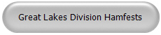
Just click to get to the latest hamfest updates.


Is your club website listed on the Great Lakes Division website?

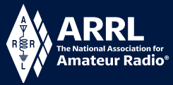
Youth Licensing Grant Program

Here’s one of those little talked about programs to help our youth. I’ll be that many of you didn’t even know about the ARRL Youth Licensing Grant Program. It started in 2022 and covers the one-time FCC $35 application fee for new license candidates younger than 18-years old for tests administered under the ARRL Volunteer Examiner Coordinator (ARRL VEC) program. Yes, the ARRL will cover the $35 FCC fee for youth who are getting into Amateur Radio
Additionally, candidates younger than 18-years old would pay a reduced exam session fee of $5 to the ARRL VEC VE team at the time of the exam. The $5 fee is for all candidates under the age of 18 regardless of the exam level taken. Proof of under 18 status is required at the session (what to bring to an exam session).
Both of these programs are sponsored by YOUR ARRL.

Candidates younger than 18-years old will pay a reduced exam session fee of $5 to the ARRL VEC VE team when taking an exam. Proper identification must be presented to and verified by the team, per the procedures for all exam candidates (what to bring to an exam session). The $5 fee is for all candidates under the age of 18 regardless of the exam level taken. Want more information about these programs? Licensing Grant Program

Wanted… Your Photo’s
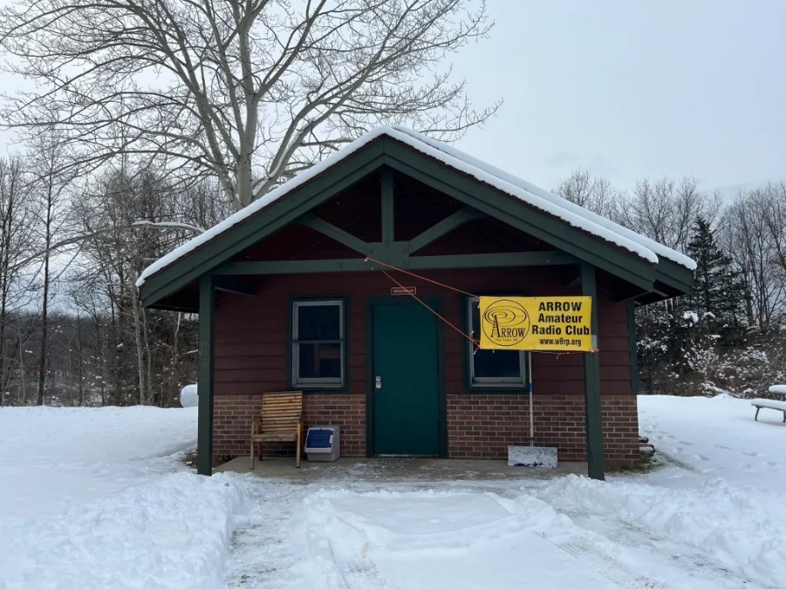

Have you seen the Photo Gallery on the Great Lakes Division website? If you haven’t you really need to, your face may be among the many already posted there.

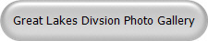

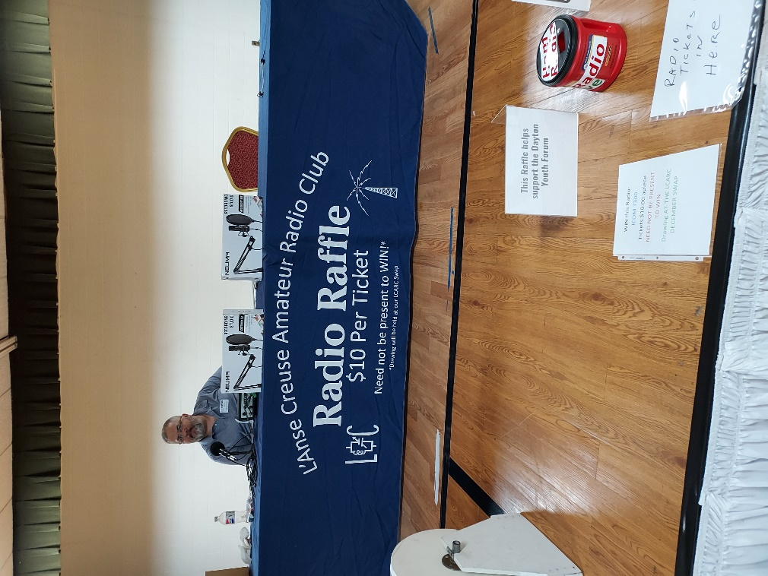
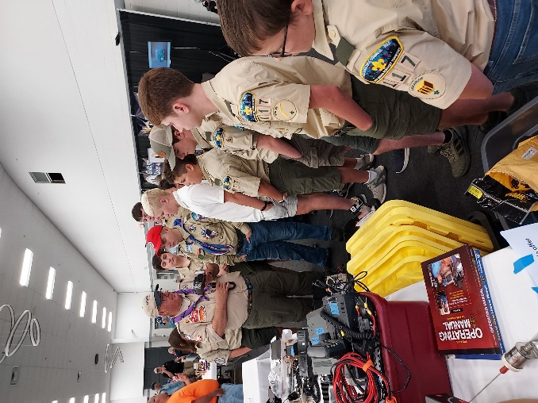
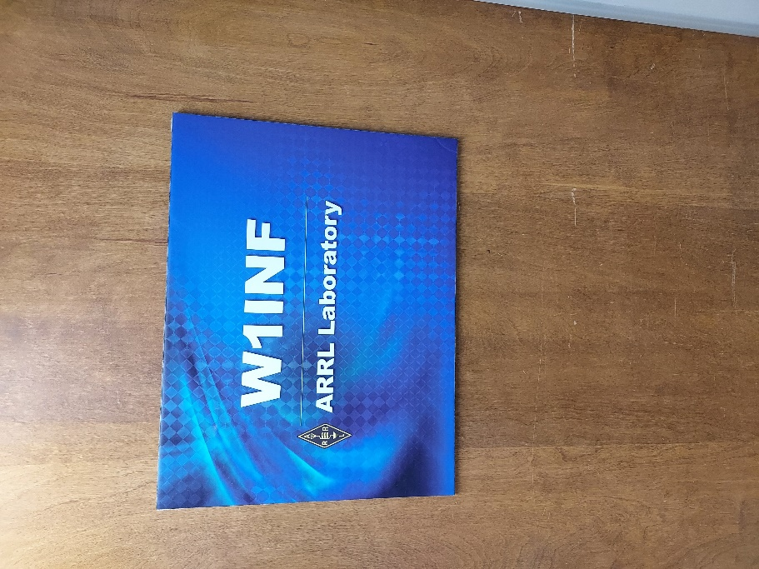
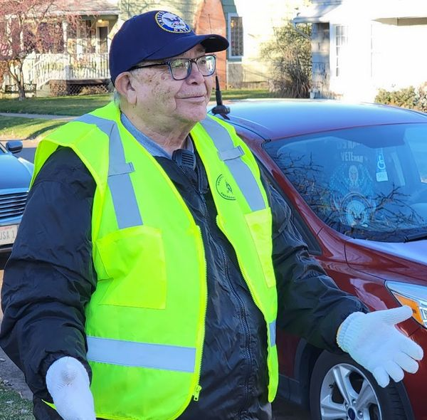
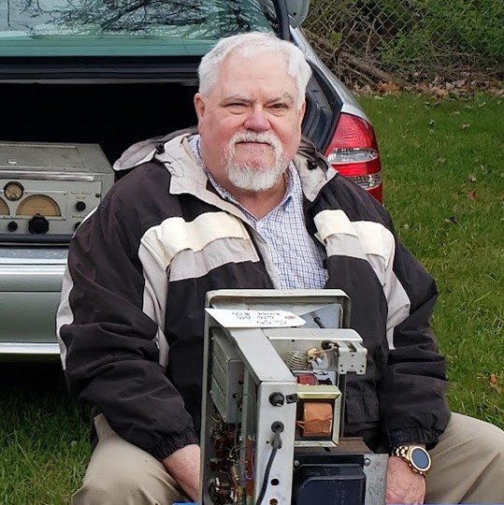
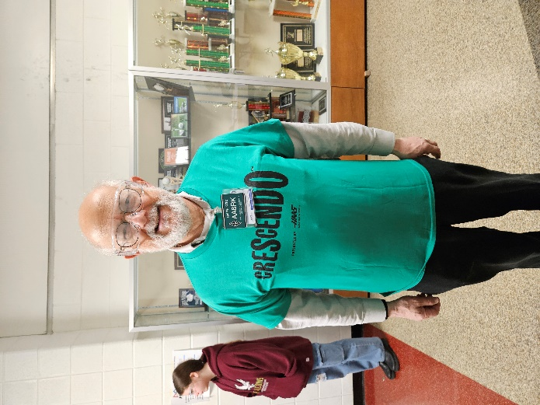
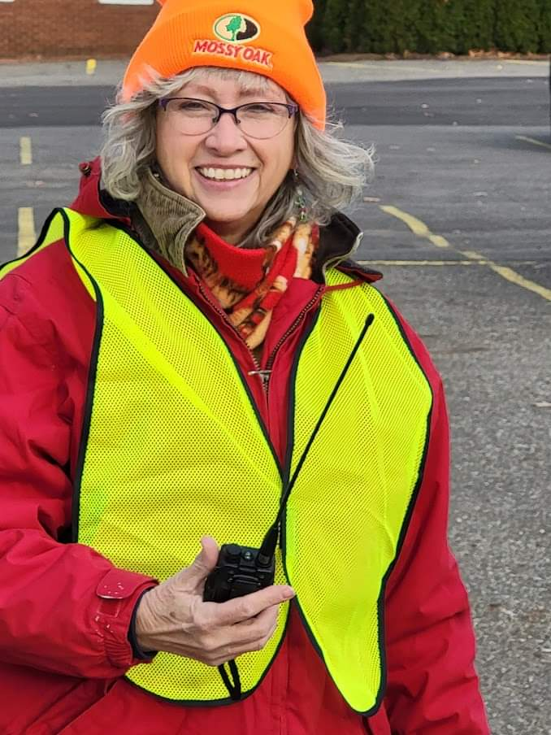

I’m always looking for more pictures to use in the Gallery, newsletter, banner and video display. Please, send me your pictures!!! Send them to: n8sy@n8sy.com

#####

