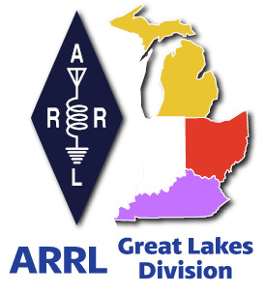
Radio Waves
^{The} Great Lakes Division
Monthly Journal

June 2024

What’s inside…

What is Your Definition of our Hobby? | Results from Survey
2024 Division Hamfests  Youth Licensing Grant Program | ARRL Club Grant Program  Wanted

Scott’s Stuff
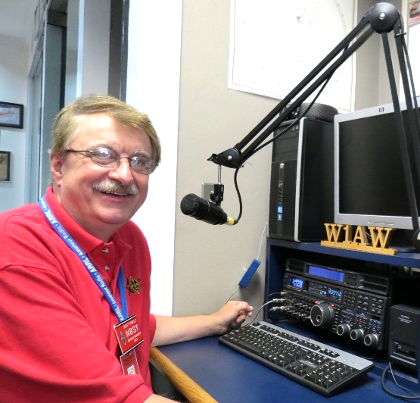
Hi Gang,

Welcome to the first edition of “Radio Waves.” I want to thank Scott Pyles, WX1J of Traverse City, Michigan for coming up with this great name for sure. Scott not only came up with this name, but several others as well. Many of you submitted great ideas and I want to thank all of you for that. It was a real toss up as to what would fit the best, but I think “Radio Waves” fits perfectly. Thanks so much Scott for the wonderful new name.

June has arrived and with it comes Field Day. I know that there’s been some discussion around the country about whether Field Day is a “contest” or is it an “EmComm” event.
Well, I guess it just depends on how you look at it. From the contester’s side of things, it does appear to be a “contest” since there are points and for some, even high praise and recognition in having the highest score in a particular category.

I can also see it from the EmComm side as well. Why else would you go out to the most remote area that you could find, where there’s no modern conveniences, electricity, towers and so forth and not only setup and operate, but also invite your local government officials and public to attend and yes, even operate!
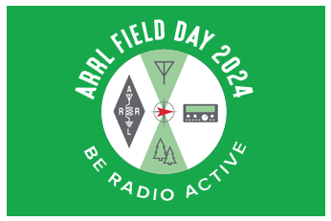
I think it can be easily said that it’s clearly both. But here’s something else that it is… it’s also a Public Relations event as well. Again, why invite the public to come watch and even participate if it’s not about PR?

Whatever way you decide Field Day is for your group of folks really doesn’t matter. What matters is to get everyone out and becoming “radio active” in this really wonderful 24 hour event!!

Field Day is June 22 and 23. I’ll bet your club is already making plans to have a Field Day event this year? Are you participating?

Hey clubs… don’t forget to get signed up on the Field Day locator http://www.arrl.org/field-day-locator and make sure that you meet with your local government officials and ask them for a Proclamation for Amateur Radio that weekend. Most local governments will be happy to do this and don’t forget to invite the news media to be there as well. This is great PR for everyone, and you get extra points for your efforts too! Amateur radio groups are encouraged to share a copy of their proclamations with ARRL via pr@arrl.org

ARRL is working on sharing these proclamations that it receives to help advance legislative efforts, creating additional support of awareness for amateur radio among lawmakers.

Oh, and one more thing... This isn’t mentioned much but is so very important to make sure you do. Have someone assigned to take pictures!! Lots of them. Just about everyone nowadays has a phone with a camera built into it, so there’s really no excuse anymore for not taking pictures, and.... send them to me at: n8sy@n8sy.com

I will be out and about again this year visiting as many of the Field Day sites as I can get to on Saturday and Sunday. There are a lot of great sites to visit, and I’ll do my best to try to get to yours!
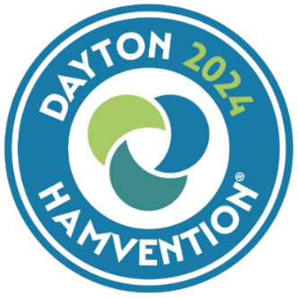
Hamvention… By now I’m sure that you’ve already heard the attendance numbers for this year’s event, 35,877. I think I talked to just about that many on Friday alone. It was great getting to see so many of you and talking a bit with you. I also want to thank those of you who attended the ARRL Forum on Saturday morning. We had a really good turnout, and it was so nice to see so many people there.

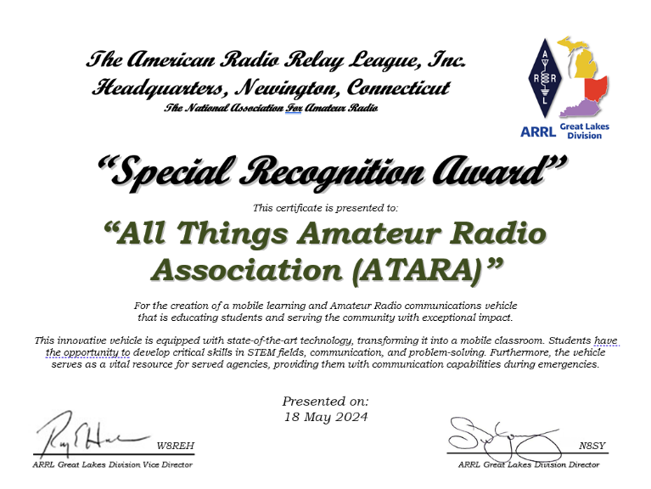
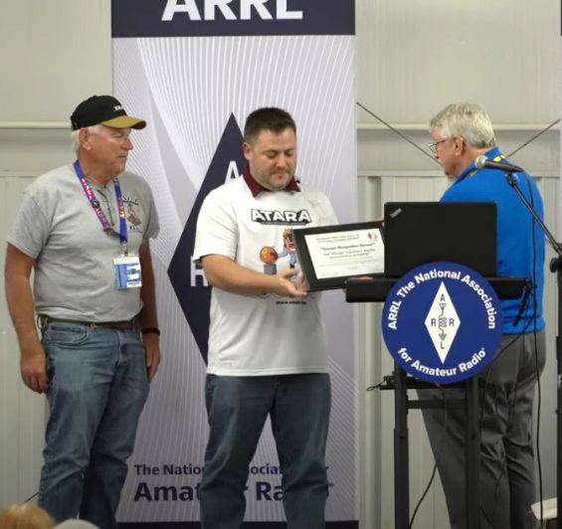
I want to congratulate the “All Things Amateur Radio Association” for receiving the “Great Lakes Division Special Recognition Award” for all that they have done these past several years in advancing and promoting Amateur Radio to not only our youth, but also many government officials and the general public as well.

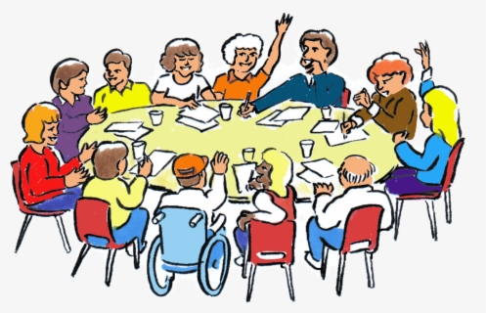
Survey… I found the responses to the Survey last month once again very fascinating to say the least. The results are posted below.

Is there a question that you’d like to see posted that hasn’t been so far? Let me know. Oh, and there’s another questionnaire posted, GLD-5.
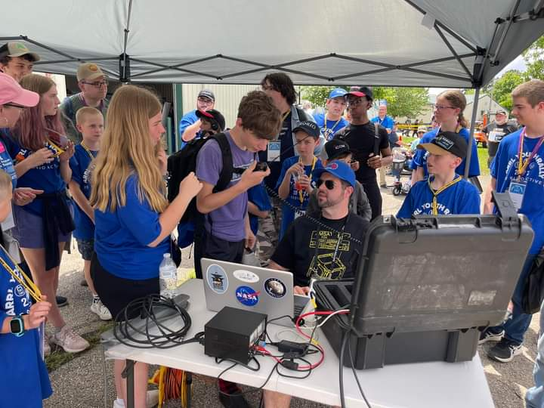
Pictures… I’ll bet that your club members have thousands of pictures that could be assembled in a video or even just in a photo book that could be passed around from time to time at a meeting or special gathering. It’s really a very special tool that the club can use to gain members and show off some of the really great things your club has done over the years.

It takes some work organizing them, but the payoff is well worth the effort for sure, especially if the entire club gets involved. So, why not have FUN and enjoy those magical moments together!

That’s going to do it from me this time around. Hope to catch ya’ on the air, at a club meeting or a hamfest soon!!

73,

Scott Yonally, N8SY
Director
Great Lakes Division
n8sy@arrl.org



What’s Your Definition of our Hobby, Ham Radio?
Roy, W8REH

I started asking around for the definition of ham radio years ago as it became apparent that it was significantly different to different people. In trying to understand the definition of “Ham or Amateur Radio”, let’s start with the definition of the word “definition”: “A statement expressing the essential nature of something”.

Many people in the hobby gravitate to the term “Radio” as the common denominator. After all, Radio is in our name.

Definitions today seem to narrow things down to what the word has matured to, including broadcasting, communication, etc. Looking back to the historical beginning of the word, broader interpretations of the word’s origin emerge.

- pertaining to or employing radiations, as of electrical energy
- relating to electric currents or phenomena (such as electromagnetic radiation) of frequencies between about 3000 hertz and 300 gigahertz
- derived from the Latin word "radius", radius beam or ray
- shortening of terms, radiotelegraph or radiotelegraphy (1910–15)

In 1914, Hiram Percy Maxim, the co-founder of the American Radio Relay League, named our organization using terminology of the day.

He realized that messages could be sent more reliably over long distances if relay stations were organized much like what wired telegraphy had already done. Maybe not now known by the term “relay”, the concept is used throughout the hobby from the National Traffic System (NTS) to digipeaters. It is my opinion our founders organizing the participants of our hobby has proven to be critical and likely the tool that will preserve us into the future. ARRL and its members’ efforts are key to maintaining our playground for existing and future talented, scientific minds making up the hams of the future who will impact the world as our predecessors have.

The word “relay” in our name certainly does not carry the same significance to most of us as it did when the organization was founded. Maybe our use of the word “radio” in its strictest interpretation has evolved as well. I’m not suggesting we should change our name but I do suggest maybe we should not simply define our hobby solely with the strictest definition of Radio or Communication. As we move our hobby into the future, I speculate there are new passionate interests involving technology related to our hobby. Those who have yet to discover ham radio might be more easily attracted if we create a more welcoming environment.

While trying to understand the essence of our hobby, a look back in history seems appropriate. The study of the physics behind what is today known as “radio” waves, began with the theory of electromagnetism by James Clerk Maxwell in 1873 where he predicted the existence of Electromagnetic waves. Heinrich Hertz’s discovery of "Hertzian waves" came around 1886. After Maxwell’s 1873 theories, research continued around the world for nearly 20 more years when the French physicist Édouard Branly created what he called the “radio-conducteur”. The device he created was a detector of Hertzian waves. The name Branly chose could have been the spark for the word “Radio” which slowly began replacing the term “wireless”. In 1895 Guglielmo Marconi’s "wireless telegraphy invention", led the way to the first practical wireless communications.

These are just examples of the physics research that would later be engineered into Radio. The first significant use of the word “Radio” may actually be credited to the British Post Office back as far as 1904 in a communication regarding telegraph. Regardless, communication had clearly established itself as a good use for this magical technology fulfilling a highly sought after need.

To further complicate the understanding of the word radio in today’s environment, enter Internet radio, also known as online radio, web radio, net radio, streaming radio, e-radio and IP radio. Broadcasting on the Internet is referred to by many as webcasting. Since it is not transmitted broadly through wireless means. Internet Radio” is thought by some with strict interpretations of the word Radio, an invalid use of the word. I discovered that a term like radio can sometimes evolve, becoming technically inaccurate when judged by its traditional standard definition just by common usage and acceptance of a broad portion of society. Have you ever heard of iHeartRadio?

This month, Dayton Hamvention, the largest event of its kind, provided a multitude of opportunities for our hobby. We all owe DARA and over 700 volunteers a big “Thank You” for their tremendous effort putting on this extremely successful event every year. I really appreciate all of you who stopped to share ideas and communicate with us.

What did YOU learn? Keep in mind our history that I just described which shows our hobby began as a learning endeavor. I really enjoy discovering the many new unfamiliar things attracting people to the hobby found all around this event. The important traditional activities of operating, DX’ing, and contesting was certainly well covered. However, we should not let the entertaining aspects of the hobby we all have learned to love to drown out sparks of enthusiasm for new learning opportunities. With your help, we will find more. I’m starting a living, all-inclusive list I hope might help answer the question, “What is the essence of ham radio?” I believe articulating this information will be helpful to ultimately describe our hobby to the world and reach new, yet untapped minds.

- POTA (Parks On The Air) | - Fox Hunting
- CW Training-Proficiency | - Satellite Communications
- VE Service | - Emergency Service
- NCS and Traffic Passing Preparedness | - Radio Amateur Balloon Science
- Organization Leadership Service | - County Hunting
- Equipment Home Brew | - Kit Building
- Wireless Remote Control | - Robotics
- Station Automation | - Computer coding
- 3D Printing | - STEM – Science, Tech, Eng., Math
- DX chasing | - Radio Sport – Contesting
- Antenna Design Experimentation | - Rover operation
- Digital modes | - Weather spotting
- Repeaters | - Astronomy
- Field Day | - Space Weather
- ??? | - ???

As this list grows and becomes more inclusive my mind rushes to attempt to hierarchically organize it, but let’s not attempt to do that yet. More to come, hopefully with comments and input from you.

Most importantly June 22 and 23 (fourth weekend in June) is Field Day 2024. As you might have guessed from my March article, nothing describes the essence of ham radio more to me than this long-standing event. Many discussions continue around Field Day, our most popular and long-standing event within the hobby. Please understand its popularity stems from its all-inclusive nature.
It certainly has a completive component, but don’t miss all the opportunities of the event to promote the hobby for everyone. There are nearly 600 published contests annually excluding the many weekly contests for those that feel contesting is the most important part of the hobby to them.

I hope every one of you gets out there with fellow hams, club members and friends to experience the fun and true essence of our hobby. Scott and I will be visiting as many Field Day sites in our division as we can. As a wonderful club building event, make sure your FD site is registered on the ARRL Field Day site locator: https://www.arrl.org/field-day-locator . If you don’t have a site in mind to participate with, you can find one in your part of the world on this locator map. See you soon.

73,

Roy Hook, W8REH
Vice Director
Great Lakes Division
w8reh@arrl.org

Results from GLD-4 Survey:

I do hope that some of the answers to this survey surprise you. They did me for sure. Club officers, you need to pay particular attention to the answers on question 2. I think you could get some very valuable information from these answers and hopefully make some good course corrections. It all starts with the clubs. They are the backbone of Amateur Radio. Without their willingness to have classes, mentoring, testing, forums and so forth where would you as a ham be today? It was once said “No one person is bigger than the club as a whole.” I take a lot of stock in that statement as that when I first started my adventure as a perspective ham, I had a lot of help from many different club members to get me where I am today. It’s those special friendships and willingness to “give back” that advances Amateur Radio. Yes, we can get licensed without a club, but what happens then? Many folks that go down this path are never heard from again. Why? There is no one there to help them along and mentor them in all the different aspects of Amateur Radio.

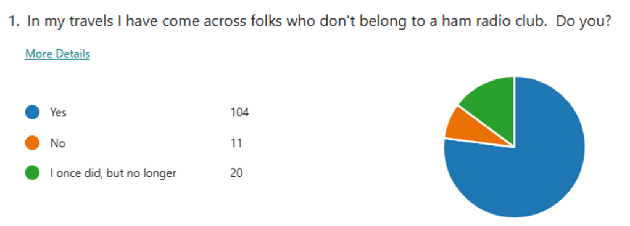

2. If you don't belong to a ham radio club, why?

Responses
I volunteered at the club, was one of the more active participants. Skywarn team leader, VHF and UHF repeater custodian, 2m ssb net controller, volunteer grant writer, and also helped the Emergency Coordinator schedule bike/foot races throughout the year. Short story, I identified an issue, offered a solution, and offered to implement the solution to improve the race assignments. EC quit talking to me, then asked someone else to do it. That someone else came to me for help. So I resigned. Interestingly, NOT A SINGLE Board member inquired why.
I've never been much of a 'joiner'.
Local club was unwelcoming.
Time and distance
The local club is only involved in EMCOM and nothing else. I'm a DXer, Honor Roll member, 8 Band DXCC, 5 Band WAZ, 2 meter weak signal guy. When I attended club meetings, I was a fish out of water.
New to the area.
Just starting to ask to join.
No good reason...just lazy?
I’m a caregiver for my spouse so getting out of the house other then for taking her to doctors appointments or picking up groceries or home necessities is about it.
family commitments
The local club turned into a joke fest as people moved into the area and joined up. Most of these moved into one of the small towns and eventually decided they did not want to be the ones to drive all the time. They started their own little cliques which wound up leaving one whole county pretty much out of things. Of the officers and others from the early 2000's, few are still members. About half dropped out over the years, me being one of them. I blame most of it on the fact that in all organizations, over half want all kinds of things to happen. About twenty percent offer to help, but only about ten percent or less actually wind up doing ALL THE WORK.
I am a member of one club and associated with another club. Each has their MAJOR drawbacks, but sometimes I need help from others. If it wasn't for that...I would probably save money by not spending it on club dues.
Found the group not very inviting and friendly.
I just have not been that active. Neither have the upper bands.
Never get around to sending membership application and don't attend meetings. Meetings at wrong time of day.
They don’t do many activities that interest me.
Already very active on air with no more free time.
The one to which I used to belong has an unusable set of bylaws, which is evidenced by the members' flagrant disregard for them. The meetings were poorly run; and they still are, I hear. Meetings do not have good programs, and activities are lacking. In the past the membership alienated some local hams by spreading vicious lies, which persist even today.There is more, but these are the main reasons.
Doesn't fit with work and family schedules.
Busy familylife
When I first became a ham I tried two clubs, but was mostly ignored and left to figure out everything on my own, which I never did completely and I have never been very active in the hobby since then. I have tried to figure out FT8 digital on my own to get some kind of radio participation going, but have struggled with it for a while. If things compete for my time, ham radio is the first to lose out.
Local club is very small, full of grumpy old men
Too busy...
Attended a meeting of the local club, put in an application, absolutely no feedback. Not even a notice of the next meeting.
Nearest club is too far away.
good old boys clubs.
STUPID LEADERSHIP
I do not want to.
To much politics.
I've ALWAYS belonged to a local club - I seek them out.
the club dose want to help ham to up grade
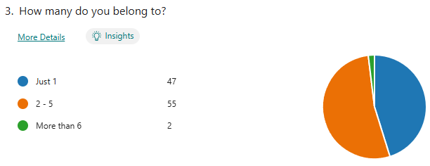

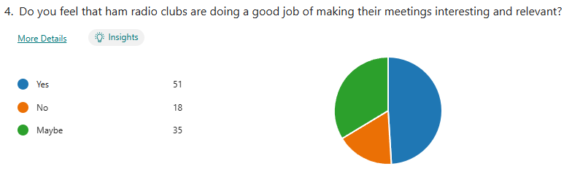

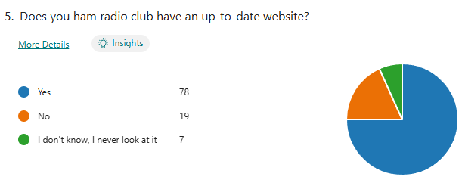

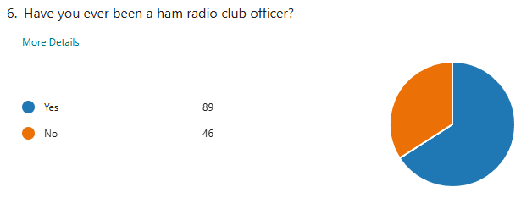

7. Bonus Question: I'd like the Great Lakes Division Newsletter to have a name, got any
ideas????

Responses
ARRL Great Lakes Division Newsletter
?
The Great Lakes Ham Dynamo
The ARRL Great Lakes Division Newsletter
"From the Mountains to the Lakes"
QST de GLD
Great Lakes Ham Radio Club
nope, just not in the creative mood right now...
Scott...I think GLDN is the most appropriate and meaningful name for it.... See you at HV!
Water Winter Wonderland Amateur Radio Press, or Ham Press
Great Lakes Radiogram
Picture People Here Are Always Smiling (unlike other ham publications)
What’s wrong with the one it has now?
The existing name is perfect! "the Great Lakes Division Newsletter"!
Ham it Up
The GLD Caller; The KOM Port (KY, Ohio, MI)
GLAD Tidings (Great LAkes Division)
The Radio Flyer
The Communicator
Nope. Fine just like it is!
QUSOS
QUSOS
Lakeside Waves
The Great Lakes Wave
KENTUCKY IS NOT A GREAT LAKE STATE
How about something with H.O.M.E.S the Great Lakes Acronym?
Shark free and unsalted
Having a name other than "Great Lakes Division Newsletter" will most likely create confusion and end up going to spam in many cases. Why not just leave it as is?
There is nothing wrong with the way it is. It is descriptive.
Radiogram - Should Also have the ARRL reference. - OOOh Just to mind. . . ARRL Great Lakes Division Radio Waves! Thanks, de
Ham Radio Unsalted
Radio in the HOMES!!!!
Do not really care that much as long as the quality is maintained.
Great Lakes Ham Report
GLAD News (Great Lakes Arrl Division)
MIOHKY, OHMIKY
Qsos
Great Lakes Radio Waves
GL Signals
I'm not very creative, but something with "waves" - Great Lakes and radio.
The Lake Net
The Radio Itch
Going to have to think about it!
Great Lakes Contacts
Waves across the Airwaves
The Laker ( a Great Lakes freighter), Great Lakes salt free shark free
Scott’s Scribbles
Qsos
Great Lakes Beacon
Great Lakes Division Newsletter is fine.
The Spark Gap
"Great Lakes Hamwaves" or "Lakefront Radio Relay"
The Freighter (with a picture of an Ore Boat on the master of the first page).
Not at this time.
No ideas. Sorry.
no.
Great Lakes Division Newsletter
The Inland Seas Newsletter
it make me look bad

There’s another new survey on the website GLD-5. I really would like to hear your feedback to the questions asked. Please take just a couple of minutes of your time and take the survey.
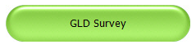

Here’s a link to it…

Got a question that you think should be asked? Let me know… n8sy@n8sy.com

ARRL Foundation Club Grant Program
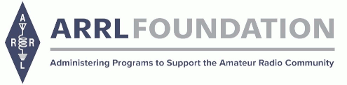
The ARRL Foundation is pleased to announce the return of the Club Grant Program for 2024.

ARRL Club Grant Program at a glance:
·Applications will be accepted between June 3rd and July 26th

·The link to apply will be on this site beginning June 3rd

·Grants will be available up to $25,000

·Clubs who receive grants will be required to share updates and reports with ARRL

·Clubs do not need to be ARRL-affiliated clubs or 501(c)(3) nonprofit organizations

·Emphasis is given to projects that are transformative in nature.

·Examples of projects include, but are not limited to: get on the air projects; ham training and skills development through mentoring; STEM and STEAM learning through Amateur Radio; station resources for use by the ham community; and emergency communications and public service projects that emphasize training

·Grant funds may not be used for commercial or for-profit projects

Follow the links below for Club Grant application templates:

Project narrative

Grant milestones

Grant project budget
The ARRL has long recognized that it is in the best interests of Amateur Radio to encourage and support amateur radio clubs. Historically, clubs have recruited, licensed and trained new radio amateurs and have provided the community setting for radio amateurs to continue their education and training.

Check this site and the ARRL newsfeeds for updated information.

Questions about the Club Grant Program can be sent to clubgrants@arrl.org.

2024 Great Lakes Division Hamfests
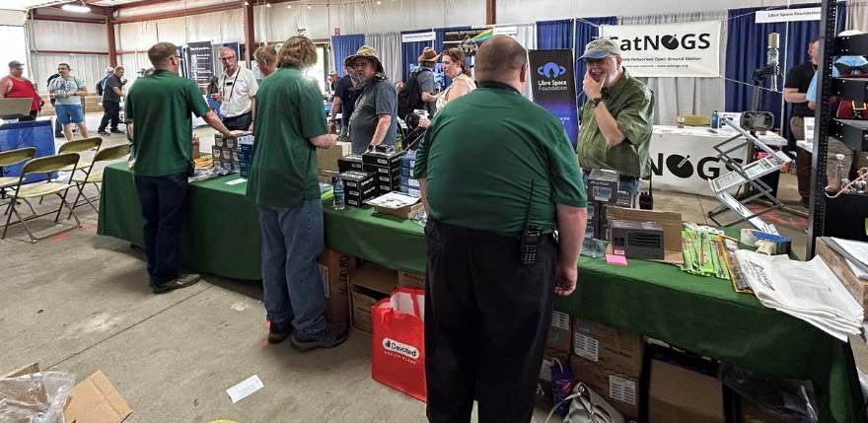
Here in the Great Lakes Division, we have over 50 hamfests a year, including the largest one in the country, Hamvention. This year Hamvention will also be the ARRL’s National Convention as well, which means that there will be some very special things happening there.

So, if you haven’t started planning your hamfest schedule yet, you really need to start now.

Please post this listing in your club's newsletter and announce the swaps on your local nets. Talk them up. Let's fully support all of our hamfests in every way possible. It means success for everyone. Be sure to invite your ARRL Officials as soon as your date is set.

If your ARRL Affiliated club plans to request Hamfest Sanctioning, you should make that request well in advance of the scheduled Hamfest date, as this allows adequate time for QST Listings. QST announcements require a 3-month lead time. To be fair to our division’s clubs, the Great Lakes Division policy now has 2 requirements for any ARRL Sanctioning.

Any club requesting ARRL sanctioning within the Great Lakes Division must now be an ARRL Affiliated Club with a maximum of two hamfests/swaps in any given calendar year, and they must be at least four months apart.

If your swap is cancelled or the date is going to change, please notify ARRL HQ.

06/01/2024 - FCARC Summer Hamfest  Location: Wauseon, OH  Type: ARRL Hamfest  Sponsor: Fulton County Amateur Radio Club  Website: https://k8bxq.org/hamfest  Learn More | 06/01/2024 - IRA Hudsonville Hamfest  Location: Hudsonville, MI  Type: ARRL Hamfest  Sponsor: Independent Repeater Association  Website: http://www.w8ira.org  Learn More
06/02/2024 - Annual Chelsea Amateur Radio Club Swap Meet  Location: Chelsea, MI  Type: ARRL Hamfest  Sponsor: Chelsea Amateur Radio Club  Website: http://wd8iel.com  Learn More | 06/08/2024 - LARS 2024 Yooper Hamfest  Location: Newberry, MI  Type: ARRL Hamfest  Sponsor: Luce Amateur Radio Services, Inc.  Website: www.w8nby.org  Learn More
06/15/2024 - MARC Hamfest  Location: Midland, MI  Type: ARRL Hamfest  Sponsor: Midland Amateur Radio Club  Website: http://w8kea.org  Learn More | 06/16/2024 - Monroe Hamfest  Location: Monroe, MI  Type: ARRL Hamfest  Sponsor: Monroe County Radio Comm Association  Website: http://mcrca.org/  Learn More
07/06/2024 - Mansfield Mid Summer Trunkfest  Location: Mansfield, OH  Type: ARRL Hamfest  Sponsor: Intercity Amateur Radio Club  Website: http://W8WE.ORG  Learn More | 07/20/2024 - Ashtabula County Hamfest 2024  Location: Pierpont, OH  Type: ARRL Hamfest  Sponsor: Amigos Radio Club Ashtabula  Website: https://sites.google.com/view/arca-home/  Learn More
07/20/2024 - NOARSFEST  Location: Elyria, OH  Type: ARRL Hamfest  Sponsor: Northern Ohio Amateur Radio Society  Website: http://www.noars.net  Learn More | 07/21/2024 - Van Wert Hamfest  Location: Van Wert, OH  Type: ARRL Hamfest  Sponsor: Van Wert Amateur Radio Club  Website: http://w8fy.org  Learn More

08/03/2024 - 2024 Columbus Hamfest  Location: Grove City, OH  Type: ARRL Hamfest  Sponsor: Aladdin Shrine Audio Unit  Website: http://www.columbushamfest.com  Learn More | 08/03/2024 - U.P Hamfest  Location: Rapid River, MI  Type: ARRL Hamfest  Sponsor: Delta County Amateur Radio Society  Learn More
08/10/2024 - Cincinnati Hamfest  Location: Owensville, OH  Type: ARRL Hamfest  Sponsor: Milford ARC  Website: https://CincinnatiHamfest.org  Learn More | 08/18/2024 - Warren Hamfest  Location: Cortland, OH  Type: ARRL Hamfest  Sponsor: Warren Amateur Radio Association  Website: https://www.w8vtd.com/  Learn More
09/07/2024 - Branch County ARC Fall Trunk Swap  Location: Coldwater, MI  Type: ARRL Hamfest  Sponsor: Branch County Amateur Radio Club, Inc.  Website: http://branchcountyarc.org  Learn More | 09/07/2024 - Grand Rapids Area Hamfest  Location: Wyoming, MI  Type: ARRL Hamfest  Sponsor: Grand Rapids Amateur Radio Association  Website: https://w8dc.org/2024/02/05/grand-rapids-area-hamfest/  Learn More
09/07/2024 - Greater Louisville Hamfest 2024  Location: Shepherdsville, KY  Type: ARRL Hamfest  Sponsor: Greater Louisville Hamfest Association  Website: http://LouisvilleHamfest.com  Learn More | 09/08/2024 - Findlay Hamfest  Location: Findlay, OH  Type: ARRL Hamfest  Sponsor: Findlay Radio Club  Website: http://w8ft.org  Learn More
09/14/2024 - GMARC Trunk Swap at the PPG  Location: Shelby Twp., MI  Type: ARRL Hamfest  Sponsor: General Motors Amateur Radio Club (GMARC)  Website: http://GMARC.org  Learn More | 09/14/2024 - OAARS Ham Swap  Location: West Branch, MI  Type: ARRL Hamfest  Sponsor: Ogemaw Arenac Amateur Radio Society  Website: http://www.k8oar.club  Learn More

09/14/2024 - Richmond, Kentucky, Hamfest  Location: Richmond, KY  Type: ARRL Hamfest  Sponsor: Central KY ARS (CKARS)  Website: http://ckars.org  Learn More | 09/15/2024 - Adrian Hamfest  Location: Adrian, MI  Type: ARRL Hamfest  Sponsor: AARC  Website: http://w8tqe.com  Learn More
09/22/2024 - Cleveland Hamfest  Location: Berea, OH  Type: ARRL Hamfest  Sponsor: Hamfest Association of Cleveland  Website: https://www.hac.org  Learn More | 09/28/2024 - Paintsville KY4ARC Hamfest  Location: Paintsville, KY  Type: ARRL Hamfest  Sponsor: KY4ARC  Website: http://ky4arc.com  Learn More
09/28/2024 - Top of Michigan Amateur Radio Club & Thunder Bay Amateur Radio Club Hamfest  Location: Gaylord, MI  Type: ARRL Hamfest  Sponsor: Top of Michigan ARC Gaylord and Thunder Bay ARC Alpena  Website: http://www.nm8rc.org  Learn More | 10/05/2024 - Central Kentucky Hamfest  Location: Lexington, KY  Type: ARRL Hamfest  Sponsor: Bluegrass Amateur Radio Society  Website: http://www.bluegrassars.org  Learn More
10/05/2024 - Kalamazoo Hamfest  Location: Kalamazoo, MI  Type: ARRL Hamfest  Sponsor: Kalamazoo Amateur Radio Club (KARC), Southwest Michigan Amateur Radio Team (SMART)  Website: http://www.kalamazoohamfest.org/  Learn More | 10/05/2024 - Northwest Ohio Amateur Radio Club (NWOARC) Hamfest  Location: Lima, OH  Type: ARRL Hamfest  Sponsor: Northwest Ohio Amateur Radio Club, Inc.  Website: http://www.nwoarc.com  Learn More
10/05/2024 - Scioto Valley Amateur Radio Club Hamfest  Location: Piketon, OH  Type: ARRL Hamfest  Sponsor: Scioto Valley Amateur Radio Club  Learn More | 10/06/2024 - U.S.E.C.A. (Utica Shelby Emergency Communication Association) Hamfest  Location: St. Clair Shores, MI  Type: ARRL Hamfest  Sponsor: U.S.E.C.A.  Website: http://USECAARC.ORG  Learn More

10/12/2024 - Muskegon Color Tour Hamfest  Location: Muskegon, MI  Type: ARRL Hamfest  Sponsor: Muskegon County Emergency Communication Services, Inc.  Website: http://www.mcecs.net/hamfest  Learn More | 10/26/2024 - Hazard Hamfest  Location: Hazard, KY  Type: ARRL Hamfest  Sponsor: Kentucky Mountains Amateur Radio Club  Learn More
10/27/2024 - 2024 MARC Hamfest at MAPS  Location: N. Canton, OH  Type: ARRL Hamfest  Sponsor: Massillon Amateur Radio Club  Website: https://www.w8np.net  Learn More | 12/01/2024 - LCARC Amateur Radio Swap/Hamfest  Location: Troy, MI  Type: ARRL Hamfest  Sponsor: L'Anse Creuse Amateur Radio Club  Website: http://www.n8lc.org  Learn More
12/07/2024 - Winter Hamfest
Location: Archbold, OH
Type: ARRL Hamfest
Sponsor: FCARC
Website: https://k8bxq.org/hamfest
Learn More

You can always find the latest updates for upcoming hamfests on the Great Lakes Division website.

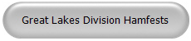
Just click to get to the latest hamfest updates.

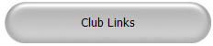
Is your club website listed on the Great Lakes Division website?

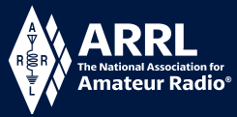
Youth Licensing Grant Program

Here’s one of those little talked about programs to help our youth. I’ll be that many of you didn’t even know about the ARRL Youth Licensing Grant Program. It started in 2022 and covers the one-time FCC $35 application fee for new license candidates younger than 18-years old for tests administered under the ARRL Volunteer Examiner Coordinator (ARRL VEC) program. Yes, the ARRL will cover the $35 FCC fee for youth who are getting into Amateur Radio
Additionally, candidates younger than 18-years old would pay a reduced exam session fee of $5 to the ARRL VEC VE team at the time of the exam. The $5 fee is for all candidates under the age of 18 regardless of the exam level taken. Proof of under 18 status is required at the session (what to bring to an exam session).
Both of these programs are sponsored by YOUR ARRL.

Candidates younger than 18-years old will pay a reduced exam session fee of $5 to the ARRL VEC VE team when taking an exam. Proper identification must be presented to and verified by the team, per the procedures for all exam candidates (what to bring to an exam session). The $5 fee is for all candidates under the age of 18 regardless of the exam level taken. Want more information about these programs? Licensing Grant Program

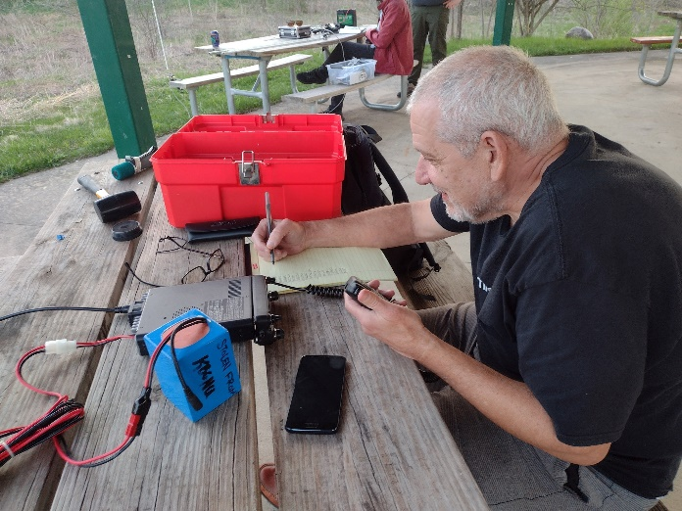
Wanted… Your Photo’s

Have you seen the Photo Gallery on the Great Lakes Division website? If you haven’t you really need to, your face may be among the many already posted there.

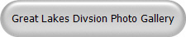

I’m always looking for more pictures to use in the Gallery, newsletter, banner and video display. Please, send me your pictures!!! Send them to: n8sy@n8sy.com

#####

