
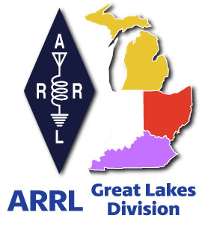
Radio Waves
^{The} Great Lakes Division
Monthly Journal

July 2024

What’s inside…

Field Day Success | Dual-band Beam Antenna
ARRL Club Grant Program  2024 Division Hamfests | Youth Licensing Grant Program  YOTA Americas Camp

Scott’s Stuff
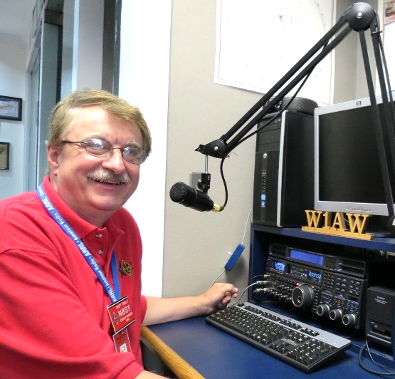
Hi Gang,

Well, it’s July… Hot, humid and I am so thankful that the rain we got wasn’t snow. Can you imagine shoveling snow in this heat??? Hi… Hi…

I am hopeful that most of you are reading this before the 4th and enjoying the holiday as it is meant to be, with family and friends. Please, don’t forget to say a little something for those who have and are currently serving our great nation today. It is because of them that we get to celebrate our nation’s birthday.

Field Day is in the books and later this year the results will be published as to how every group did. I only got to 10 clubs this year due to road conditions and the sweltering heat, but I had fun, nonetheless. Janie and I drove just about 800 miles between the 2 days.
I hope all of you had as much fun as we did. I want to thank everyone where we went for the really great time that we had with all of you. Every stop was a new adventure and all of you were so gracious and generous with not only your time, but food and drink as well. Yes, it was a very hot day, but it was a blast to get out and see so many of you having fun and enjoying this really great hobby of ours and being RADIO ACTIVE!

Oh, and one more thing... Did you take pictures of your Field Day? I have a Field Day Gallery started on the website. Here’s a direct link … https://arrl-greatlakes.org/fd24/index.php I took a bunch of pictures, but many of them displayed are what I could find on websites and Social Media posts… If you have pictures, please send them to me at: n8sy@n8sy.com
so that I can get them added to the Gallery. Yes, sometimes I also use these pictures for other things, like our banner or even in this newsletter.

I’ve been on the road attending hamfests as well. I want to thank the folks at the Yooper and Monroe hamfests for putting on such great shows. It was a blast to get out and walk around and talk with so many of you. The weather for both hamfests was absolutely perfect. Hope to be able to go back next year!

July is also the Board of Directors meeting. Roy and I are working hard at getting things in order for our respective duties to the Board as well as our committees for that weekend.

Survey… I have quickly realized just how important the ARRL ListServer really is in getting the word out to everyone in the Division that there is a new Survey posted.

The survey I posted last month hasn’t had the views like our previous ones have experienced. I am somewhat disappointed, but I do understand as well.

Survey GLD-5 is on the website and waiting for input from you. I really would like to hear your feedback. Please take just a couple of minutes of your time and take the survey.


Here’s a link to it…

Got a question that you think should be asked? Let me know… n8sy@n8sy.com

Hopefully the ListServer will get back up and running soon and I can get the word out to all of you in a larger way. Since the responses have been extremely low this time around, I’m going to leave the current survey up there for a little longer, hopefully more of you will get curious and take the plunge and view the website and participate in the Survey.

That’s going to do it from me this time around. Hope to catch ya’ on the air, at a club meeting or a hamfest soon!!

73,

Scott Yonally, N8SY
Director
Great Lakes Division
n8sy@arrl.org


Field Day Success!
Roy, W8REH

Amateur Radio has been enjoying Field Day since 1933 as I hope each of you did this last month. You should have concluded from my March article; FD is the most significant event in the hobby for me. That is why I hit the road instead of the air for Field Day weekend with a carefully planned out list and route to include 20 of the Great Lakes Divisions FD sites south and west found on the ARRL Field Day locator map. After setting out at 10 AM Saturday morning for an early start, not unexpectedly, reality quickly changed the targets and 566 miles later mid Sunday afternoon, I called 11 sites a huge success.

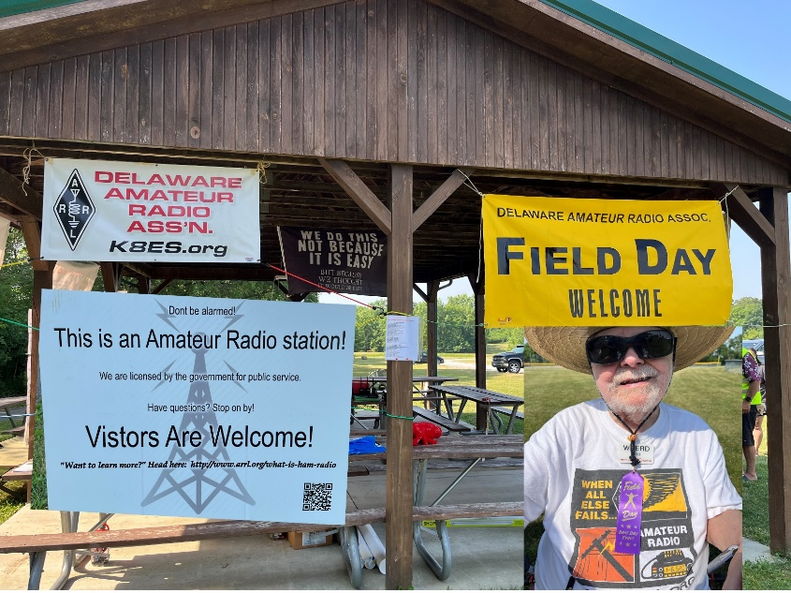
Although not the quantity I expected, the quality of the visits eliminated any disappointment. From Mid-Ohio to northern Kentucky hearing firsthand how all of you view the challenges we face today and how this pervasive Field Day event is contributing to the rejuvenation of our clubs and perceptions of our hobby was my reward. All FD sites I visited exemplified ham radio's open house event, each demonstrating ham radio's science, technical skill and service to our community. Clearly combining fun, education, public service, emergency preparedness, storytelling, food, all together, each in their own unique way.
Bob Dixon, W8ERD - DELARA FD Guru
Delaware ARA

Although 2024 will be remembered as the HOT one, even the sites demonstrating the preparedness aspects of the event in true “Field” Day fashion, expressed the fun and satisfaction they were having. Knowing that we had clubs taking everyone’s health and safety seriously by cancelling or closing early, took away any frustration of arriving to a vacated site.
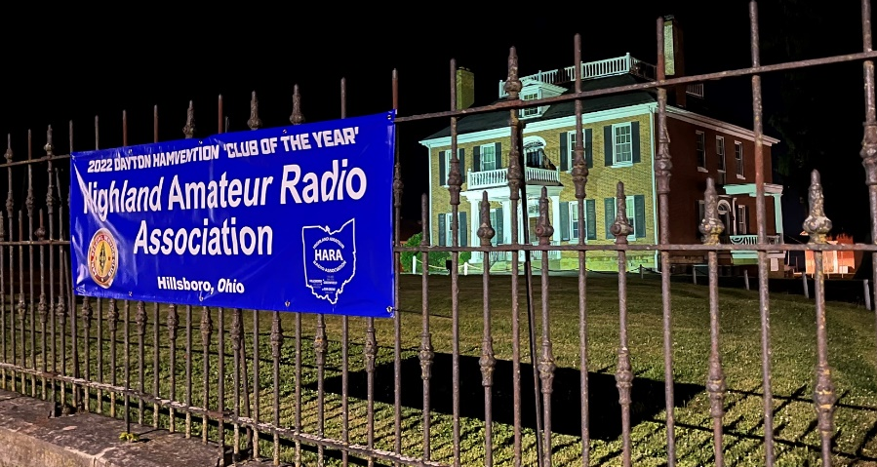
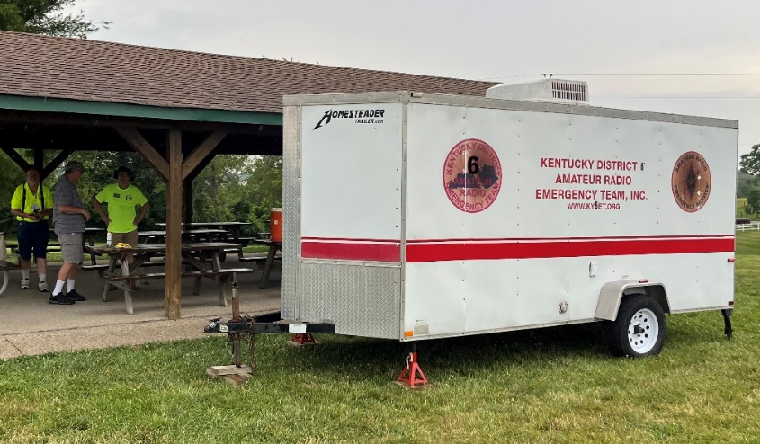
A day full of mind-expanding friendly encounters and running insanely behind, I arrived at the Highland County FD site around 11 PM Saturday night. After a long day at their downtown historical property where they were a spotlight in the center of the community, they were all looking to bed down, so I concluded my Saturday travel with the next stop at Clinton County ARA still going strong. Renewing long standing friendships with my childhood club there concluded with steak and eggs at 1:00 AM. My wife had given me permission to drive the family RV so after a few winks of sleep in the RV and thanks to a power drop from the host providing some wonderful AC, I was back on the road at 5:30 AM back to southern Ohio and on to Kentucky. Although Sunday was a bit cooler between some scattered rain drops, the heat had taken a toll on some groups, and it was clear I should celebrate my successes and continue my travels north to get back home somewhat after the close of the event.

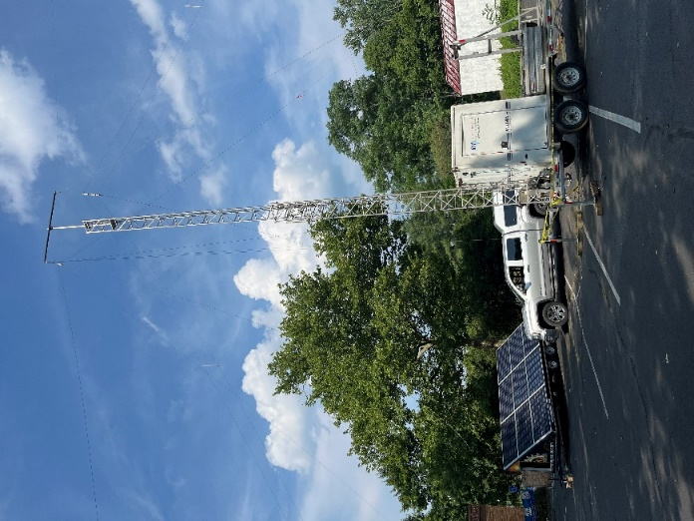

Northern Kentucky ARC

Roy Hook, W8REH
Athens County ARA
Vice Director
Successfully relocated their site at the last minute with solar power, antennas – everything
Very much in true FD fashion!
Great Lakes Division
w8reh@arrl.org

ARRL and Momobeam Introduce Dual-band Beam Antenna

ARRL has a new product to help radio amateurs get active and on the air

As Solar Cycle 25 continues to increase HF radio propagation on the upper bands, ARRL has partnered with the Italian antenna manufacturer Momobeam to design a dual band beam antenna to help take full advantage of the exciting opportunities for distant contacts. The ARRL Dual band Momobeam 6/10 Antenna is an easy-to-use antenna with a small footprint and a big reach. The beam features a 10 meter Moxon (28 MHz) and 6 meter Yagi (50 MHz).

At just over 10 pounds and with a turning radius of approximately 6.5 feet, the design is compact enough to fit places that otherwise wouldn’t have space for a beam antenna. It comes with two sets of hardware for both permanent installation and portable use for temporary deployments such as 2024 ARRL Field Day or park activations.

The ARRL Dual-band Momobeam 6/10 Antenna is ideal for Technician-class operators to be able to work DX. “This is a great ‘first’ beam antenna for every ham,” said ARRL Director of Marketing and Innovation Bob Inderbitzen, NQ1R. “If you’ve ever been intimidated by the prospect of owning a beam antenna, this one will allay your fears and give you a whole lot of fun. Radio clubs will want to add this beam to their deployment gear, as it’s a great fit for field operating and special event stations. College radio clubs that don’t have room for a large beam, or another beam, will enjoy adding this antenna for some gain on 6- and 10-meters. It is lightweight and can be turned with a simple TV rotator."

The 10-meter Moxon is an effective design for this dual-band antenna, as it’s around 30% smaller than a traditional Yagi and uses no traps or other shortening techniques that reduce performance. A Moxon antenna includes a number of antenna configurations that were referred to by Les Moxon, G6XN (SK), and have received attention over the years in QST and editions of The ARRL Antenna Book.

The feed system uses an open sleeve feed method, coupling the driven element of the 50 MHz section by proximity and length to the 10-meter driven element with minimal loss. “Just attach a single coaxial cable to included SO-239 equipped coaxial pigtail, and you’re ready to go on two bands!” said Inderbitzen.

The antenna debuted at the 2024 ARRL National Convention hosted at Dayton Hamvention® in May. The first run sold out at the show, but ARRL has taken delivery of more units, available now.

“It’s surprising how few amateurs have experience with antennas beyond basic wire designs,” said Inderbitzen. “Our interest in introducing this antenna is to increase the depth and breadth of knowledge and experience among our members.”
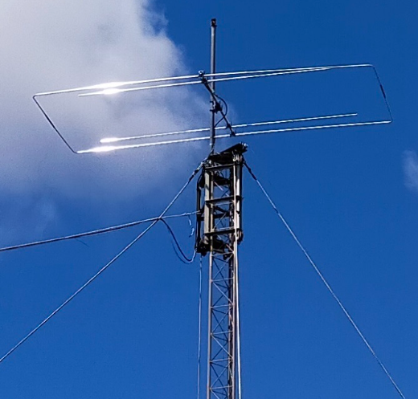
Inderbitzen added that members should watch for more content, including video tutorials, coming from ARRL about the antenna. More information about the antenna can be found at www.arrl.org/beam where future content will also be published.

While this antenna was produced exclusively for ARRL, Momobeam offers many of its popular antenna designs in the US through its partnership with Ham Radio Outlet.

The ARRL Dual-band Momobeam 6/10 Antenna is available from the ARRL Store at www.arrl.org/shop (ARRL Item No. 0084, $299.95 retail plus shipping, handling, and sales tax where applicable. Available to ship in the US, only.

Call 860-594-0355 or, toll-free in the US, 888-277-5289).

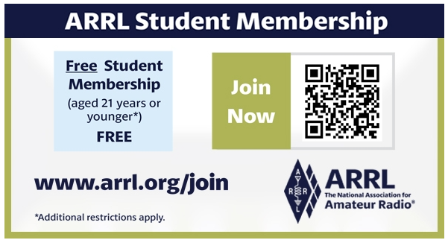

ARRL Foundation Club Grant Program
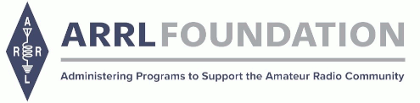
The ARRL Foundation is pleased to announce the return of the Club Grant Program for 2024.

ARRL Club Grant Program at a glance:
·Applications will be accepted between June 3rd and July 26th

·Grants will be available up to $25,000

·Clubs who receive grants will be required to share updates and reports with ARRL

·Clubs do not need to be ARRL-affiliated clubs or 501(c)(3) nonprofit organizations

·Emphasis is given to projects that are transformative in nature.

·Examples of projects include, but are not limited to: get on the air projects; ham training and skills development through mentoring; STEM and STEAM learning through Amateur Radio; station resources for use by the ham community; and emergency communications and public service projects that emphasize training

·Grant funds may not be used for commercial or for-profit projects

Follow the links below for Club Grant application templates:

Project narrative

Grant milestones

Grant project budget

The ARRL has long recognized that it is in the best interests of Amateur Radio to encourage and support amateur radio clubs. Historically, clubs have recruited, licensed and trained new radio amateurs and have provided the community setting for radio amateurs to continue their education and training.

Check this site and the ARRL newsfeeds for updated information.

Questions about the Club Grant Program can be sent to clubgrants@arrl.org.

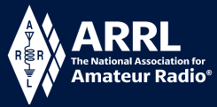
Youth Licensing Grant Program

Here’s one of those little talked about programs to help our youth. I’ll be that many of you didn’t even know about the ARRL Youth Licensing Grant Program. It started in 2022 and covers the one-time FCC $35 application fee for new license candidates younger than 18-years old for tests administered under the ARRL Volunteer Examiner Coordinator (ARRL VEC) program. Yes, the ARRL will cover the $35 FCC fee for youth who are getting into Amateur Radio
Additionally, candidates younger than 18-years old would pay a reduced exam session fee of $5 to the ARRL VEC VE team at the time of the exam. The $5 fee is for all candidates under the age of 18 regardless of the exam level taken. Proof of under 18 status is required at the session (what to bring to an exam session).

Both of these programs are sponsored by YOUR ARRL.

Candidates younger than 18-years old will pay a reduced exam session fee of $5 to the ARRL VEC VE team when taking an exam. Proper identification must be presented to and verified by the team, per the procedures for all exam candidates (what to bring to an exam session). The $5 fee is for all candidates under the age of 18 regardless of the exam level taken. Want more information about these programs? Licensing Grant Program

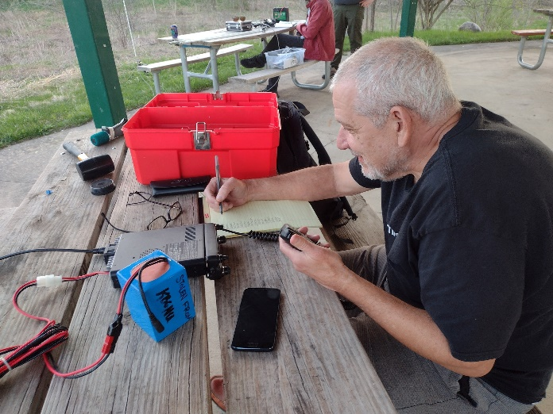
Wanted… Your Photo’s

Have you seen the Photo Gallery on the Great Lakes Division website? If you haven’t you really need to, your face may be among the many already posted there.



I’m always looking for more pictures to use in the Gallery, newsletter, banner and video display. Please, send me your pictures!!! Send them to: n8sy@n8sy.com

2024 Great Lakes Division Hamfests
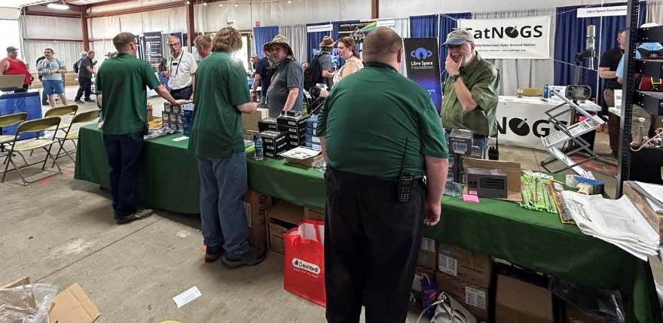
Here in the Great Lakes Division, we have over 50 hamfests a year, including the largest one in the country, Hamvention. This year Hamvention will also be the ARRL’s National Convention as well, which means that there will be some very special things happening there.

So, if you haven’t started planning your hamfest schedule yet, you really need to start now.

Please post this listing in your club's newsletter and announce the swaps on your local nets. Talk them up. Let's fully support all of our hamfests in every way possible. It means success for everyone. Be sure to invite your ARRL Officials as soon as your date is set.
If your ARRL Affiliated club plans to request Hamfest Sanctioning, you should make that request well in advance of the scheduled Hamfest date, as this allows adequate time for QST Listings. QST announcements require a 3-month lead time. To be fair to our division’s clubs, the Great Lakes Division policy now has 2 requirements for any ARRL Sanctioning.

Any club requesting ARRL sanctioning within the Great Lakes Division must now be an ARRL Affiliated Club with a maximum of two hamfests/swaps in any given calendar year, and they must be at least four months apart.

07/06/2024 - Mansfield Mid Summer Trunkfest  Location: Mansfield, OH  Type: ARRL Hamfest  Sponsor: Intercity Amateur Radio Club  Website: http://W8WE.ORG  Learn More | 07/20/2024 - Ashtabula County Hamfest 2024  Location: Pierpont, OH  Type: ARRL Hamfest  Sponsor: Amigos Radio Club Ashtabula  Website: https://sites.google.com/view/arca-home/  Learn More
07/20/2024 - NOARSFEST  Location: Elyria, OH  Type: ARRL Hamfest  Sponsor: Northern Ohio Amateur Radio Society  Website: http://www.noars.net  Learn More | 07/21/2024 - Van Wert Hamfest  Location: Van Wert, OH  Type: ARRL Hamfest  Sponsor: Van Wert Amateur Radio Club  Website: http://w8fy.org  Learn More

08/03/2024 - 2024 Columbus Hamfest  Location: Grove City, OH  Type: ARRL Hamfest  Sponsor: Aladdin Shrine Audio Unit  Website: http://www.columbushamfest.com  Learn More | 08/03/2024 - U.P Hamfest  Location: Rapid River, MI  Type: ARRL Hamfest  Sponsor: Delta County Amateur Radio Society  Learn More
08/10/2024 - Cincinnati Hamfest  Location: Owensville, OH  Type: ARRL Hamfest  Sponsor: Milford ARC  Website: https://CincinnatiHamfest.org  Learn More | 08/17/2024 – Portsmouth Hamfest  Location: New Boston, OH  Type: ARRL Hamfest  Sponsor: Portsmouth ARC  Website: https://cincinnatihamfest.org/  Learn More
08/18/2024 - Warren Hamfest  Location: Cortland, OH  Type: ARRL Hamfest  Sponsor: Warren Amateur Radio Association  Website: https://www.w8vtd.com/  Learn More | 09/07/2024 - Branch County Fall Trunk Swap  Location: Coldwater, MI  Type: ARRL Hamfest  Sponsor: Branch County Amateur Radio Club  Website: http://branchcountyarc.org  Learn More
09/07/2024 - Grand Rapids Area Hamfest  Location: Wyoming, MI  Type: ARRL Hamfest  Sponsor: Grand Rapids ARA  Website: https://w8dc.org/2024/02/05/grand-rapids-area-hamfest/  Learn More | 09/07/2024 - Greater Louisville Hamfest 2024  Location: Shepherdsville, KY  Type: ARRL Hamfest  Sponsor: Greater Louisville Hamfest Association  Website: http://LouisvilleHamfest.com  Learn More
09/08/2024 - Findlay Hamfest  Location: Findlay, OH  Type: ARRL Hamfest  Sponsor: Findlay Radio Club  Website: http://w8ft.org  Learn More | 09/14/2024 - GMARC Trunk Swap at the PPG  Location: Shelby Twp., MI  Type: ARRL Hamfest  Sponsor: General Motors Amateur Radio Club (GMARC)  Website: http://GMARC.org  Learn More
09/14/2024 - OAARS Ham Swap  Location: West Branch, MI  Type: ARRL Hamfest  Sponsor: Ogemaw Arenac Amateur Radio Society  Website: http://www.k8oar.club  Learn More | 09/14/2024 - Richmond, Kentucky, Hamfest  Location: Richmond, KY  Type: ARRL Hamfest  Sponsor: Central KY ARS (CKARS)  Website: http://ckars.org  Learn More

09/15/2024 - Adrian Hamfest  Location: Adrian, MI  Type: ARRL Hamfest  Sponsor: AARC  Website: http://w8tqe.com  Learn More | 09/22/2024 - Cleveland Hamfest  Location: Berea, OH  Type: ARRL Hamfest  Sponsor: Hamfest Association of Cleveland  Website: https://www.hac.org  Learn More
09/28/2024 - Paintsville KY4ARC Hamfest  Location: Paintsville, KY  Type: ARRL Hamfest  Sponsor: KY4ARC  Website: http://ky4arc.com  Learn More | 09/28/2024 - Top of Michigan Amateur Radio Club & Thunder Bay Amateur Radio Club Hamfest  Location: Gaylord, MI  Type: ARRL Hamfest  Sponsor: Top of Michigan ARC Gaylord and Thunder Bay ARC Alpena  Website: http://www.nm8rc.org  Learn More
10/05/2024 - Central Kentucky Hamfest  Location: Lexington, KY  Type: ARRL Hamfest  Sponsor: Bluegrass Amateur Radio Society  Website: http://www.bluegrassars.org  Learn More | 10/05/2024 - Kalamazoo Hamfest  Location: Kalamazoo, MI  Type: ARRL Hamfest  Sponsor: Kalamazoo Amateur Radio Club (KARC), Southwest Michigan Amateur Radio Team (SMART)  Website: http://www.kalamazoohamfest.org/  Learn More
10/05/2024 - Northwest Ohio ARC Hamfest  Location: Lima, OH  Type: ARRL Hamfest  Sponsor: Northwest Ohio Amateur Radio Club  Website: http://www.nwoarc.com  Learn More | 10/05/2024 - Scioto Valley ARC Hamfest  Location: Piketon, OH  Type: ARRL Hamfest  Sponsor: Scioto Valley Amateur Radio Club  Learn More
10/06/2024 - U.S.E.C.A. Hamfest  Location: St. Clair Shores, MI  Type: ARRL Hamfest  Sponsor: U.S.E.C.A.  Website: http://USECAARC.ORG  Learn More | 10/12/2024 - Muskegon Color Tour Hamfest  Location: Muskegon, MI  Type: ARRL Hamfest  Sponsor: Muskegon County Emergency Communication Services, Inc.  Website: http://www.mcecs.net/hamfest  Learn More
10/26/2024 - Hazard Hamfest  Location: Hazard, KY  Type: ARRL Hamfest  Sponsor: Kentucky Mountains Amateur Radio Club  Learn More | 10/27/2024 - 2024 MARC Hamfest at MAPS  Location: N. Canton, OH  Type: ARRL Hamfest  Sponsor: Massillon Amateur Radio Club  Website: https://www.w8np.net  Learn More
12/01/2024 - LCARC Amateur Radio Swap/Hamfest  Location: Troy, MI  Type: ARRL Hamfest  Sponsor: L'Anse Creuse Amateur Radio Club  Website: http://www.n8lc.org  Learn More | 12/07/2024 - Winter Hamfest  Location: Archbold, OH  Type: ARRL Hamfest  Sponsor: FCARC  Website: https://k8bxq.org/hamfest  Learn More

You can always find the latest updates for upcoming hamfests on the Great Lakes Division website.

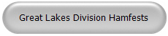
Just click to get to the latest hamfest updates.


Is your club website listed on the Great Lakes Division website?

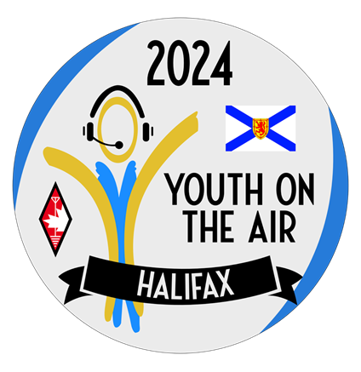
YOTA Americas Upcoming Camp
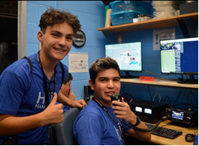
In memory of Bob Heil, K9EID, the Youth on the Air Camp shack will be named the Bob Heil, K9EID Memorial YOTA Camp Amateur Radio Shack. Operating times for the camp are also being announced.
INDIANAPOLIS, Indiana, June 28th, 2024—In memory of Bob Heil, K9EID, the Youth on the Air shack will be named the Bob Heil, K9EID Memorial YOTA Camp Amateur Radio Shack. Bob Heil, along with the company he founded - Heil Sound, have supported Youth on the Air from the very beginning.

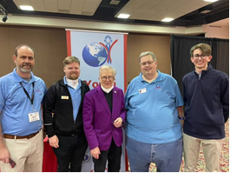
Regardless of what was needed for camp, Bob would never fail to send what we needed and more to use at camp. Youth on the Air will forever remember his legacy in the amateur radio community and his support for YOTA in the Americas.
Activation of the VE1YOTA callsign from the camp in Halifax, Nova Scotia will begin the evening of Sunday, July 7th and conclude on Friday, July 12th. Campers will operate the memorial station as they finish projects, between sessions, and during free time.
In addition, campers will have the opportunity to operate the Bob Heil Memorial Shack during the following dedicated times:

- Sunday, July 7th: 0000Z to 0200Z
- Monday, July 8th; Wednesday, July 10th; and Thursday, July 11th: 2100Z to 0200Z

Campers will also have dedicated satellite operating times on Wednesday, July 10th from 1230Z to 1500Z.
Campers will be able to ask questions of an astronaut on the International Space Station during the camp as well. The ARISS contact is currently scheduled to take place on Tuesday, July 9th at 1430Z or a backup of Wednesday, July 10th at 1345Z.
A highlight of the camp will be a day of POTA activations, one of which will be on an island with a lighthouse - which according to the Parks on the Air website has only very recently been activated once previously. Georges Island National Historic Site POTA ID CA-4838 & ILLW ID CA0053 will be active on Thursday, July 11 from 1300Z to 1800Z. Activations will simultaneously take place from the Maritime Museum of the Atlantic, the HMCS Sackville POTA ID CA-5821, and possibly the C.S.S. Acadia POTA ID CA-5432.
The opening and closing ceremonies and the International Space Station contact (ARISS) will be streamed live on the Youth on the Air YouTube channel. The opening ceremony is Sunday, July 7th from 2000Z to 2200Z. The closing ceremony is Friday, July 12th from 1300Z to 1400Z. The channel will also feature a daily highlight video spotlighting the activities of the previous day.
For details about the camp, download the brochure and camp handbook on youthontheair.org/halifax2024/
For additional information, please contact YOTA Americas Public Relations at pr@youthontheair.org or Camp Director Neil Rapp, WB9VPG at director@youthontheair.org.

#####

