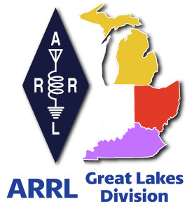
Radio Waves
^{The} Great Lakes Division
Monthly Journal

August 2024

What’s inside…

Survey | Derby Hats
NTS Letter  Youth Licensing Grant Program | Student Membership  2024 Division Hamfests

Scott’s Stuff
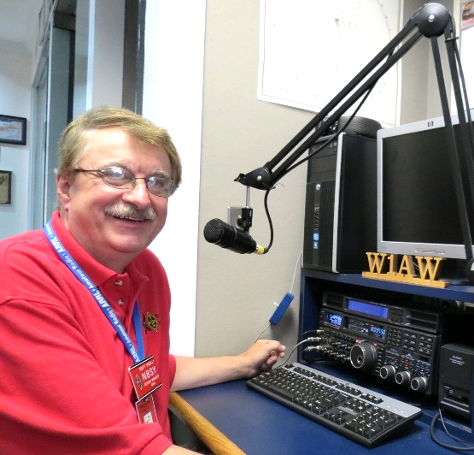
Hi Gang,

Well, it’s finally here, the Dog Days of Summer… Hot, muggy and just plain miserable out. Boy, am I glad! Could you imagine having to shovel snow in this heat???

July was a busy month for me. I didn’t get to go to as many hamfests as were scheduled due to the Board meeting, but I did have a lot of fun visiting with many of you at your local club meetings. I do want to say the Board meeting this time around was soooo much different. We got a lot of business done in a short time and I have to say I was so impressed that we all worked together as a team this time. Yes, this Board can do the work it was elected to do and even do it in good time. We finished our work on Friday late so there was no need for a Saturday meeting. This was the first time in more than 20 years that this has happened this way.
I do feel that everyone on the Board came with the idea that they wanted to work together as a team and get things done. A number of times throughout the day something would come up that someone felt wasn’t quite right and we would huddle together and collaboratively work out the issues to come to an agreement that we all could live with. This is the way it should always be. Working together as a team.

As I’m sure most of you have already read that the Board unanimously accepted a report establishing a 3-year strategy for ARRL. This is a huge step forward in getting this big ship (ARRL) turning around and implementing a plan to move us forward.

The Board also unanimously voted to establish the ARRL Information Technology Advisory Committee (ITAC), acknowledging the importance of providing information technology-based services to ARRL members, and to improve and protect ARRL systems. The ITAC will engage experts in the field of IT to help oversee the development, operations, and evolution of the ARRL IT system infrastructure and applications.

And, to make sure that LoTW wasn’t left behind, the Board unanimously voted to reassign the Logbook of The World® (LoTW) Maintenance Committee to the newly established Information Technology Advisory Committee (ITAC). ITAC will support the Maintenance Committee’s responsibilities with LoTW development, including technical changes and future upgrades to the system.

On the matter of Advocacy. The Board unanimously voted to recommend and authorized the creation of additional publications, including books and online resources, and products, such as antenna kits, to help expand ARRL's commitment to help hams who are faced with limits on station building capabilities due to space limitations and/or limited resources.

Governance, the Board unanimously voted to request that the President appoint a study group to review the current structure of ARRL governance and the Field Organization and suggest changes that would improve the organization and better support the membership. Now, I want to set something straight here… Yes, a study group will be looking at everything ARRL to see if it is operating at its optimum level. This doesn’t mean that they will be looking to cut any positions, they are assigned to review and report. It will be up to the Board later to determine what actions, if any, will be taken.

The Director’s Workbook. The Board unanimously voted to request that the President establish an ad hoc committee to review the ARRL Director’s Workbook and establish an annual review process to keep the document up to date with Board practice and procedure.

Trademarks, the Board unanimously voted to review ARRL’s trademarks and the completion of related registrations and trademark renewals. The Board requested the CEO to provide a report at its next meeting consisting of efforts and actions taken during 2024 to identify, remedy, and protect the use of its trademarks by other parties.

Finally, the Board approved expanding the policy for recording roll call votes to being required for any pending motions pertaining to ARRL governance documents. This was the only motion that wasn’t unanimously approved. This motion actually makes it mandatory for any governess motions (By-law or Constitutional changes) to be by roll call vote only, without the need for 5 Directors voting in favor of a roll call vote. YES, you read that right, it makes it easier (more transparent) to get a roll call vote on a motion of such importance! I voted for it. I feel that the membership needs to know how their Director voted on these kinds of motions that can and most generally do affect the membership.

Other actions that the Board unanimously passed were for the following awards.

- Edward Menasian, N8LPQ of Toledo, Ohio is the 2024 recipient of the Technical Service Award

- Ed Kees Van Oosbree, W0AAE of Maple Grove, Minesota is the 2024 recipient of the Hiram Percy Maxim Award

- Hans Summer, G0UPL, of Sussex England is the recipient of the 2024 ARRL Technical Innovation Award

As you can see, a lot of work was done at this Board meeting. All but one motion was unanimous. I don’t know if that set a record or not, but I do know that it does indicate a change in attitude that the Board must start working together, collaborate more so that we can move forward and regain the trust of the membership.

What is listed here is just a short synopsis of all the discussions and work that was put into each of these motions. Many hours of thought and collaboration go into each and every motion before it is introduced to the Board. Yes, several of them will have substantial costs to ARRL, but keeping our infrastructure safe and free of bad actors is priority one. We still have many of our tools that aren’t working yet, and they may have to be rebuilt over time, but as we do, this new path that the Board has moved toward should keep us safe from anything like what we have experienced in the past several months from ever happening again.
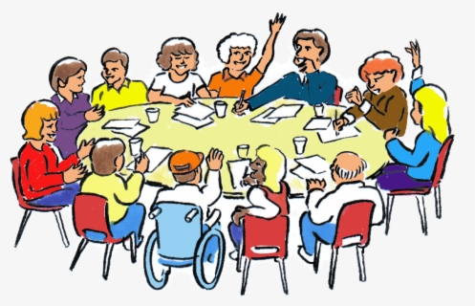
Survey… There is a new survey posted. Survey
GLD-6 is on the website and waiting for input from you.

I really would like to hear your feedback. Please take just a couple of minutes of your time and take the survey.


Here’s a link to it…

Got a question that you think should be asked? Let me know… n8sy@n8sy.com

That’s going to do it from me this time around. Hope to catch ya’ on the air, at a club meeting or a hamfest soon!!

73,

Scott Yonally, N8SY
Director - Great Lakes Division
n8sy@arrl.org


Will your club be remembered for its derby hats?

Roy, W8REH
Vice Director - Great Lakes Division
w8reh@arrl.org

If you have been paying attention, you know I strongly believe our clubs will be the force that propels our hobby into the future. A good non-ham friend of mine came across some very interesting history. Knowing my dedication to the hobby she knew I would be interested in some of her family stories.
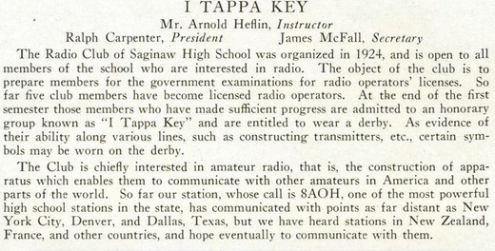
She recalled during her childhood a cousin of her grandmother, a WWII Navy veteran and an extremely dedicated amateur radio operator, often attended their family summer gatherings in Michigan. She became curious and unleashed her genealogy profession on researching some of the family radio activities. Of particular interest was some radio club pictures from the 1926 Saginaw Michigan High School year book. Besides the photo of the club station 8AOH, the text published with it I found most enlightening. Does your club offer pins for your derby hat?
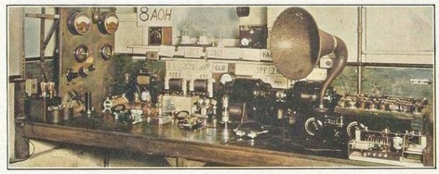

I’m not sure if there is a YAZO in there, but it looks expensive. Think about how your club will be remembered. Not much has changed in 100 years, has it?

Proud wearing of the derby hat and pins:
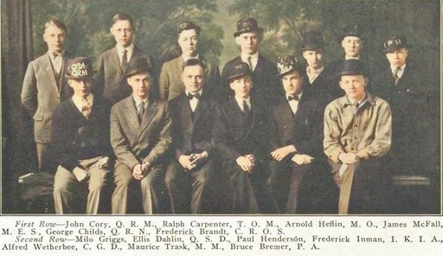

“The NTS Letter”
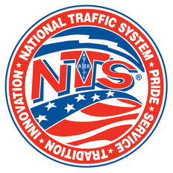
Did you know that there is a monthly newsletter just for folks interested in NTS? There is, and it is edited by Marcia Forde, KW1U, who is a veteran traffic handler and serves as the Section Traffic Manager for the ARRL Eastern and Western Massachusetts and Rhode Island Sections.

The NTS is a network that allows for rapid movement of messages, referred to as "traffic," from origin to destination, and for training amateur operators to handle written traffic and to participate in directed nets. The network consists of the layering and sequencing of both voice and CW traffic nets, as well as a digital system that operates 24/7. This nationwide system operates 365 days a year, generally relaying routine message traffic for training purposes and for maintaining readiness if called upon in an emergency. If called upon, these operators stand ready to assist emergency communications personnel and served-agency partners in relaying welfare and other messages. It is the modern continuation of the historic "radio relay" from ARRL's founding in 1914.

The NTS Letter is published monthly and is free of charge to ARRL members. Members can subscribe at arrl.org/opt-in-out by selecting "edit" to view all of their subscription preferences (members need to be logged in to their ARRL website account to do this).

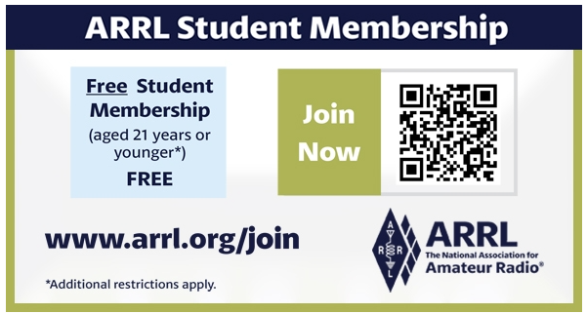

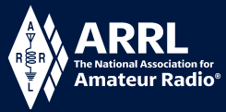
Youth Licensing Grant Program

Here’s one of those little talked about programs to help our youth. I’ll be that many of you didn’t even know about the ARRL Youth Licensing Grant Program. It started in 2022 and covers the one-time FCC $35 application fee for new license candidates younger than 18-years old for tests administered under the ARRL Volunteer Examiner Coordinator (ARRL VEC) program. Yes, the ARRL will cover the $35 FCC fee for youth who are getting into Amateur Radio
Additionally, candidates younger than 18-years old would pay a reduced exam session fee of $5 to the ARRL VEC VE team at the time of the exam. The $5 fee is for all candidates under the age of 18 regardless of the exam level taken. Proof of under 18 status is required at the session (what to bring to an exam session).

Both of these programs are sponsored by YOUR ARRL.

Candidates younger than 18-years old will pay a reduced exam session fee of $5 to the ARRL VEC VE team when taking an exam. Proper identification must be presented to and verified by the team, per the procedures for all exam candidates (what to bring to an exam session). The $5 fee is for all candidates under the age of 18 regardless of the exam level taken. Want more information about these programs? Licensing Grant Program

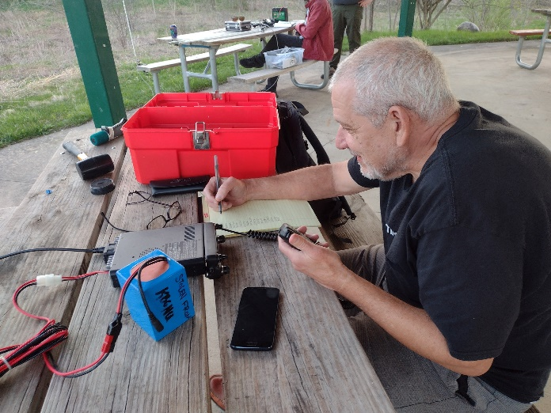
Wanted… Your Photo’s

Have you seen the Photo Gallery on the Great Lakes Division website? If you haven’t you really need to, your face may be among the many already posted there.



I’m always looking for more pictures to use in the Gallery, newsletter, banner and video display. Please, send me your pictures!!! Send them to: n8sy@n8sy.com

2024 Great Lakes Division Hamfests
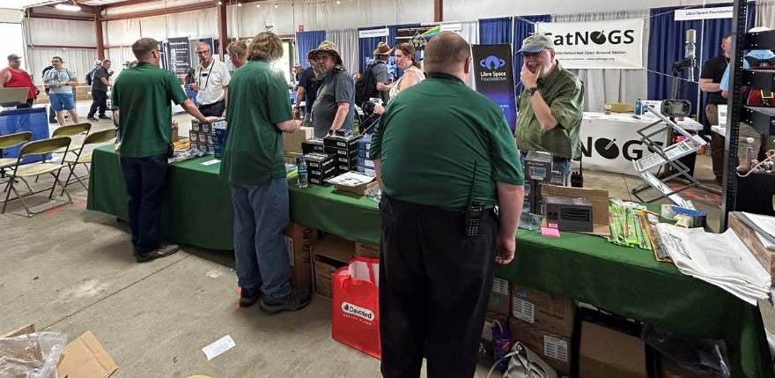
Here in the Great Lakes Division, we have over 50 hamfests a year, including the largest one in the country, Hamvention. This year Hamvention will also be the ARRL’s National Convention as well, which means that there will be some very special things happening there.

So, if you haven’t started planning your hamfest schedule yet, you really need to start now.

Please post this listing in your club's newsletter and announce the swaps on your local nets. Talk them up. Let's fully support all of our hamfests in every way possible. It means success for everyone. Be sure to invite your ARRL Officials as soon as your date is set.
If your ARRL Affiliated club plans to request Hamfest Sanctioning, you should make that request well in advance of the scheduled Hamfest date, as this allows adequate time for QST Listings. QST announcements require a 3-month lead time. To be fair to our division’s clubs, the Great Lakes Division policy now has 2 requirements for any ARRL Sanctioning.

Any club requesting ARRL sanctioning within the Great Lakes Division must now be an ARRL Affiliated Club with a maximum of two hamfests/swaps in any given calendar year, and they must be at least four months apart.

08/03/2024 - 2024 Columbus Hamfest  Location: Grove City, OH  Type: ARRL Hamfest  Sponsor: Aladdin Shrine Audio Unit  Website: http://www.columbushamfest.com  Learn More | 08/03/2024 - U.P Hamfest  Location: Rapid River, MI  Type: ARRL Hamfest  Sponsor: Delta County Amateur Radio Society  Learn More
08/10/2024 - Cincinnati Hamfest  Location: Owensville, OH  Type: ARRL Hamfest  Sponsor: Milford ARC  Website: https://CincinnatiHamfest.org  Learn More | 08/17/2024 – Portsmouth Hamfest  Location: New Boston, OH  Type: ARRL Hamfest  Sponsor: Portsmouth ARC  Website: https://cincinnatihamfest.org/  Learn More

08/18/2024 - Warren Hamfest  Location: Cortland, OH  Type: ARRL Hamfest  Sponsor: Warren Amateur Radio Association  Website: https://www.w8vtd.com/  Learn More | 09/01/2024 – Athens Summer Trunkfest  Location: Athens, OH  Type: ARRL Hamfest  Sponsor: Athens ARA  Website: https://www.ac-ara.org/  Learn More
09/07/2024 - Branch County Fall Trunk Swap  Location: Coldwater, MI  Type: ARRL Hamfest  Sponsor: Branch County Amateur Radio Club  Website: http://branchcountyarc.org  Learn More | 09/07/2024 - Grand Rapids Area Hamfest  Location: Wyoming, MI  Type: ARRL Hamfest  Sponsor: Grand Rapids ARA  Website: https://w8dc.org/2024/02/05/grand-rapids-area-hamfest/  Learn More
09/07/2024 - Greater Louisville Hamfest 2024  Location: Shepherdsville, KY  Type: ARRL Hamfest  Sponsor: Greater Louisville Hamfest Association  Website: http://LouisvilleHamfest.com  Learn More | 09/08/2024 - Findlay Hamfest  Location: Findlay, OH  Type: ARRL Hamfest  Sponsor: Findlay Radio Club  Website: http://w8ft.org  Learn More
09/14/2024 - GMARC Trunk Swap at the PPG  Location: Shelby Twp., MI  Type: ARRL Hamfest  Sponsor: General Motors Amateur Radio Club (GMARC)  Website: http://GMARC.org  Learn More | 09/14/2024 - OAARS Ham Swap  Location: West Branch, MI  Type: ARRL Hamfest  Sponsor: Ogemaw Arenac Amateur Radio Society  Website: http://www.k8oar.club  Learn More
09/14/2024 - Richmond, Kentucky, Hamfest  Location: Richmond, KY  Type: ARRL Hamfest  Sponsor: Central KY ARS (CKARS)  Website: http://ckars.org  Learn More | 09/15/2024 - Adrian Hamfest  Location: Adrian, MI  Type: ARRL Hamfest  Sponsor: AARC  Website: http://w8tqe.com  Learn More
09/22/2024 - Cleveland Hamfest  Location: Berea, OH  Type: ARRL Hamfest  Sponsor: Hamfest Association of Cleveland  Website: https://www.hac.org  Learn More | 09/28/2024 - Paintsville KY4ARC Hamfest  Location: Paintsville, KY  Type: ARRL Hamfest  Sponsor: KY4ARC  Website: http://ky4arc.com  Learn More

09/28/2024 - Top of Michigan Amateur Radio Club & Thunder Bay Amateur Radio Club Hamfest  Location: Gaylord, MI  Type: ARRL Hamfest  Sponsor: Top of Michigan ARC Gaylord and Thunder Bay ARC Alpena  Website: http://www.nm8rc.org  Learn More | 10/05/2024 - Central Kentucky Hamfest  Location: Lexington, KY  Type: ARRL Hamfest  Sponsor: Bluegrass Amateur Radio Society  Website: http://www.bluegrassars.org  Learn More
10/05/2024 - Kalamazoo Hamfest  Location: Kalamazoo, MI  Type: ARRL Hamfest  Sponsor: Kalamazoo Amateur Radio Club (KARC), Southwest Michigan Amateur Radio Team (SMART)  Website: http://www.kalamazoohamfest.org/  Learn More | 10/05/2024 - Northwest Ohio ARC Hamfest  Location: Lima, OH  Type: ARRL Hamfest  Sponsor: Northwest Ohio Amateur Radio Club  Website: http://www.nwoarc.com  Learn More
10/05/2024 - Scioto Valley ARC Hamfest  Location: Piketon, OH  Type: ARRL Hamfest  Sponsor: Scioto Valley Amateur Radio Club  Learn More | 10/06/2024 - U.S.E.C.A. Hamfest  Location: St. Clair Shores, MI  Type: ARRL Hamfest  Sponsor: U.S.E.C.A.  Website: http://USECAARC.ORG  Learn More
10/12/2024 - Muskegon Color Tour Hamfest  Location: Muskegon, MI  Type: ARRL Hamfest  Sponsor: Muskegon County Emergency Communication Services, Inc.  Website: http://www.mcecs.net/hamfest  Learn More | 10/26/2024 - Hazard Hamfest  Location: Hazard, KY  Type: ARRL Hamfest  Sponsor: Kentucky Mountains Amateur Radio Club  Learn More
10/27/2024 - 2024 MARC Hamfest at MAPS  Location: N. Canton, OH  Type: ARRL Hamfest  Sponsor: Massillon Amateur Radio Club  Website: https://www.w8np.net  Learn More | 12/01/2024 - LCARC Amateur Radio Swap/Hamfest  Location: Troy, MI  Type: ARRL Hamfest  Sponsor: L'Anse Creuse Amateur Radio Club  Website: http://www.n8lc.org  Learn More
12/07/2024 - Winter Hamfest
Location: Archbold, OH
Type: ARRL Hamfest
Sponsor: FCARC
Website: https://k8bxq.org/hamfest
Learn More

You can always find the latest updates for upcoming hamfests on the Great Lakes Division website.

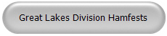
Just click to get to the latest hamfest updates.

Is your club website listed on the Great Lakes Division website?






