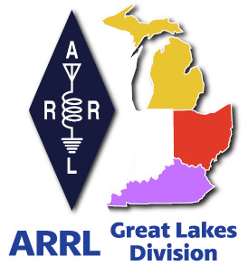
Radio Waves
^{The} Great Lakes Division
Monthly Journal

September 2024

What’s inside…

Silent Key  Youth Licensing Grant Program | Student Membership  2024 Division Hamfests

Scott’s Stuff
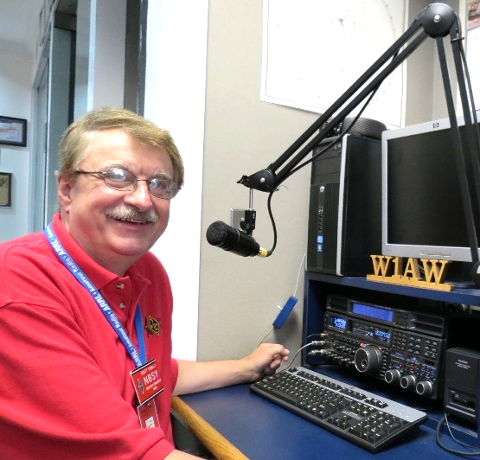
Hi Gang,

Wow… Welcome to September! I hope that you’ve all had a great Labor Day weekend!

When I wrote to you all last month, I had no idea of just how hot, hot could get until this past week. It’s been crazy hot for sure. I hope that all of you had a safe place to stay cool during this heat wave.

August turned out to be another crazy month for sure. It seems like everything that could break down around the house has. I’ve been the fix-it man now for more projects than I care to think about.

And, to top it all off, I had to bring down all of my antennas so that I can get one more project ticked off the list of things needing to be done, tree trimming. No, I’m not climbing trees, I am having a tree service come in and do that. Most of the trees around my yard are over 60 foot tall and I’m not that agile anymore.

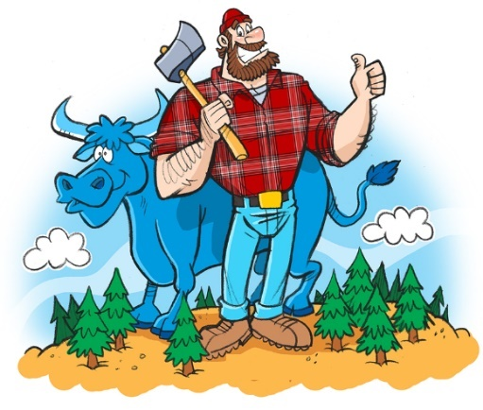
I let someone much younger and better physically fit do the Paul Bunion stuff now. I’ve got several trees coming down to make better clearance for my vertical. I have another couple of them coming down to give me more room for my dipoles as well. All in all, I should have a better signal when they get through and I get all the antenna’s back up. Now I will say this, the trees aren’t coming down just for ham radio, they are coming down to keep my house roof from needing to be replaced sooner than it should. Several of these trees are hanging right over the roof of the house and making a mess of the roof and my gutters. So, it’s time for them to go.

I’ve also been busy with many meetings and hamfests that we have around the Division. I’ll be in Kentucky and Ohio this coming weekend for hamfests at Shepherdsville and Findlay as well as I’ll most likely pop in on a couple of club meetings too. Then it’s off to Newington to help with training the newest Section Managers. I’ve been very privileged to be able to help out with their training these past number of years and it’s a lot of fun for me to be able to show them a lot of things that they are responsible for and how to make their job a little easier and definitely more fun for sure.

I’ve been really surprised at not only the number of folks responding to this latest survey. It’s really great hearing back from you just how you feel about things. I really appreciate your responses and I’m actually surprised by some of the results. The final results are posted in this newsletter.

I’ve received a number of new requests from clubs to be listed on the “Links” club page. Is your club listed? If not, send the URL to me and I’ll get it listed. n8sy@n8sy.com

That’s going to do it from me this time around. Hope to catch ya’ on the air, at a club meeting or a hamfest soon!!

73,

Scott Yonally, N8SY
Director - Great Lakes Division
n8sy@arrl.org


Who is going to be the next Silent Key?

Avid CW operator or not, tradition has identified a deceased ham as a “silent key”. A few months ago, losses of some very close ham friends, members of two clubs which clearly defined my years in ham radio, presented some seemingly ironic observations and made me ponder “Silent Key” reality. John Hull, W8RRJ, the godfather of all things repeater for Central Ohio and Paul Gehringer, WB8ZZR, the focal point and connection of Amateur Radio to the Wilmington National Weather Service since its creation, became Silent Keys. Ironic in that as Silent Keys now, the rolls they were well known for did not connect much to CW at all. In fact neither had much of a propensity to that aspect of the hobby.

In reviewing the sea of repeater and recording studio artifacts in W8RRJ’s basement with family members, imagine my surprise to find a somewhat uncommon CW artifact, a Zephyr model Vibroplex Bug. It was just sitting on a shelf, clearly protected from all around it. A similar surprise was had at WB8ZZR’s funeral where on display among QSL cards, photos and other items his family found they identified with his hobby, was a keyer paddle. In a lengthy phone conversation I had with Paul just a few weeks before his death, he had a detailed this keyer paddle. Although I had never seen it before, from Paul’s description it was clearly the hand crafted paddle we had discussed at length made by an Elmer (traditional ham term for mentor) we had in common some 50 to 60 years earlier.

Regardless of our individual hobby passions and the apparent recent renewed interest in the CW art, we all will become “Silent Keys” at some point. Researching each of the above mentioned artifacts, lead me down some much unexpected paths.
W8RRJ Vibroplex Zephyr Bug
K8SYS Homemade Paddle
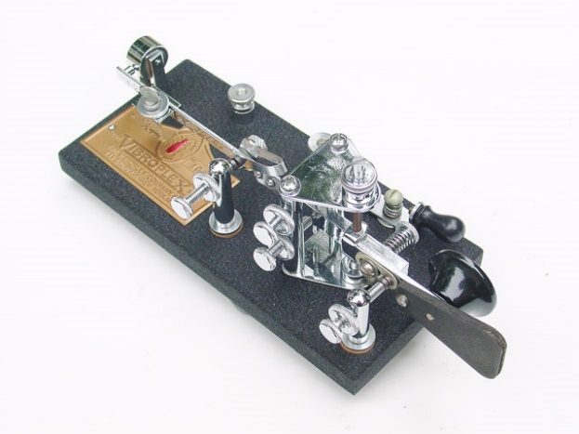
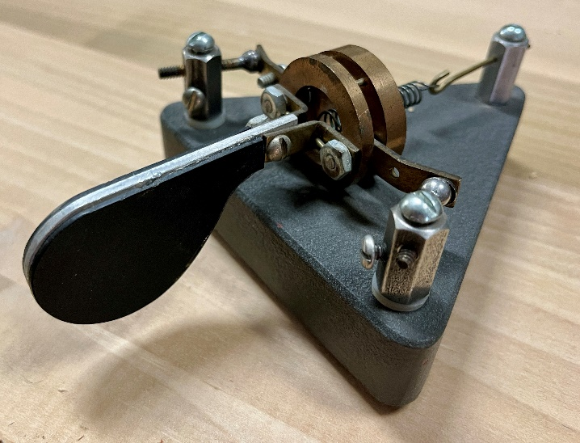
Unable to recall the call sign of the Elmer Paul and I had in common, made the loss of Paul’s knowledge begin to scare me. Luckily I found another individual who reminded me, Mac K8SYS was the SK (1995) I could not remember. How fortunate we are that the April article Paul and I did on the evolution of the central and southern Ohio weather spotting group was completed when we did. Nearly all the material in that article came from Paul.

In stark contrast, the Bug research revealed a treasure chest of knowledge, well preserved in a 130 page document by Tom French W1IMQ and a Collectors Document by Randy Cole, KN6W. The knowledge and years of work put into these documents had to have been a true labor of love.

By 1904 or 1905 (much before everyday radio became practical) about 300,000 Vibroplexes were made. Glass Arm, a term used in the early 1900’s to describe a common repetitive motion disorder in baseball players was adopted to describe a common telegraph operator affliction and was the catalyst for the invention of the Bug (semi-automatic key). Telegraph Operators from the earlier wireline telegraph days became critical during WWI for radio communication. The term Bug was originally used to describe the poor sending ability of those just learning how to master this new mechanical device.

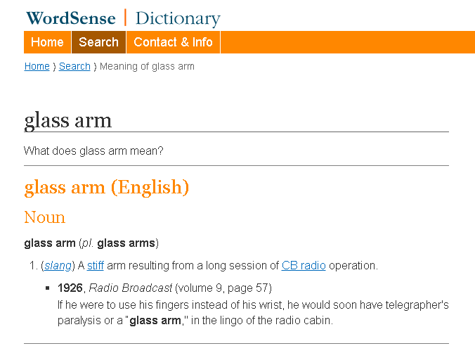
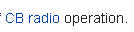
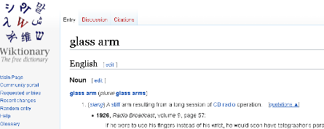
Be aware, don’t believe everything you find on the internet or social media. In researching the early 1900’s term “glass arm”, I found the following reference very humorous, since CB Radio didn’t come into existence for another 50 years. Making it even funnier, I found similar CB references in multiple places. Amazing what social media minds can do to the truth sometimes.

Last month I expressed a challenge to you, “What will your club be remembered for?” Dealing with the recent Silent Keys in my life raised the question to me, what will us as individuals be remembered for? Certainly the things and documents we each leave for others will provide some legacy for a while. Will our individual DXCC status or many awards perpetuate the hobby for the generations acquiring the space we have loved and occupied? Understand that the “usefulness” of our spectrum playground can be nearly infinite.

Not just to us as Amateur Radio operators in ham community, but also to other interests who would like to acquire our privileges in this political, capitalist society we live in. How we educate and attract not just those interested in the traditional aspects of Amateur Radio, but also how the rest of the world views us will set the direction for the future. If we can learn how to stop whining and better work together we can make our tiny piece of the spectrum a fun, valued, attractive place for all interested in science and technology; young, old or in the middle. Your innovative contributions to our clubs, groups and organizations will define the future of our hobby more than anything we do individually.

It should be no surprise I don’t know the answer to the question posed in my opening title. I do know that if we each work hard together, we can prevent Amateur Radio from becoming “SK”.

73,

Roy Hook, W8REH
Vice Director
Great Lakes Division
w8reh@arrl.org

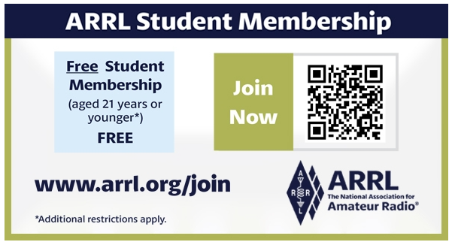

Estate Planning for Hams (What happens to all your stuff?)

August is National Make-a-Will month. Some estimates show that nearly two-thirds of Americans don't have a plan. For some, it's procrastination. Others don't know where to start. “So many times we hear from the family of a Silent Key who are overwhelmed with what to do with a lifetime worth of amateur radio gear,” said ARRL Director of Development Kevin Beal, K8EAL. “Simply thinking through what needs to be done ahead of time can prevent the stress on our loved ones after we are gone.”

ARRL this week held a webinar, hosted by Beal and Dino Papas, KLØS, to discuss the first steps of planning. “It is something that, unfortunately, doesn’t get a lot of attention. The bottom-line up front is, ‘what happens to all our beloved ham gear when that inevitable day comes along that we become a Silent Key?’... Unfortunately, that day may arrive unexpectedly – so we need to prepare ahead of time to make it as simple as possible for our families,” said Papas.
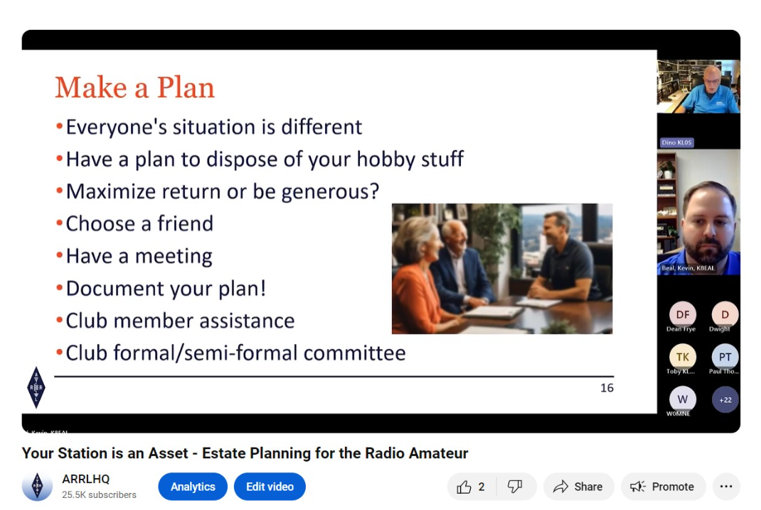
On the ARRLHQ YouTube channel, you can see a replay of the 52-minute presentation, along with the question-and-answer section at the end.

“Your station is an asset, just like anything else you’ve built and put resources into. Deciding now what happens when you become a Silent Key can help solidify your legacy to ham radio,” said Beal. The ARRL Legacy Circle recognizes the generosity of individuals who have planned support for ARRL through wills, trusts, life insurance gifts, and other ways. The ARRL Legacy Circle ensures that ARRL and amateur radio will continue to thrive for generations to come.

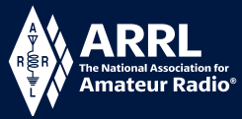
Youth Licensing Grant Program

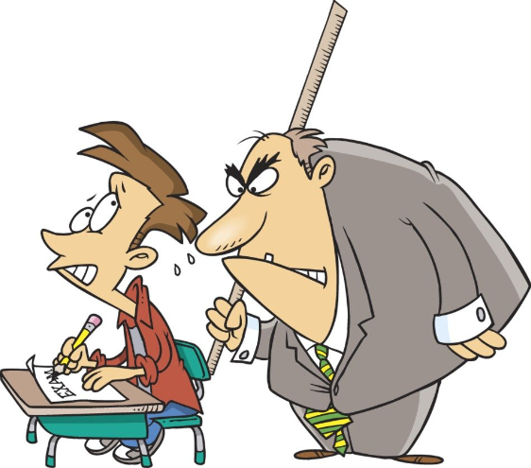
Here’s one of those little talked about programs to help our youth. I’ll be that many of you didn’t even know about the ARRL Youth Licensing Grant Program. It started in 2022 and covers the one-time FCC $35 application fee for new license candidates younger than 18-years old for tests administered under the ARRL Volunteer Examiner Coordinator (ARRL VEC) program. Yes, the ARRL will cover the $35 FCC fee for youth who are getting into Amateur Radio
Additionally, candidates younger than 18-years old would pay a reduced exam session fee of $5 to the ARRL VEC VE team at the time of the exam. The $5 fee is for all candidates under the age of 18 regardless of the exam level taken. Proof of under 18 status is required at the session (what to bring to an exam session).

Both of these programs are sponsored by YOUR ARRL.

Candidates younger than 18-years old will pay a reduced exam session fee of $5 to the ARRL VEC VE team when taking an exam. Proper identification must be presented to and verified by the team, per the procedures for all exam candidates (what to bring to an exam session). The $5 fee is for all candidates under the age of 18 regardless of the exam level taken. Want more information about these programs? Licensing Grant Program

ARRL Club Grants Will Be Awarded in November

Applications for the 2024 ARRL Club Grants program are now being reviewed (the application period closed July 26, 2024).

ARRL Field Services Manager Mike Walters, W8ZY, said 110 grant applications have been received and the awards will be announced in late November. “Grants are available up to $25,000 and emphasis is given to projects that are transformative in nature,” said Walters.

Examples of projects include but are not limited to getting on the air projects, ham training and skills development through mentoring, STEM and STEAM learning through amateur radio, station resources for use by the ham community, and emergency communications and public service projects that emphasize training.

“Since 2022, $500,000 has been distributed to amateur radio clubs,” said Walters. “With this year’s awards, that total will increase to $1,000,000 awarded.

The ARRL Club Grants are administered by The ARRL Foundation.

Results from GLD-6 Survey:

I want to thank each and every one of you for taking the time to complete the survey this past month. It’s really important to me to know just how you feel about things. We had a total of 385 responses.

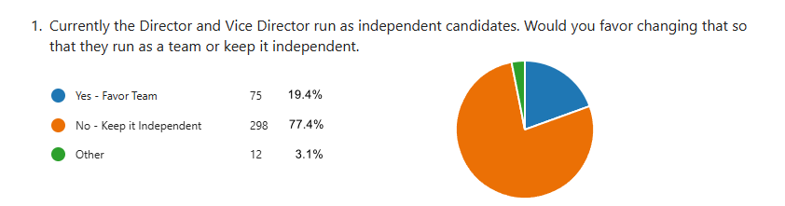
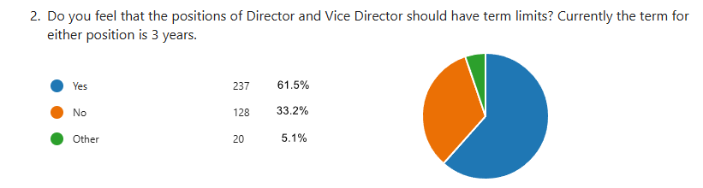
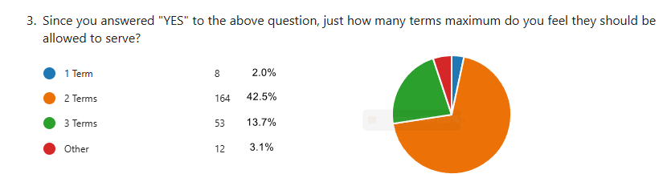

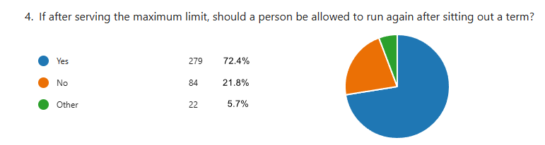

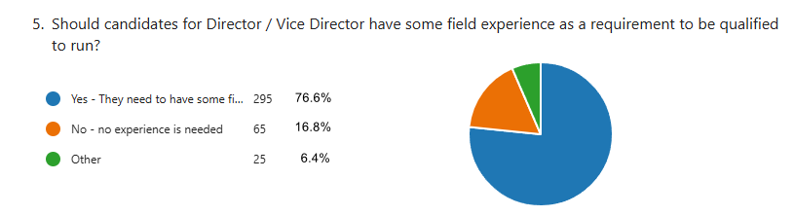

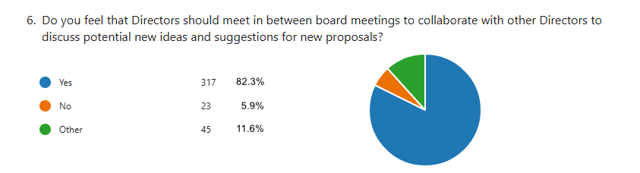

2024 Great Lakes Division Hamfests
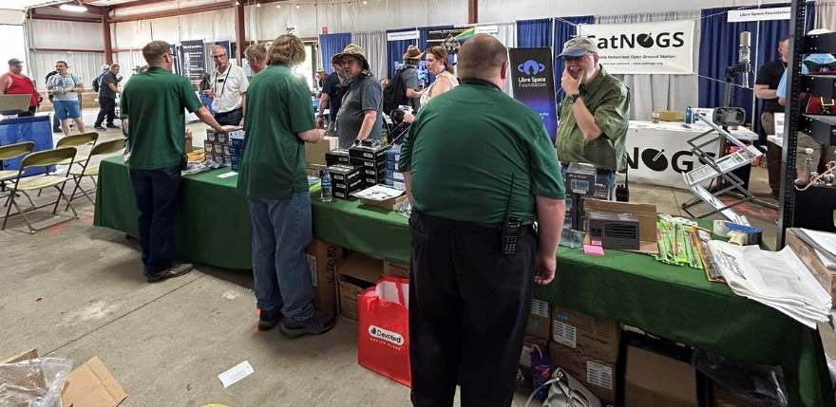
Here in the Great Lakes Division, we have over 50 hamfests a year, including the largest one in the country, Hamvention. This year Hamvention will also be the ARRL’s National Convention as well, which means that there will be some very special things happening there.

So, if you haven’t started planning your hamfest schedule yet, you really need to start now.

Please post this listing in your club's newsletter and announce the swaps on your local nets. Talk them up. Let's fully support all of our hamfests in every way possible. It means success for everyone. Be sure to invite your ARRL Officials as soon as your date is set.
If your ARRL Affiliated club plans to request Hamfest Sanctioning, you should make that request well in advance of the scheduled Hamfest date, as this allows adequate time for QST Listings. QST announcements require a 3-month lead time. To be fair to our division’s clubs, the Great Lakes Division policy now has 2 requirements for any ARRL Sanctioning.

Any club requesting ARRL sanctioning within the Great Lakes Division must now be an ARRL Affiliated Club with a maximum of two hamfests/swaps in any given calendar year, and they must be at least four months apart.

NOTE:… Since the cyber-attack at headquarters, they have been unable to process new requests for hamfests. If you have completed the on-line form for an upcoming hamfest and have yet to see it listed, please contact Steve Ewald, WV1X at 860-594-0265 and let him know. He will manually enter it into the system.

09/07/2024 - Branch County Fall Trunk Swap  Location: Coldwater, MI  Type: ARRL Hamfest  Sponsor: Branch County Amateur Radio Club  Website: http://branchcountyarc.org  Learn More | 09/07/2024 - Grand Rapids Area Hamfest  Location: Wyoming, MI  Type: ARRL Hamfest  Sponsor: Grand Rapids ARA  Website: https://w8dc.org/2024/02/05/grand-rapids-area-hamfest/  Learn More
09/07/2024 - Greater Louisville Hamfest 2024  Location: Shepherdsville, KY  Type: ARRL Hamfest  Sponsor: Greater Louisville Hamfest Association  Website: http://LouisvilleHamfest.com  Learn More | 09/08/2024 - Findlay Hamfest  Location: Findlay, OH  Type: ARRL Hamfest  Sponsor: Findlay Radio Club  Website: http://w8ft.org  Learn More
09/14/2024 - GMARC Trunk Swap at the PPG  Location: Shelby Twp., MI  Type: ARRL Hamfest  Sponsor: General Motors Amateur Radio Club (GMARC)  Website: http://GMARC.org  Learn More | 09/14/2024 - OAARS Ham Swap  Location: West Branch, MI  Type: ARRL Hamfest  Sponsor: Ogemaw Arenac Amateur Radio Society  Website: http://www.k8oar.club  Learn More
09/14/2024 - Richmond, Kentucky, Hamfest  Location: Richmond, KY  Type: ARRL Hamfest  Sponsor: Central KY ARS (CKARS)  Website: http://ckars.org  Learn More | 09/15/2024 - Adrian Hamfest  Location: Adrian, MI  Type: ARRL Hamfest  Sponsor: AARC  Website: http://w8tqe.com  Learn More
09/22/2024 - Cleveland Hamfest  Location: Berea, OH  Type: ARRL Hamfest  Sponsor: Hamfest Association of Cleveland  Website: https://www.hac.org  Learn More | 09/28/2024 - Paintsville KY4ARC Hamfest  Location: Paintsville, KY  Type: ARRL Hamfest  Sponsor: KY4ARC  Website: http://ky4arc.com  Learn More
09/28/2024 - Top of Michigan Amateur Radio Club & Thunder Bay Amateur Radio Club Hamfest  Location: Gaylord, MI  Type: ARRL Hamfest  Sponsor: Top of Michigan ARC Gaylord and Thunder Bay ARC Alpena  Website: http://www.nm8rc.org  Learn More | 10/05/2024 - Central Kentucky Hamfest  Cancelled  Location: Lexington, KY  Type: ARRL Hamfest  Sponsor: Bluegrass Amateur Radio Society  Website: http://www.bluegrassars.org  Learn More  Due to issues beyond our control, we lost our venue for the 2024 BARS (Bluegrass Amateur Radio Society) hamfest too late for us to secure a new location.
10/05/2024 - Kalamazoo Hamfest  Location: Kalamazoo, MI  Type: ARRL Hamfest  Sponsor: Kalamazoo Amateur Radio Club (KARC), Southwest Michigan Amateur Radio Team (SMART)  Website: http://www.kalamazoohamfest.org/  Learn More | 10/05/2024 - Northwest Ohio ARC Hamfest  Location: Lima, OH  Type: ARRL Hamfest  Sponsor: Northwest Ohio Amateur Radio Club  Website: http://www.nwoarc.com  Learn More
10/05/2024 - Scioto Valley ARC Hamfest  Location: Piketon, OH  Type: ARRL Hamfest  Sponsor: Scioto Valley Amateur Radio Club  Learn More | 10/06/2024 - U.S.E.C.A. Hamfest  Location: St. Clair Shores, MI  Type: ARRL Hamfest  Sponsor: U.S.E.C.A.  Website: http://USECAARC.ORG  Learn More
10/12/2024 - Muskegon Color Tour Hamfest  Location: Muskegon, MI  Type: ARRL Hamfest  Sponsor: Muskegon County Emergency Communication Services, Inc.  Website: http://mcecs.net/Download/Hamfest2024.pdf  Learn More | 10/26/2024 - Hazard Hamfest  Location: Hazard, KY  Type: ARRL Hamfest  Sponsor: Kentucky Mountains Amateur Radio Club  Learn More
10/27/2024 - 2024 MARC Hamfest at MAPS  Location: N. Canton, OH  Type: ARRL Hamfest  Sponsor: Massillon Amateur Radio Club  Website: https://www.w8np.net  Learn More | 12/01/2024 - LCARC Amateur Radio Swap/Hamfest  Location: Troy, MI  Type: ARRL Hamfest  Sponsor: L'Anse Creuse Amateur Radio Club  Website: http://www.n8lc.org  Learn More
12/07/2024 - Winter Hamfest
Location: Archbold, OH
Type: ARRL Hamfest
Sponsor: FCARC
Website: https://k8bxq.org/hamfest
Learn More

You can always find the latest updates for upcoming hamfests on the Great Lakes Division website.
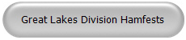
Just click to get to the latest hamfest updates.

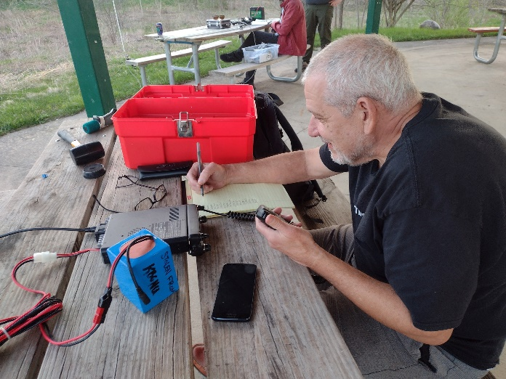
Wanted… Your Photo’s

Have you seen the Photo Gallery on the Great Lakes Division website? If you haven’t you really need to, your face may be among the many already posted there.



I’m always looking for more pictures to use in the Gallery, newsletter, banner and video display. Please, send me your pictures!!! Send them to: n8sy@n8sy.com

Is your club website listed?
