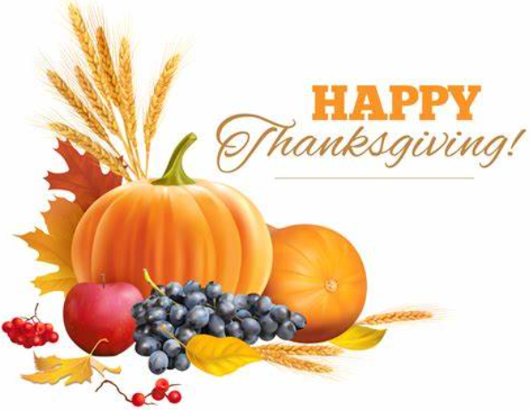
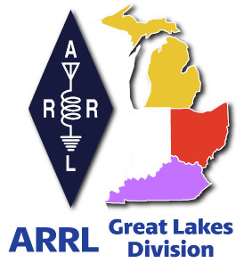
Radio Waves
^{The} Great Lakes Division
Monthly Journal

November 2024

What’s inside…

Scott’s Stuff  Out of Balance  2024 Division Hamfests  Student Membership  Carbon Monoxide | Edmund Fitzgerald  Youth Licensing Grant Program  Survey  Club Links  Estate Planning

DXCC Has Been Returned To Service
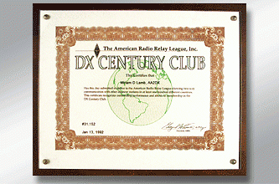
The ARRL DXCC® System has been returned to service, and our staff is again processing applications for credit toward DXCC awards. The queue includes nearly 3,000 award applications submitted via Logbook of The World® (LoTW®) accounts and mailed paper applications. We are processing the backlog as quickly as possible and will provide additional progress updates.

For now, the online DXCC application will remain offline. Any new award applications we receive will experience significant delays as we work through the backlog.

As previously reported, LoTW® was returned to service on Monday, July 1, 2024. Since then, the system has been processing log uploads with little or no processing delay.

We are grateful for your continued patience and understanding as we continue to make progress on the few remaining services that have required additional attention to bring back online.

Daylight Saving Time Ends
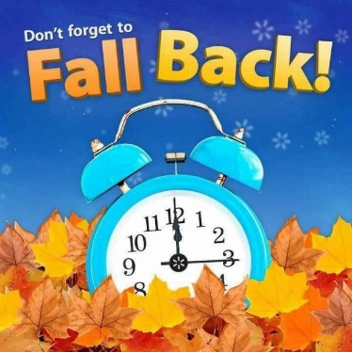
Despite efforts by 19 states to make Daylight Saving Time (DST) permanent, most of the US will “fall back” to standard time on Sunday, November 3, 2024. The DST debate continues, but the time shift stays for now.

A map of time zones and DST in the US.
DST ends in the US and Canada on Sunday, November 3, 2024.

Clocks will be set back 1 hour from 02:00 (2 am) to 01:00 (1 am), local time, on Sunday, November 3, 2024.

DST in the US starts again on Sunday, March 9, 2025.

K8UNS Edmund Fitzgerald Activation November 8-10
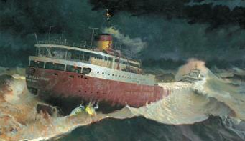

The Edmund Fitzgerald sank during a storm while in route from Superior, WI to Detroit, MI on November 10, 1975. Twenty-nine crew members were lost when the vessel went down in 530 feet of water 17 miles northwest of Whitefish Bay, near the twin cities of Sault Ste. Marie, MI, and Sault Ste. Marie, Ontario, Canada.

As in past years, we are commemorating the sinking of the SS Edmund Fitzgerald with our annual Special Event operations. From November 1-15 LARC Members may sign as W8F Special Event station. QSO partners will be able to confirm and receive our certificate only via an online link (no postal, email, or LoTW).
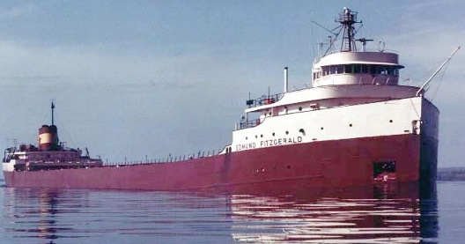
On Saturday November 9, LARC will be on-air as W8F from the Dossin Great Lakes Museum at Belle Isle State Park, from 11am 3:30p. Members are invited to take part helping with antenna raising at 10a and operations until 3:30pm. Besides being the Fitzgerald event, we will also be a POTA (Parks on the Air) activation for this day only.

Find more information on the Club website at: Edmund Fitzgerald Special Event Station – Livonia Amateur Radio Club. If you or your family haven’t been to the Dossin, it’s a great place to visit.

Scott’s Stuff
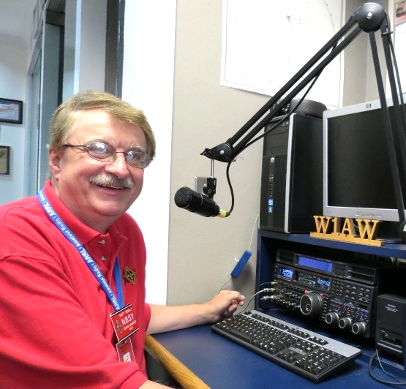
Hi Gang,

Fall has definitely arrived. The leaves have already turned bright colors everywhere and are now clogging up your gutters and making for a lot of work cleaning them up from your expensive newly planted Bermuda Grass at $15 per square foot. The squirrels and chipmunks are making nests in your attic and there is a cold bite in the morning air to cool your coffee down.

Are you ready for what is coming next? Now that Halloween is out of the way let’s start the really festive holidays. Oh, but before we get to shove all that great food into our tummies and gulp down grandpa’s special spiced up egg nogg, we do have the annual returning to "normal" time coming up this Sunday, November 3rd! Yes, you will need to set the clocks back to Standard Time unless of course your clocks are set to UTC. I also want to remind you that Christmas is just 55 days away! Santa already has his naughty and nice list started so I hope you are on his nice list this year!

I want to let you all know about a really great program that can help your club get money. It’s called the Club Commission Program that the ARRL has expanded. Want more details on this? There’s a great new video that was produced for ARRL by Anita Kemmerer, AB1QB in the ARRL Learning Center.

This video is about 21 minutes long and goes step by step through the process of how to get all this setup for your club. If your club isn’t doing this program, why not? It’s FREE money.

Here's the URL... https://learn.arrl.org/courses/52440/video_presentations/272930

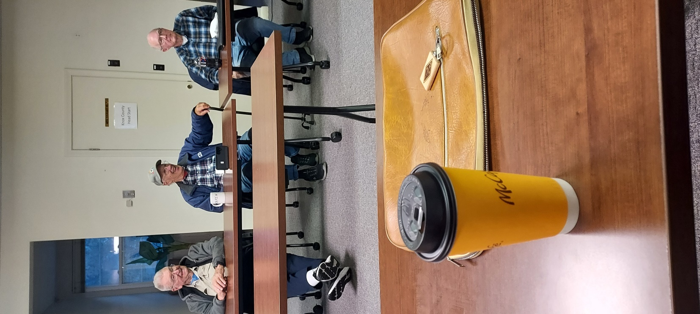
Oh, and just one quick note about this course, you will need to be logged into the Learning Center to reach this video.
.

It's been a blast visiting with all of you at your club meetings, events and hamfests.

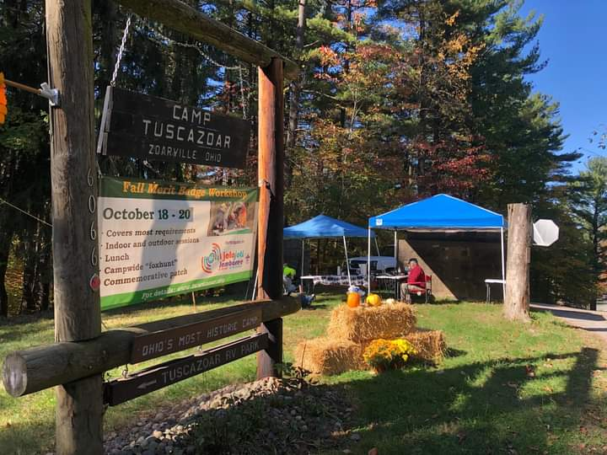
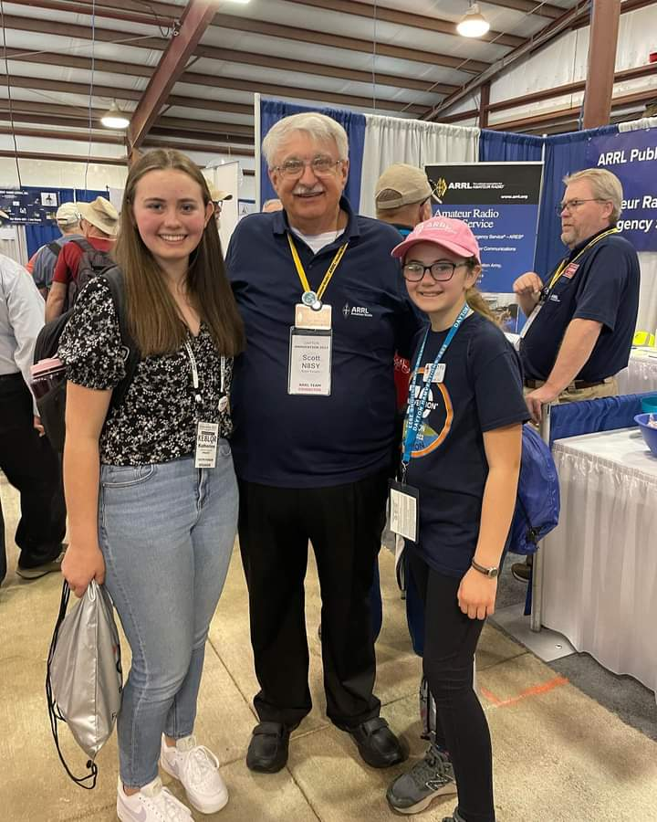
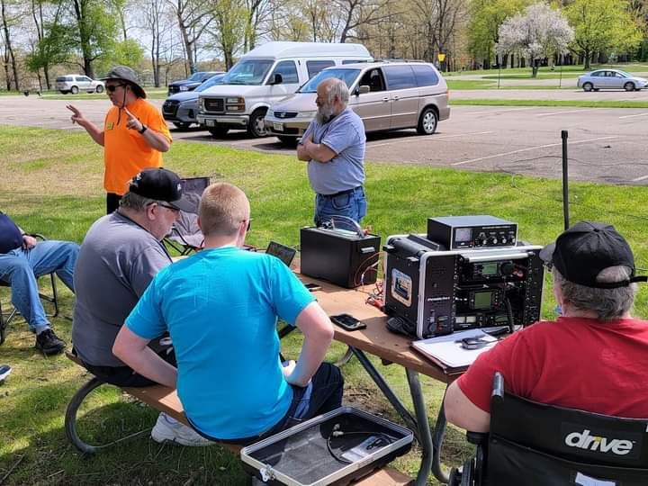

That’s going to do it from me this time around. Hope to catch ya’ on the air, at a club meeting or a hamfest soon!!

73,

Scott Yonally, N8SY
Director - Great Lakes Division
n8sy@arrl.org

New Survey

There’s another new survey on the website GLD-8. I really would like to hear your feedback to the questions asked. Please take just a couple of minutes of your time and take the survey.


Here’s a link to it…

Got a question that you think should be asked? Let me know… n8sy@n8sy.com

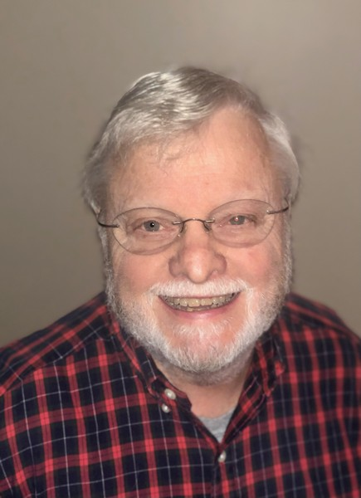
Are We Out Of Balance?
Roy Hook, W8REH

The word amateur does not accurately describe Amateur Radio to me. In my observations Amateur Radio appears to be made up of a multitude of unpaid professionals, in support of our hobby in very individual ways. I have often heard our avocation described as 1000 hobbies within a hobby. We need to more completely describe all the nooks and crannies of our technological world to better convey to the world the welcoming environment we have. How can we balance all this technical diversity without creating polarization?

In my search for some answers to the challenges our clubs, and volunteer associations face, I have looked to some sociology professionals for clues that provide some interesting concepts new to me. I am sure I cannot do their professional knowledge justice, but I want to share some of my interpretations from an everyday ham’s perspective. Sociology is a science that studies human societies, their interactions, behaviors and the processes that preserve and change them. Organizations play an important role in this process.

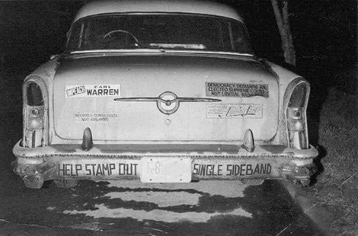
We are dealing with a period of such rapid change (no end in sight), none of us can possibly keep up with everything. Back in the beginning of the ARRL we started with CW, then AM. Later SSB came along and disrupted our happy home.

Today the number of technical pursuits in the hobby seems endless. Imagine the look on the face of the owner of the car shown here if you could have told him his grandchildren would be talking to a space station by ham radio. All of this diversity today creates specialization out of necessity. Exploring some professional sociologists work has convinced me that without more tolerance and cooperation, specialization will continue to create polarization.

Our clubs provide many opportunities, especially to share our specialized interests. Hopefully clubs will want to try to reestablish that sense of co-operation our ham community once had. That was easier in the past when technical opportunities were more limited.

As we learn from history we must be watchful to avoid silo thinking and understand the difference between tradition and ritualism. As we set out on a new future for our avocation, we should explore new ways of ham community social interaction. Let’s not just focus on the soap box of podcasts or blogs that may thrive on a clash and burn mentality. We must support our need for specialization. However, at the same time we must obtain respect, tolerance and cooperation for the vast technology diversity already here and evolving. Any attempt by one specialty to promote itself by attempting to drown out others is counterproductive and should stop. In considering how we might be socially organized in the future, a hub approach vs. club silos might be an alternative. For example a hub could be comprised of all the diverse groups located within the draw of a localized region, maybe a regional hamfest area. Much hard work and critical thinking will be required at all community levels for new concepts to succeed. From Albert Einstein: “We cannot solve our problems with the same thinking we used when we created them.”

Thanks for supporting the League since that it is one of the most practical tools we have to succeed.

73,

Roy Hook, W8REH
Vice Director
Great Lakes Division
w8reh@arrl.org

CARBON MONOXIDE (CO) POISONING

Hi Gang, I’m sure that a number of you are asking what the heck is the Division Director writing about this stuff, it’s not Amateur Radio related!!

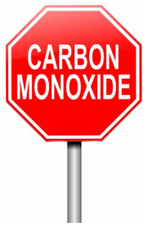
Well, my friends, you are very mistaken. It’s not only Amateur Radio related, but also something that as a HAM operator you may not ever have thought about. Where's your ham shack located? In the basement, garage or outbuilding? Most generally ham shacks are not in the living room or main part of the house. As such, heating devices are usually some sort of a supplemental heater/furnace, and that’s why I’m writing about this.

First, let’s describe what Carbon Monoxide (CO) is. Carbon Monoxide (CO) is the poisonous gases emitted from carbon fueled heat sources (i.e... gas or fuel oil furnaces, wood burning fireplaces or stoves, kerosene heaters, propane heaters). I could go on, but I think you get the idea. It’s colorless, odorless and it will definitely kill you if you breathe very much of it in. How does this gas kill? It migrates into the blood stream and replaces the oxygen in your blood with the Carbon Monoxide. Once it invades your blood stream it will be with you for a very long time, in fact, most of your life! Just ask any firefighter about that. Going into burning buildings without a Self-Contained Breathing Apparatus (SCBA) on like we used to do will definitely get you a lung full of Carbon Monoxide poisoning. It takes years and years to get it out of your system, if ever. Sometimes, if consumed in a large enough quantity, you may need a complete blood transfusion to just keep you alive.

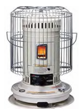
Yes Virginia, it is that deadly!! Why am I writing about this! It’s very personal to me. A number of years ago a very close friend (and his entire family) died in their sleep because they consumed Carbon Monoxide (CO) without knowing it. They lived in an old house on the north side of Mansfield and because it was old, it was drafty with leaks around the doors and windows and the walls didn’t have any insulation in them. We had gotten a cold snap in early November, and back in the middle 1970’s kerosene heaters were all the rage to supplement heat in just this kind of house.

Well, with the help of my co-workers we were able to purchase a big kerosene heater to help them through this cold snap. They got the heater all set up and running and all was fine for the first several days, then on the third day the dad came to work complaining of a very bad headache. None of us thought much about it that day and the dad continued his job on the assembly line with the rest of us. The next afternoon we all found out that the heater had been malfunctioning and every member of the family had died of this very dangerous gas. I was absolutely torn apart. I was one of several people at work that helped take up the collection to purchase the heater.
It took me a long, long time to get over that. Don’t get me wrong, there’s nothing wrong with using these types of supplemental heating sources but be very careful when you do. At that time CO detectors were truly nonexistent for homes, and the ones that were available were for scientific and commercial use, and cost hundreds and hundreds of dollars. That’s all changed now. CO detectors are as cheap now as smoke detectors. You can get one for as little as $10 now. That’s an extremely cheap form of protection from this deadly gas.

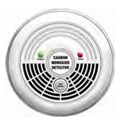
Winter is almost here. I don’t know how it is at your house, but here in the little burg of Lexington, when it gets cold outside, you’ll see the smoke coming out of many chimneys around here. That means that the temperature has dropped to below where it is comfortable. This is the point where the furnaces come on and people start thinking about lighting up the fireplaces and so forth. Now if these devices haven’t been recently serviced, birds can make nests in the chimney’s and like your car, the heat source most likely needs a tune-up to make sure that it’s running efficiently and safely. Having the chimney stuffed up with bird nests or the heat source not burning correctly can cause Carbon Monoxide to accumulate in your house without you even knowing it. That’s where the CO detector comes into play...

Please, please buy one or two of these really inexpensive CO detectors for your safety and use it!

By the way, it’s not all about detection either. Do you have a properly rated fire extinguisher within your reach? If not, get one. Learn how to properly use it. It will save you from a lot of damage if you know how to use it properly. Don’t assume that all you do is pull the pin and squeeze the trigger. It’s about knowing how to sweep and aim at the base of the fire. Do yourself a HUGE favor, buy an extinguisher or two and teach your entire family how to properly use it!

Yes, even the kids need to know how to properly use a fire extinguisher!

Club Links


I’ve received a number of new requests from clubs to be listed on the “Links” club page.

Is your club listed? If not, send the URL of your club website to me n8sy@n8sy.com and I’ll get it listed.

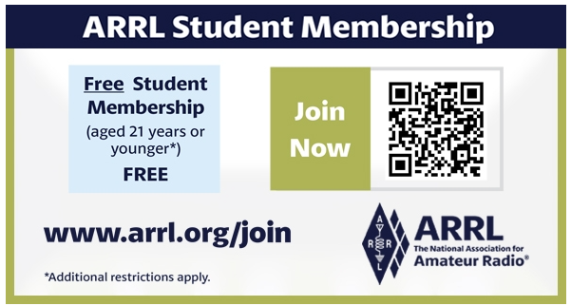

Estate Planning for Hams (What happens to all your stuff?)


August is National Make-a-Will month. Some estimates show that nearly two-thirds of Americans don't have a plan. For some, it's procrastination. Others don't know where to start. “So many times we hear from the family of a Silent Key who are overwhelmed with what to do with a lifetime worth of amateur radio gear,” said ARRL Director of Development Kevin Beal, K8EAL. “Simply thinking through what needs to be done ahead of time can prevent the stress on our loved ones after we are gone.”

ARRL this week held a webinar, hosted by Beal and Dino Papas, KLØS, to discuss the first steps of planning. “It is something that, unfortunately, doesn’t get a lot of attention. The bottom-line up front is, ‘what happens to all our beloved ham gear when that inevitable day comes along that we become a Silent Key?’... Unfortunately, that day may arrive unexpectedly – so we need to prepare ahead of time to make it as simple as possible for our families,” said Papas.

On the ARRLHQ YouTube channel, you can see a replay of the 52-minute presentation, along with the question-and-answer section at the end.

“Your station is an asset, just like anything else you’ve built and put resources into. Deciding now what happens when you become a Silent Key can help solidify your legacy to ham radio,” said Beal. The ARRL Legacy Circle recognizes the generosity of individuals who have planned support for ARRL through wills, trusts, life insurance gifts, and other ways. The ARRL Legacy Circle ensures that ARRL and amateur radio will continue to thrive for generations to come.

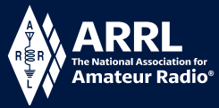
Youth Licensing Grant Program
Here’s one of those little talked about programs to help our youth. I’ll be that many of you didn’t even know about the ARRL Youth Licensing Grant Program. It started in 2022 and covers the one-time FCC $35 application fee for new license candidates younger than 18-years old for tests administered under the ARRL Volunteer Examiner Coordinator (ARRL VEC) program.

Yes, the ARRL will cover the $35 FCC fee for youth who are getting into Amateur Radio.

Additionally, candidates younger than 18-years old would pay a reduced exam session fee of $5 to the ARRL VEC VE team at the time of the exam. The $5 fee is for all candidates under the age of 18 regardless of the exam level taken. Proof of under 18 status is required at the session (what to bring to an exam session).
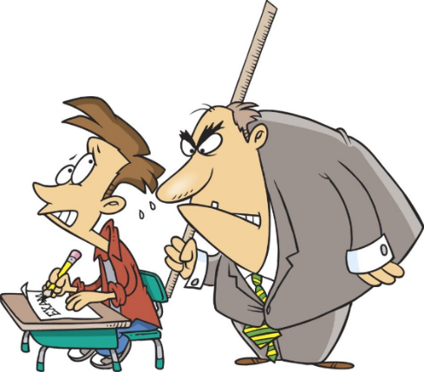
Both of these programs are sponsored by YOUR ARRL.

Candidates younger than 18-years old will pay a reduced exam session fee of $5 to the ARRL VEC VE team when taking an exam. Proper identification must be presented to and verified by the team, per the procedures for all exam candidates (what to bring to an exam session). The $5 fee is for all candidates under the age of 18 regardless of the exam level taken. Want more information about these programs? Licensing Grant Program

2024 Great Lakes Division Hamfests
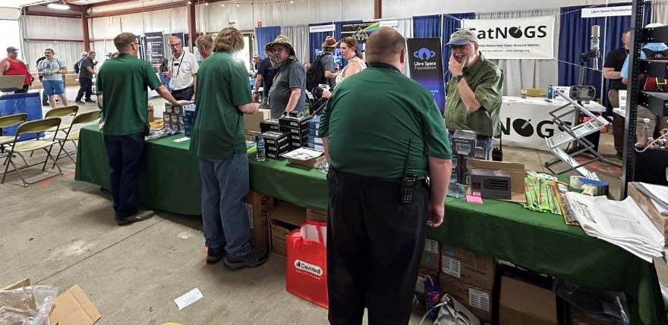
Here in the Great Lakes Division, we have over 50 hamfests a year, including the largest one in the country, Hamvention. This year Hamvention will also be the ARRL’s National Convention as well, which means that there will be some very special things happening there.

So, if you haven’t started planning your hamfest schedule yet, you really need to start now.

Please post this listing in your club's newsletter and announce the swaps on your local nets. Talk them up. Let's fully support all of our hamfests in every way possible. It means success for everyone. Be sure to invite your ARRL Officials as soon as your date is set.
If your ARRL Affiliated club plans to request Hamfest Sanctioning, you should make that request well in advance of the scheduled Hamfest date, as this allows adequate time for QST Listings. QST announcements require a 3-month lead time. To be fair to our division’s clubs, the Great Lakes Division policy now has 2 requirements for any ARRL Sanctioning.

Any club requesting ARRL sanctioning within the Great Lakes Division must now be an ARRL Affiliated Club with a maximum of two hamfests/swaps in any given calendar year, and they must be at least four months apart.

NOTE:… Since the cyber-attack at headquarters, they have been unable to process new requests for hamfests. If you have completed the on-line form for an upcoming hamfest and have yet to see it listed, please contact Steve Ewald, WV1X at 860-594-0265 and let him know. He will manually enter it into the system.

12/01/2024 - LCARC Amateur Radio Swap/Hamfest  Location: Troy, MI  Type: ARRL Hamfest  Sponsor: L'Anse Creuse Amateur Radio Club  Website: http://www.n8lc.org  Learn More | 12/07/2024 - Winter Hamfest  Location: Archbold, OH  Type: ARRL Hamfest  Sponsor: FCARC  Website: https://k8bxq.org/hamfest  Learn More

You can always find the latest updates for upcoming hamfests on the Great Lakes Division website.
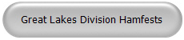
Just click to get the latest hamfest updates.

Do you know someone who isn’t getting this newsletter

Hi Gang,

If you know someone who isn’t already getting Radio Waves, have them sign up to receive it!! They don’t have to be ARRL members to sign up, just click on the button below and in no time, they will start receiving it.
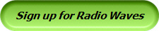

Wanted… Your Photo’s
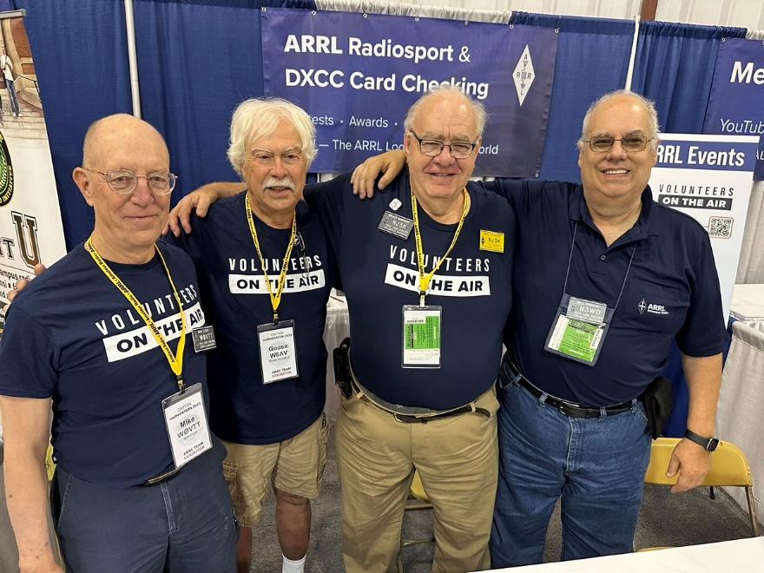
Have you seen the Photo Gallery on the Great Lakes Division website? If you haven’t you really need to, your face may be among the many already posted there.

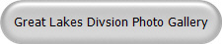

I’m always looking for more pictures to use in the Gallery, newsletter, banner and video display. Please, send me your pictures!!! Send them to: n8sy@n8sy.com

