
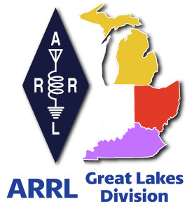
Radio Waves
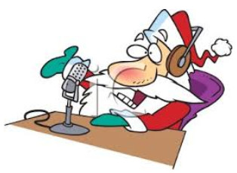
^{The} Great Lakes Division
Monthly Journal

December 2024

What’s inside…

2024 ARRL Technical Service Award  Have We Met The Enemy  2024 Division Hamfests | Santa Net  Club Links  Scott’s Stuff

25th Annual SKYWARN Recognition Day December 7, 2024
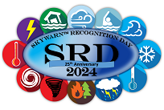
SKYWARNTM Recognition Day is December 7, 2024. The annual event is celebrating its 25th anniversary. SRD was established in 1999 by the National Weather Service and ARRL® to commemorate the contributions of SKYWARN volunteers. Using amateur radio and other means of communication, SKYWARN spotters provide real time ground truth to NWS offices. The ham-volunteers can also provide vital communications between NWS and local emergency management officials when other means go down.

In a video posted to the SRD web page, National Weather Service Director Ken Graham, WX4KEG, said the information ham radio operators and other SKYWARN volunteers provide is critical. “I, along with the entire National Weather Service, want to acknowledge and thank you for your invaluable service to the communities we serve.”
There will be a SRD special event from 0000 – 2359 UTC on the day. The objective is for all amateur stations to exchange QSO information with as many Amateur Radio SKYWARN Spotters and National Weather Service Stations as possible on the 80, 40, 20, 15, 10, 6, 2-meter and 70-centimeter bands.

ARRL will be on the air during the event from the ARRL Radio Laboratory station, W1HQ, using the call sign WX1AW. ARRL Public Relations and Outreach Manager Sierra Harrop, W5DX, said SRD is a great opportunity to welcome non-ham SKYWARN volunteers to explore amateur radio. “Storm spotting was my original draw into ham radio. I watched a large tornado tear up my community on May 3, 1999, and was listening via my mom’s 2-meter mobile radio to spotter reports being relayed to the NWS Norman, Oklahoma, office. I knew I wanted to be a part of that and within months I was licensed. Amateur radio was my path into that community service and has been the hobby of a lifetime ever since,” she said.

ARRL has a web page to help those interested with getting licensed. Find details at https://www.arrl.org/getting-licensed.

Spotters are encouraged to register for SRD at: https://www.weather.gov/crh/skywarnrecognition. There will be participation certificates available after the event.

Ed Menasian, N8LPQ, Receives 2024 ARRL Technical Service Award

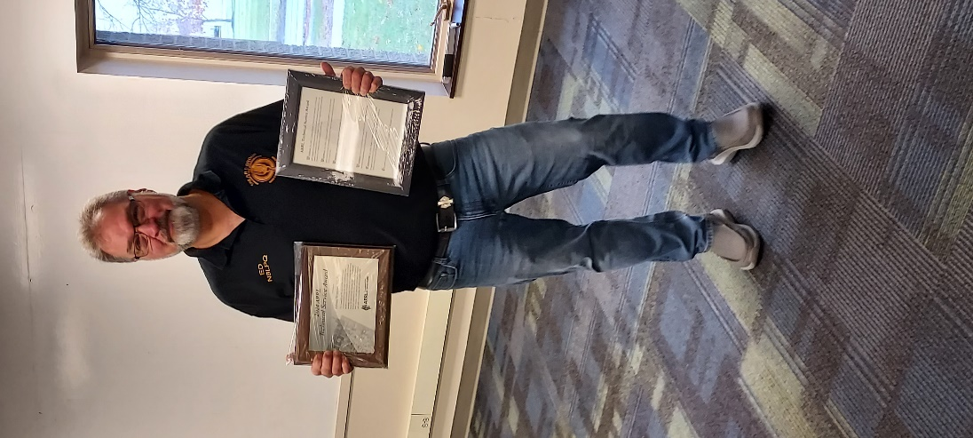
Ed Menasian, N8LPQ, of Toledo, Ohio, is the recipient of the 2024 ARRL Technical Service Award. He was presented the award plaque and motion certificate by ARRL Great Lakes Division Director Scott Yonally, N8SY, at a ceremony held November 23 at the Toledo Emergency Management Agency.

The ARRL Technical Service Award is given annually to one or more licensed radio amateurs whose service to the amateur community and/or society at large is of the most exemplary nature within the framework of amateur radio technical activities.

The award motion certificate presented to Menasian noted he exemplifies the spirit of the award through creating ways to learn and share technical information, including his weekly breakfast meetings and his licensing classes that train both prospective and current hams.

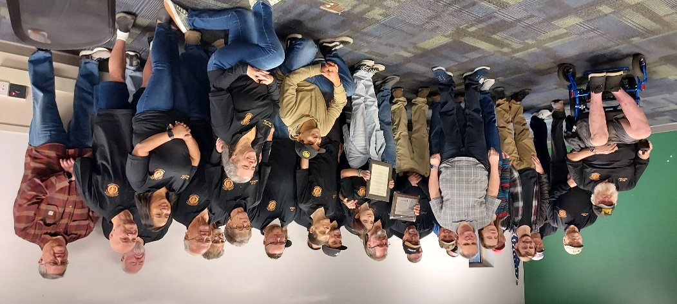

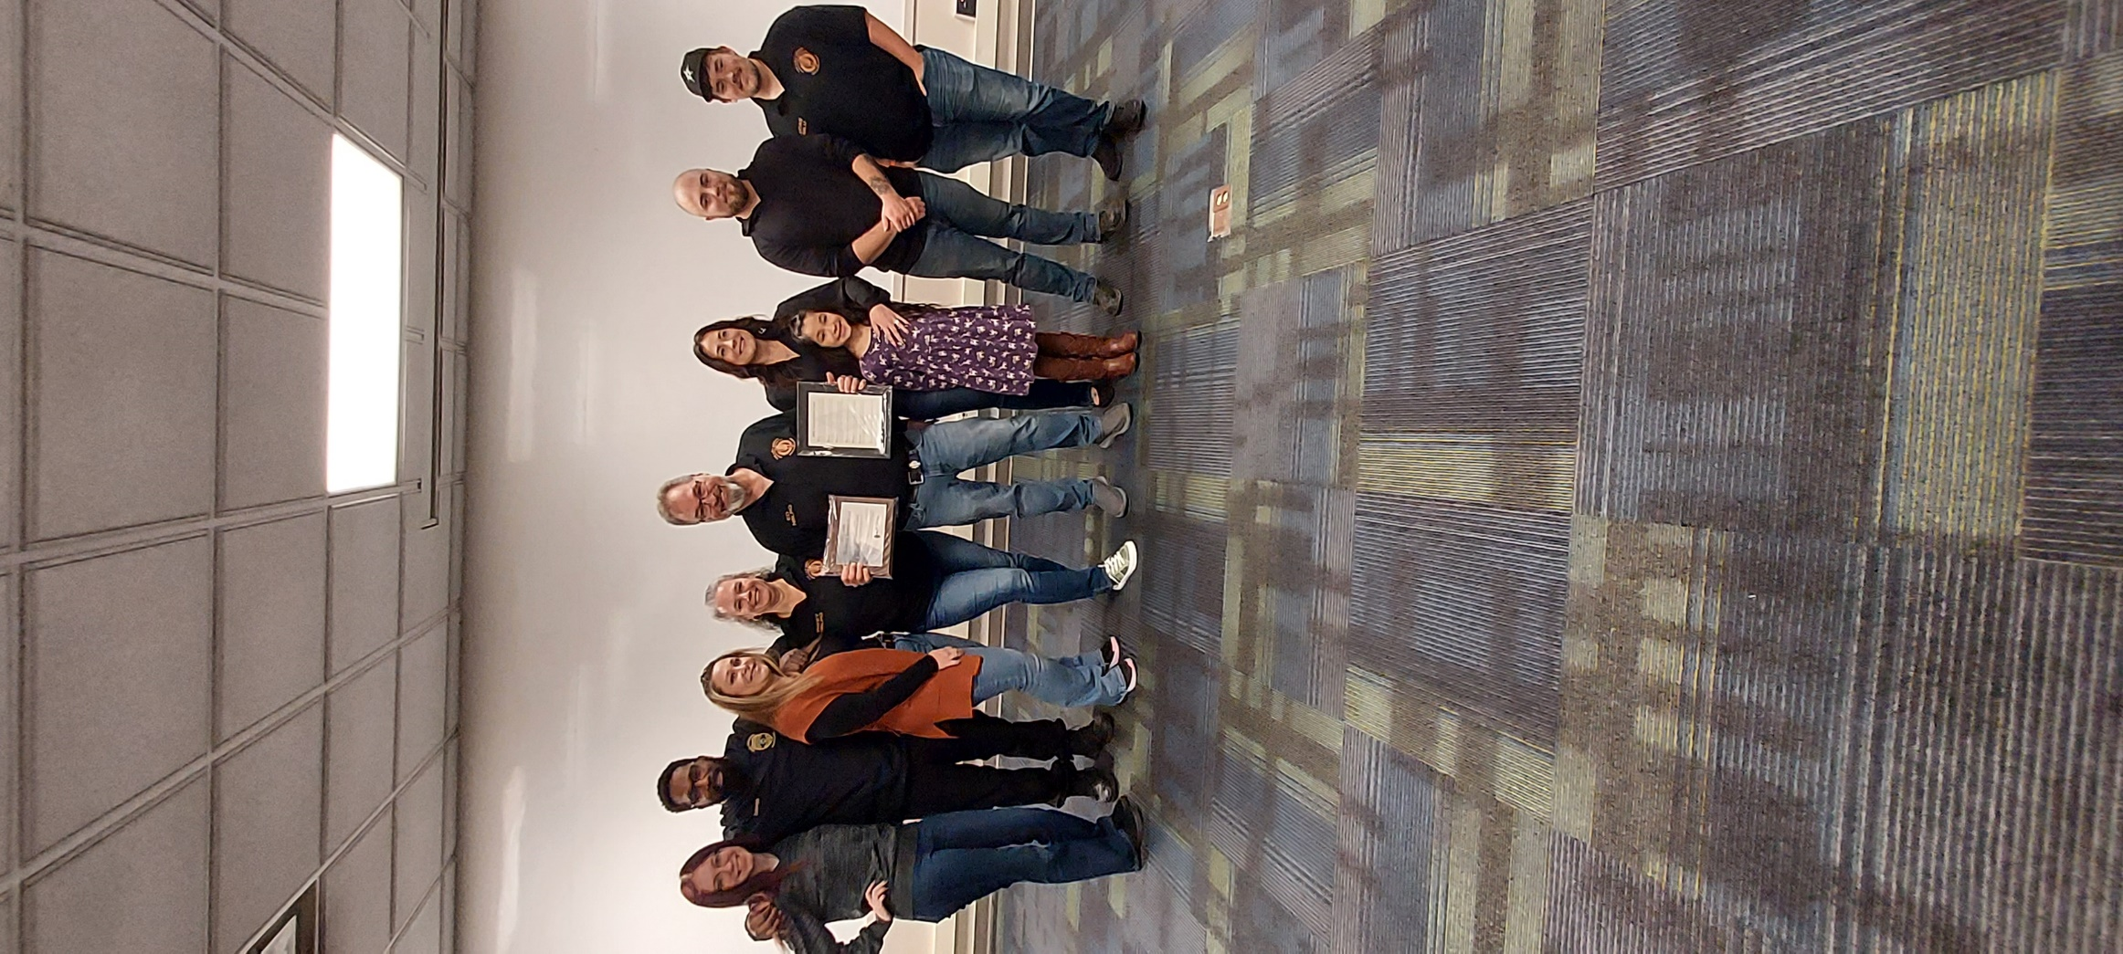
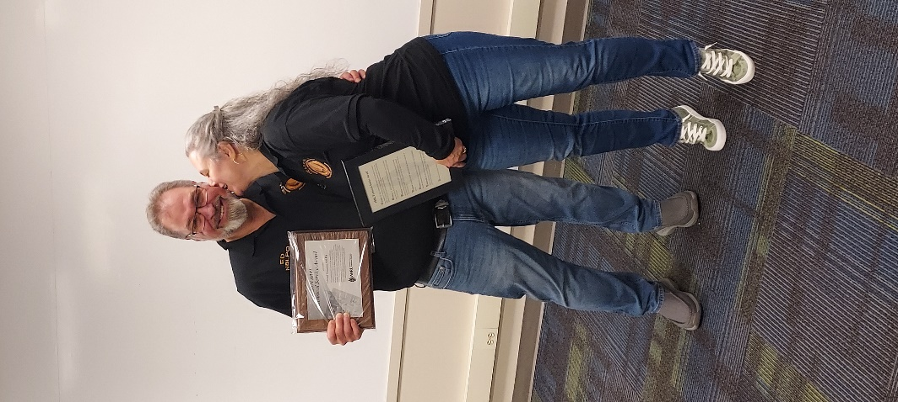

“It was a great day for me,” said Director Yonally. “A room full of his students each got up and did a short testimonial on how Ed has helped them in not only getting licensed, but also getting on the air, and how he encourages them to upgrade as well. What a day it was.” Yonally added, “ This is what being a member of ARRL is all about.”

Menasian has been licensed since 1981, holds a General Class license and has been an ARRL member for 13 years.

Club Links


I’ve received a number of new requests from clubs to be listed on the “Links” club page.

Is your club listed? If not, send the URL of your club website to me n8sy@n8sy.com and I’ll get it listed.

Scott’s Stuff
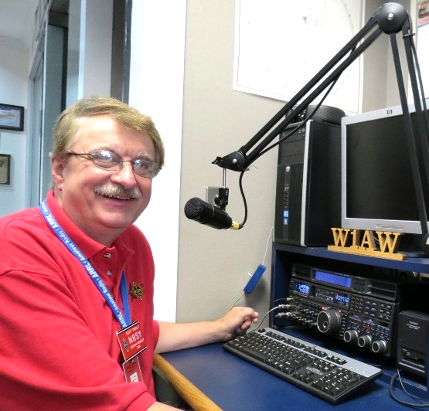
Hi Gang,

May we have peace and goodwill to all in this Season of Hope, Joy and Celebration. Have you been good little girls and boys? I sure hope so, and I hope that you get everything on your wish list as well!

Did you survive turkey day? You know... that one day above all others that you eat everything in sight, including the dishes, tablecloths and if you’re really hungry, you’ll even go after the dog's food bowl and then sit back with your pants unbuttoned in your recliner chair complaining that there's no leftovers and you'll have to make a run to the store for some snacks! Anyway, I hope that You and Yours had a wonderful Thanksgiving and that you remembered to give a very special thanks to all of those in uniform that keep us safe all year long.
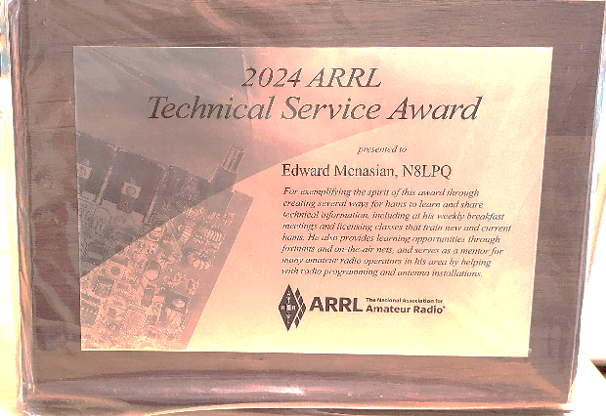
I had a blast this past couple of weeks attending some meetings and one very special awards ceremony where I presented the 2024 ARRL Technical Service Award to Ed Menasian, N8LPQ. A lot of Ed’s students and club members stood up and thanked Ed for all that he did to help them become hams and keep them going by getting them to become an active member of the club. He’s a one of a kind “Elmer” / mentor.

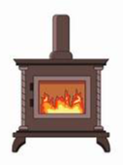
Have you had a chance to read the article I wrote last month about Carbon Monoxide (CO) poisoning? I sure hope you didn’t just skim over it as that we sometimes ignore the signals of something wrong until it’s too late. Now that the snow has fallen along with the temperatures, those old potbelly stoves and modified propane heaters and/or pellet stoves are starting to get fired up to give us some extra heat in those unheated shacks.

If they are not burning correctly or the chimney flew has a dozen or so squirrel nets in it, you could get overwhelmed with CO poisoning without really noticing it until it’s too late. Please, take a good look at that article and really read it. It has some very good information on how to keep you safe.
It's been really busy lately with the holidays and getting things ready for the upcoming Board of Directors meeting in January. Roy and I are working hard at completing a number of projects before the end of the year.

Have you been working any DX over these holidays? Don’t forget to check-in with our good friend Jack Shirley, N8DX, who is our QSL card sorter manager for the 8th call area to make sure that you don’t have some cards just waiting for you. You work these rare stations and even log them to LoTW, but forget that there may be a QSL card also waiting for you. If you have questions, make sure you touch base with Jack at: w8buro@gmail.com

I’m happy to inform you that the scholarship application process is once again now open. There is a link on the ARRL homepage in addition to the link on the scholarship page. More than 100 scholarships ranging from $500 to $25,000 will be awarded in 2025. Hey, this is FREE money for your kids to go to college on! How many kids do you know that couldn't use a helping hand with their college tuition? All applicants must be active, FCC-licensed amateur radio operators and all applicants must submit a completed online application no later than January 6, 2025, at 12pm. Go to: http://www.arrl.org/scholarship-program

This month we have the 160-meter, 10-meter and Rookie Roundup (CW) contests coming up, not to mention that there are a few hundred more contests that you could get involved with as well. Here's the link to see them all... https://www.contestcalendar.com/

Okay, that is going to do it from here this month. Stay safe and "Catch Me On The Air, at a meeting or hamfest!!!" But most of all... Have FUN and…. Get On The Air!!!!

73,

Scott Yonally, N8SY
Director - Great Lakes Division
n8sy@arrl.org

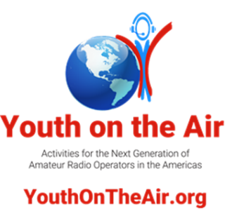
Youth On The Air

Amateur radio operators ages 25 and younger will be on the air as special event stations around the world throughout December in celebration of youth in amateur radio. YOTA Month stations will be on all bands and modes at various times. QSL and award information is at events.ham-yota.com.
In the United States this year, the callsigns returning will be K8Y, K8O, K8T, as well as W8A.
Argentina will be active as LT4YOTA, and Canada as VC2YOTA, VC3YOTA, and VB7YOTA. El Salvador will operate as YS1YOTA, and Costa Rica will be TIØYOTA.
The Honduras callsign is pending approval. Amateur radio operators should be encouraged to listen for and contact these stations as well as all callsigns ending in the letters “YOTA” across the globe.
Last year, young hams worldwide surpassed their goal of 100,000 QSOs in the month of December with a final tally of 103,788.
Overlapping with YOTA month is round 3 of the YOTA Contest, which is on December 30, 2024 from 1000 to 2159 UTC.
More information about YOTA Month specifically in the Americas can be found at YouthOnTheAir.org including a link to all YOTA station spots on DXSummit.com. The Youth on the Air website is sponsored by ICOM America.
More information about YOTA Month globally can be found at events.ham-yota.com.
To schedule interviews or obtain additional information about YOTA Month participation in the Americas, please contact YOTA Month Americas participation coordinators Blake Pearson, KN4VKY, Ryan Pearson, KN4VKW, and Kees Van Oosbree, WØAAE at yotamonth@youthontheair.org.

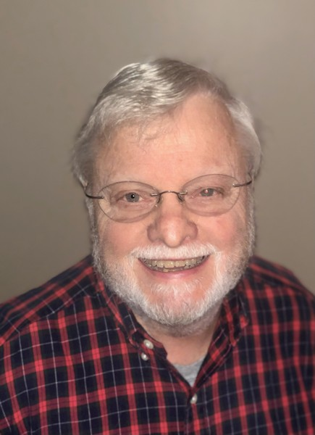
Have we Met the Enemy?
Roy Hook, W8REH

Welcome to December, the last month of the first of our three year terms, where Scott Yonally as Director and I as Vice Director are privileged to represent you on the ARRL Board of Directors. We thank you for your support and the important input and advice you provide us at club meetings and hamfests where we likely have met and look forward to the future working together. Thanks for sharing your thoughts!

The events coming out of November 2024 will elicit an extreme range of feelings from all of you. Regardless of yours, let’s look at the bright side, no more ads in your mailbox or on TV. Don’t allow our minds to equate divisive national politics with the way we manage through the Amateur Radio challenges at hand. It is true, change is inevitable. Brendan Carr the presumed new FCC Chairman has not commented on Amateur Radio specifically that I know of, but besides expected staffing reductions (read enforcement) at the FCC, he appears to be significantly aligned with the well-funded and politically connected wireless carrier commercial interests.
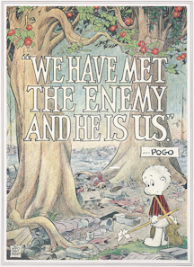
With his possible perception from a fiscal and political perspective that Amateur Radio benefits a small subset of citizens having essentially free wireless spectrum, supporting the expert professionals retained by ARRL is more important than ever now. Understanding and accepting the things we cannot personally change may leave us the best approach of continuing to provide visibility to all the positive things we do, avoiding negative discussions or perceptions which can be viewed publicly and support the efforts of our national organization. Amateur radio survival may benefit most by continuing to stay under the radar at the FCC.

We believe strongly that our local organizations and clubs are where we need to focus for solutions to the challenges this constantly changing world present us. We are in a time of so much polarization everywhere which I attribute to extreme diversification, especially from the proliferation of technology all around us. I have found one more thing as constant as death and taxes and that is change. Many within our ranks are “change adverse” and focus on trying to make things the way they “remember”. I continue to try to think bigger picture the best I can especially understanding and accepting things that can’t change, working to preserving the good things we have and embracing change where change is possible and needed.

It is only natural that the slash and burn attacks on some of our hard working volunteer efforts leads to defensive responses not necessarily viewed as helpful.

Maybe we can’t stop the attacks and negative dialog, but we can all work harder to work toward positive efforts to build on the great things our organizations have accomplished. Over the last 100 years our hobby has proven significant value, education and enjoyment for our close fraternity of lifelong friends and relationships we should value greatly.

Maybe we are all a piece of the problem.

I was recently briefed on a brainstorming session that evolved from a club VE planning session. My take away was that we realize we’re doing pretty well at training folks to pass the licensing exams, but not so good at retaining their interest in the hobby. There was a conclusion that it might be time to revisit the concept of incentive licensing and I do hear support for that from other discussions. My thought is we should step back a bit further to more clearly identify what things we might incentify if we were to pursue this kind of change. Are our hobby and our clubs an educational resource or just instructors on test taking?

Before we jump to the idea that we need to provide more HF phone or digital privileges to the entry Technician class, is there more to be done with the existing privileges already available?

Right now in the current solar cycle, existing 10 meter phone and digital privileges should be gold if someone is truly interested in learning how to communicate around the world. The renewed interest in CW might be a promotional point for technician privileges on 80, 40, 15 meters.

GMRS is a reality. Modern day CB or not, the FCC has provided a communication tool open to the public. VHF/UHF amateur repeaters may not be all that much different from a public point of view. Have our clubs become a repeater utility company? I am proud of the many efforts and out of the box thinking I hear coming from some of our deeper thinkers. I leave you again with one of my favorite quotations: “Thinking is hard work. If it weren’t, more people would do it”.

Thanks for supporting the League since that it is one of the most practical tools we have to succeed.

73,

Roy Hook, W8REH
Vice Director
Great Lakes Division
w8reh@arrl.org


Committee Proposes Changes to ARRL By-Laws 42 and 46

At the 2024 ARRL Annual Meeting held in January, the Board of Directors unanimously voted to approve the establishment of a committee to assure the existence of a set of ethical standards and guidelines for Board Members as called for in ARRL By-Law 42. In addition, the committee was tasked to review By-Laws 42 (Ethics and Elections Committee) and 46 (Conflict of Interest Policy) for possible revision.

I was selected by President Rick Roderick, K5UR, to chair the ARRL Special Committee on By-Law 46 Revisions. I am writing to share an update on our efforts. The committee scrutinized By-Laws 42 and 46 for revisions, and incorporated feedback from legal counsel. After diligent work, the committee has finalized its recommendations and, earlier today, presented its report and proposed By-Law revisions at a meeting of the Committee. All of the ARRL Board Members were invited to participate in that meeting.

All of our committee’s work, including our report and documents pertaining to proposed By-Law revisions, is readily available for your review at www.arrl.org/by-laws-update. I encourage you to consider reviewing the documents to help develop your own perspective on these issues.

Why This Matters: As ARRL is a federally recognized 501(c)(3) nonprofit corporation, it is imperative that our governance structure meets the legal and ethical requirements of a well-governed organization. We will reinforce trust and accountability with our members by establishing ethical standards and an independent adjudication process.

If you have any questions or concerns, please contact your Division Director.

73,
Rod Stafford, W6ROD, Chair of the Special Committee on Bylaw 46
ARRL International Affairs Vice President

2024 Great Lakes Division Hamfests
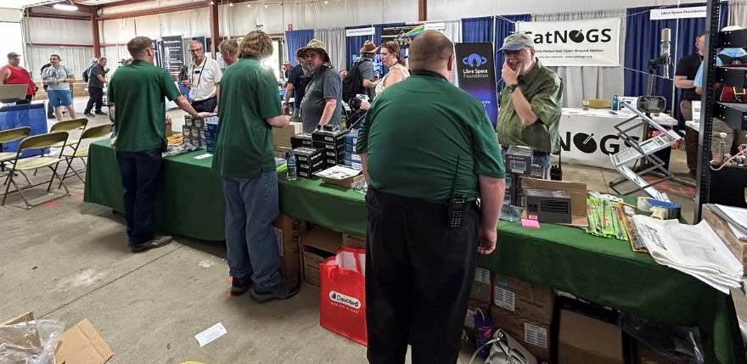
Here in the Great Lakes Division, we have over 50 hamfests a year, including the largest one in the country, Hamvention. This year Hamvention will also be the ARRL’s National Convention as well, which means that there will be some very special things happening there.

So, if you haven’t started planning your hamfest schedule yet, you really need to start now.

Please post this listing in your club's newsletter and announce the swaps on your local nets. Talk them up. Let's fully support all of our hamfests in every way possible. It means success for everyone. Be sure to invite your ARRL Officials as soon as your date is set.
If your ARRL Affiliated club plans to request Hamfest Sanctioning, you should make that request well in advance of the scheduled Hamfest date, as this allows adequate time for QST Listings. QST announcements require a 3-month lead time. To be fair to our division’s clubs, the Great Lakes Division policy now has 2 requirements for any ARRL Sanctioning.

Any club requesting ARRL sanctioning within the Great Lakes Division must now be an ARRL Affiliated Club with a maximum of two hamfests/swaps in any given calendar year, and they must be at least four months apart.

NOTE:… Since the cyber-attack at headquarters, they have been unable to process new requests for hamfests. If you have completed the on-line form for an upcoming hamfest and have yet to see it listed, please contact Steve Ewald, WV1X at 860-594-0265 and let him know. He will manually enter it into the system.
12/01/2024 - LCARC Amateur Radio Swap/Hamfest  Location: Troy, MI  Type: ARRL Hamfest  Sponsor: L'Anse Creuse Amateur Radio Club  Website: http://www.n8lc.org  Learn More | 12/07/2024 - Winter Hamfest  Location: Archbold, OH  Type: ARRL Hamfest  Sponsor: FCARC  Website: https://k8bxq.org/hamfest  Learn More

You can always find the latest updates for upcoming hamfests on the Great Lakes Division website.
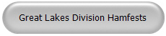
Just click to get the latest hamfest updates.

Do you know someone who isn’t getting this newsletter

Hi Gang,

If you know someone who isn’t already getting Radio Waves, have them sign up to receive it!! They don’t have to be ARRL members to sign up, just click on the button below and in no time, they will start receiving it.
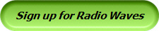

How to Let Kids Talk with Santa Over Ham Radio This Holiday Season

Santa Claus will be on the amateur radio airwaves again this year. The 3.916 Santa Net will be on the air every night at 7:00 PM CST from November 29 through December 24. Reserve a spot with Santa by making a pre-net check in. You can check in each night starting at 6:30 PM CST online at www.CQSanta.com.

Santa and Mrs. Claus will also be on the air, together, thanks to special arrangements with the Cowley County Amateur Radio Club in Kansas. They will be on the air on the 147.000 repeater and the Sunflower Net system, between 10 AM and noon CST on November 30 and beginning at 10 AM until band conditions change on December 14 and 21.

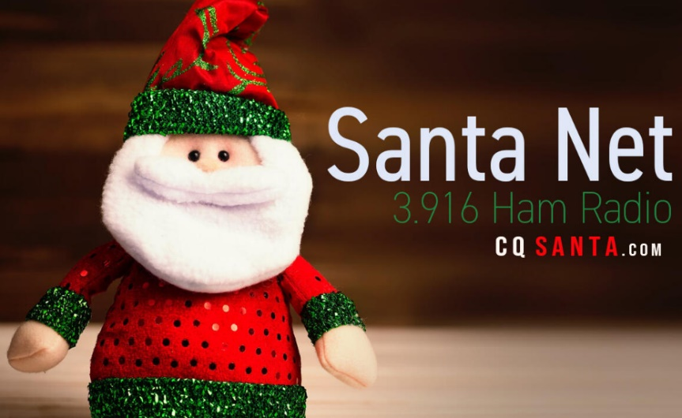
In addition to the local repeater, the Sunflower Net offers connection options to Allstar, DMR, Dstar, Echolink, Fusion, Hamshack Hotline, M17, and P25. The club is also setting up a radio link at the local library to talk to Santa. A special effort is being made to give children who are hospitalized or otherwise unable to visit personally an opportunity to reach out to Santa.

Also, for the 4th year, Santa has sent Elf Chucky and his team of amateur radio operators to northern Colorado, to help make sure children of all ages can talk to Santa on station NØP from the North Pole. Thanks to the Longmont Amateur Radio Club and the Northern Colorado Amateur Radio Club, children can get into the holiday spirit by talking to Santa on the radio. Both are ARRL Affiliated Clubs. Get the details on that operation at https://w0eno.org/santa.

Wanted… Your Photo’s

Have you seen the Photo Gallery on the Great Lakes Division website? If you haven’t you really need to, your face may be among the many already posted there.

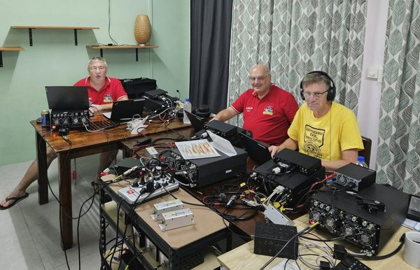


I’m always looking for more pictures to use in the Gallery, newsletter, banner and video display. Please, send me your pictures!!! Send them to: n8sy@n8sy.com

########

